

UNIVERSIDAD DEL ISTMO

FACULTAD DE INGENIERÍA

VACCINATION SYSTEM: USER MANUAL

JORGE EDUARDO GUERRERO GARCIA

**ÍNDICE**

**1.** **HOMEPAGE** 3

**2.** **INFORMATION** 4

**3.** **CONTACT** 7

**4.** **NEWS** 9

**5.** **LOGIN/SIGN UP** 9

**6.** **USER** 13

**7.** **EMPLOYEE** 16

**8.** **VALIDATION** 17

**9.** **ADMINISTRATOR** 19

**10.** **ADMINISTRATION** 19

**11.** **CONTENT** 22

**12.** **HABILITATION** 25

**13.** **CENTERS** 27

**14.** **VACCINES** 29

**15.** **REPORTS** 30

# **HOMEPAGE**

When entering the page, the home page will initially be displayed

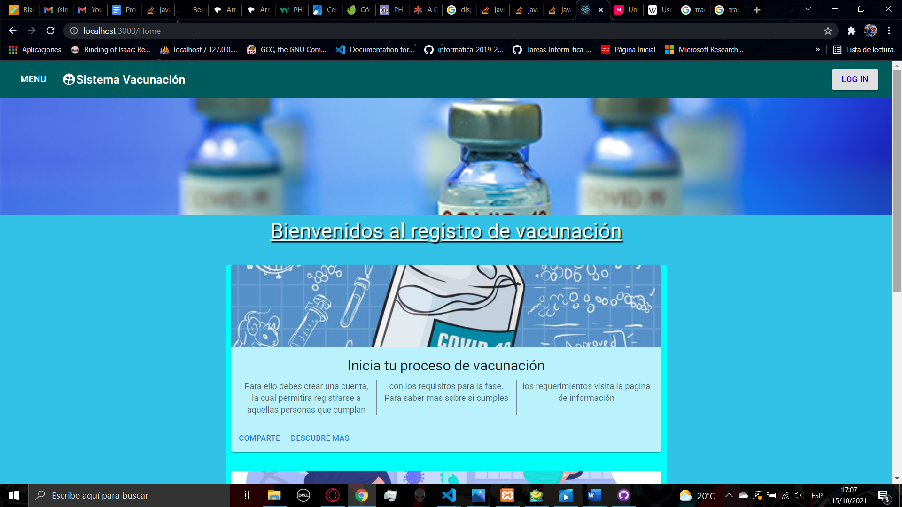

Here you will have a navbar at the top that will have at the left size a menu button and the title Sistema Vacunación, in the right side you will have a button that redirects you to the login page.

When clicking the menu button, a side bar will appear showing some links to other pages to the site

 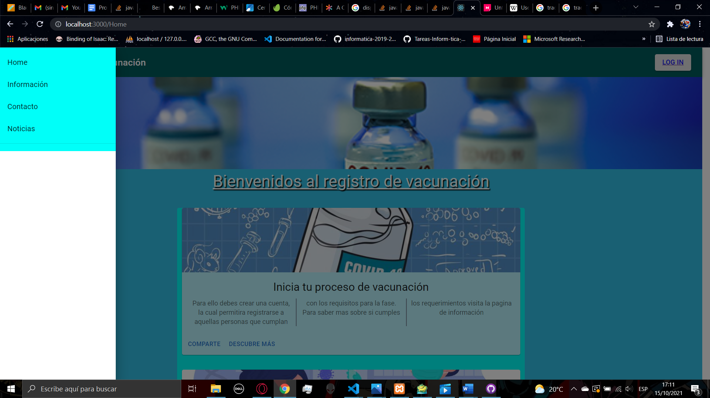

Here you have access to the home page, the Information page, the Contact page, and the News page, when you click a link, it will redirect you to the page

In the home page you will find some articles related with the vaccination process and the articles contain link for sharing and learn more about the topic

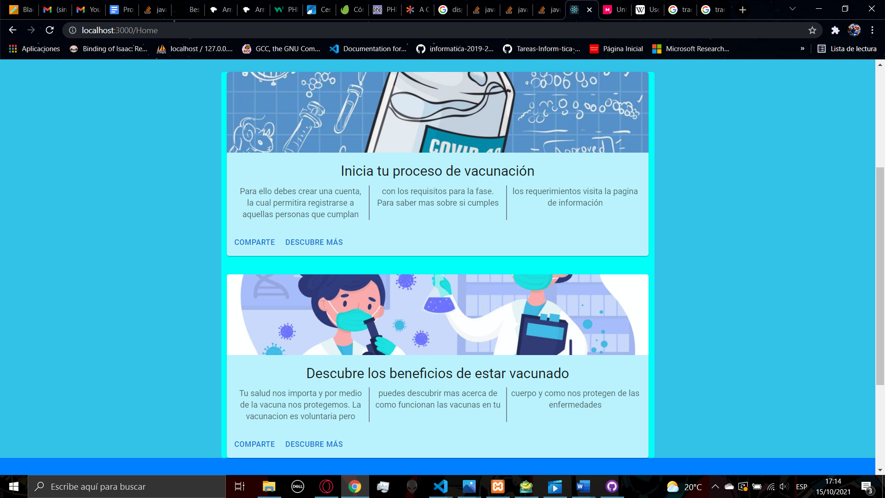

At the bottom of every page, you will find the footer that will have some sections, the first will have links to the pages Home, Information, Contact and News, the second one will have links to our social media profiles and the third one will have other links for help and support. Also, the footer will have the copyright and the actual date

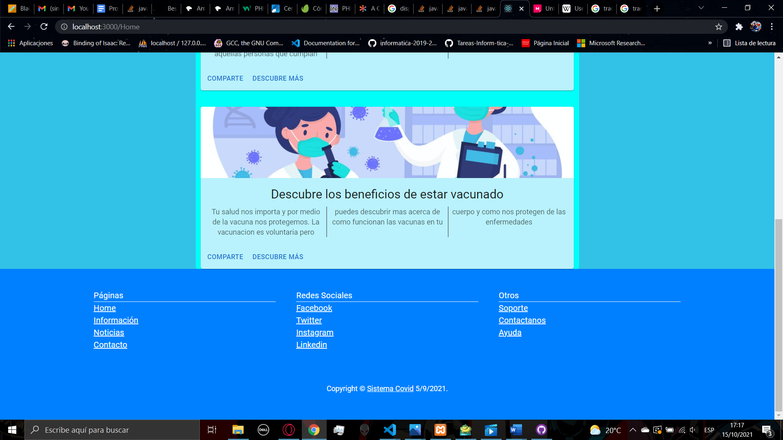

1. **INFORMATION**

With the navbar and the footer you can access to the Information page, here you can find some info about the register to start the vaccination process, you will find 3 accordions, the fist one contains information the people able to start the process that birth before the date specified, the next accordion will have the chronic illness that are accepted to start the process immediately without counting the birth date, also the next accordion in the same way will have those groups that are able to start the vaccine process immediately. This page will have real time data so you should see it frequently for actualizations.

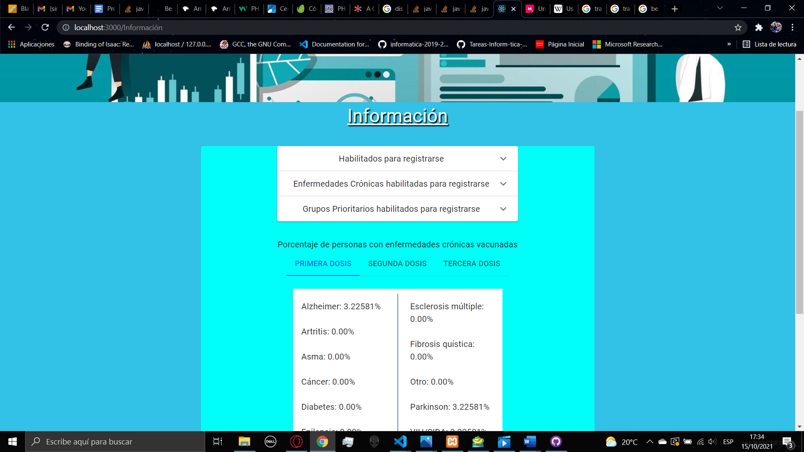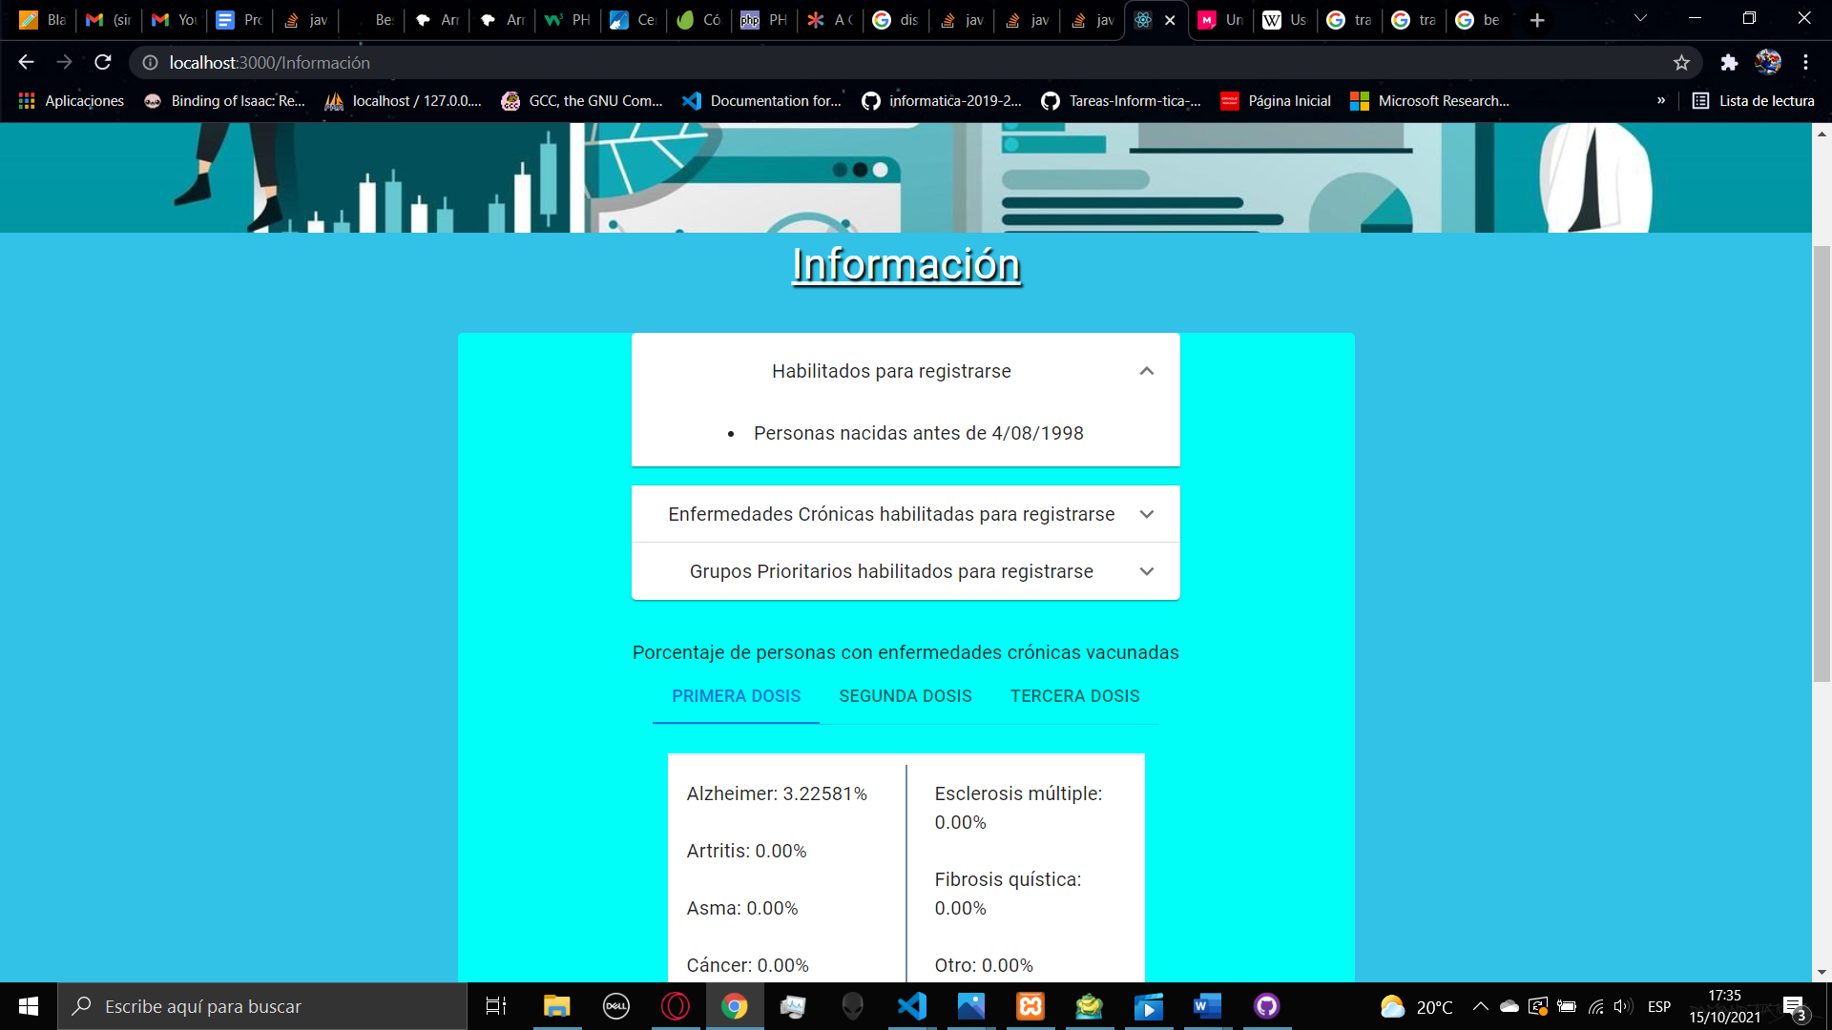

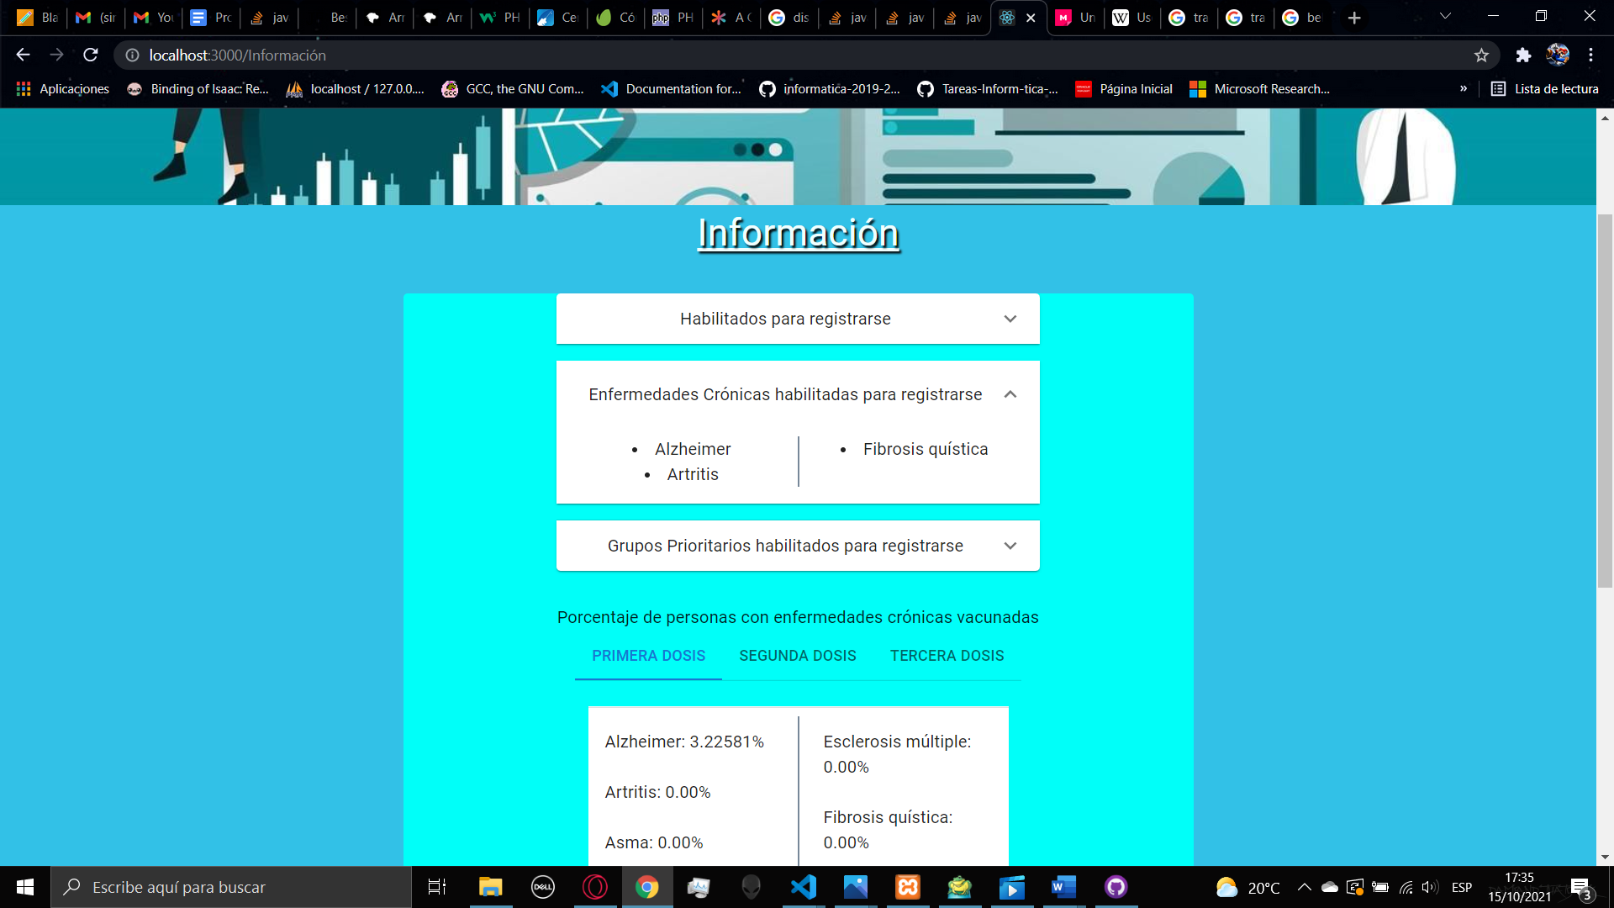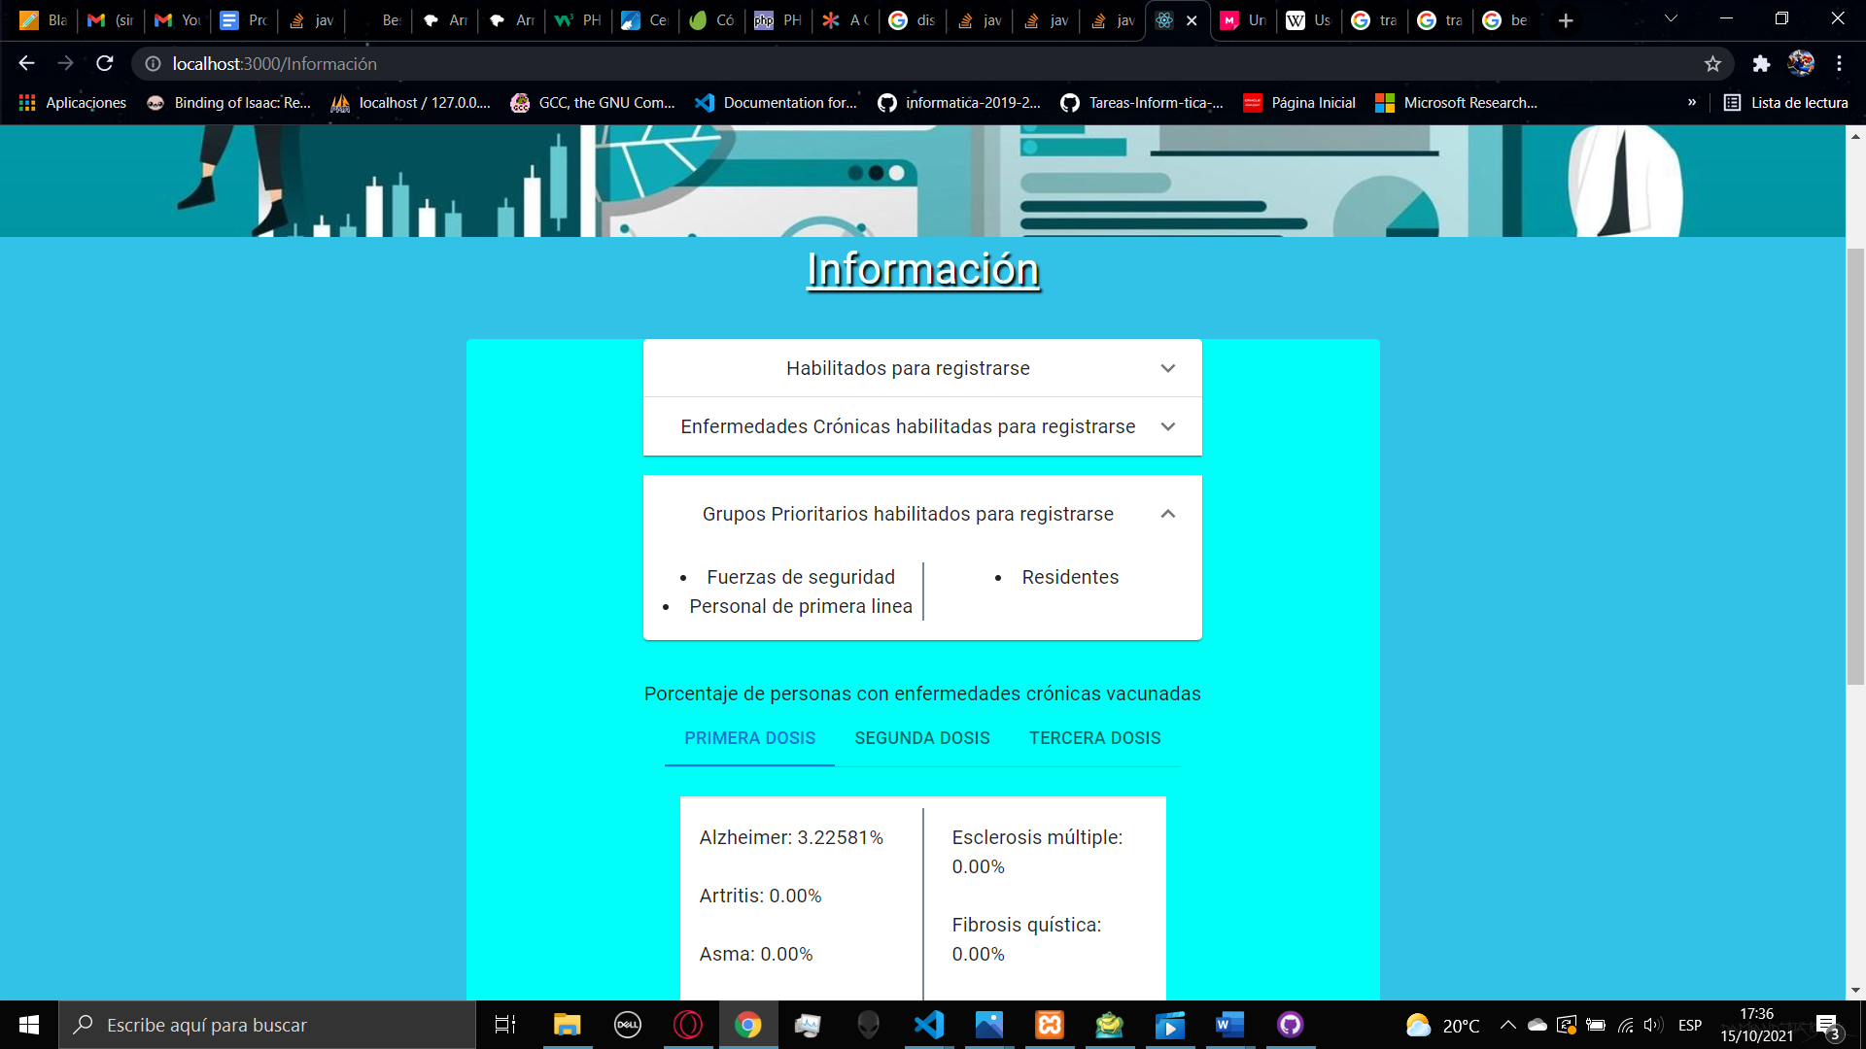

Below the accordions there will appear a tab menu that will have some statistics about the total of people with chronic illness vaccinated with a specific dose.

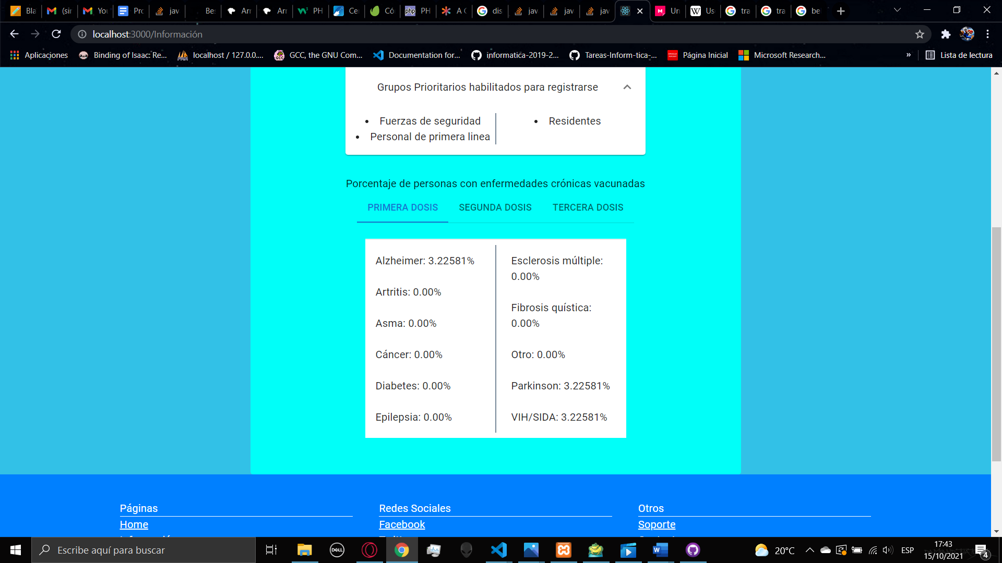 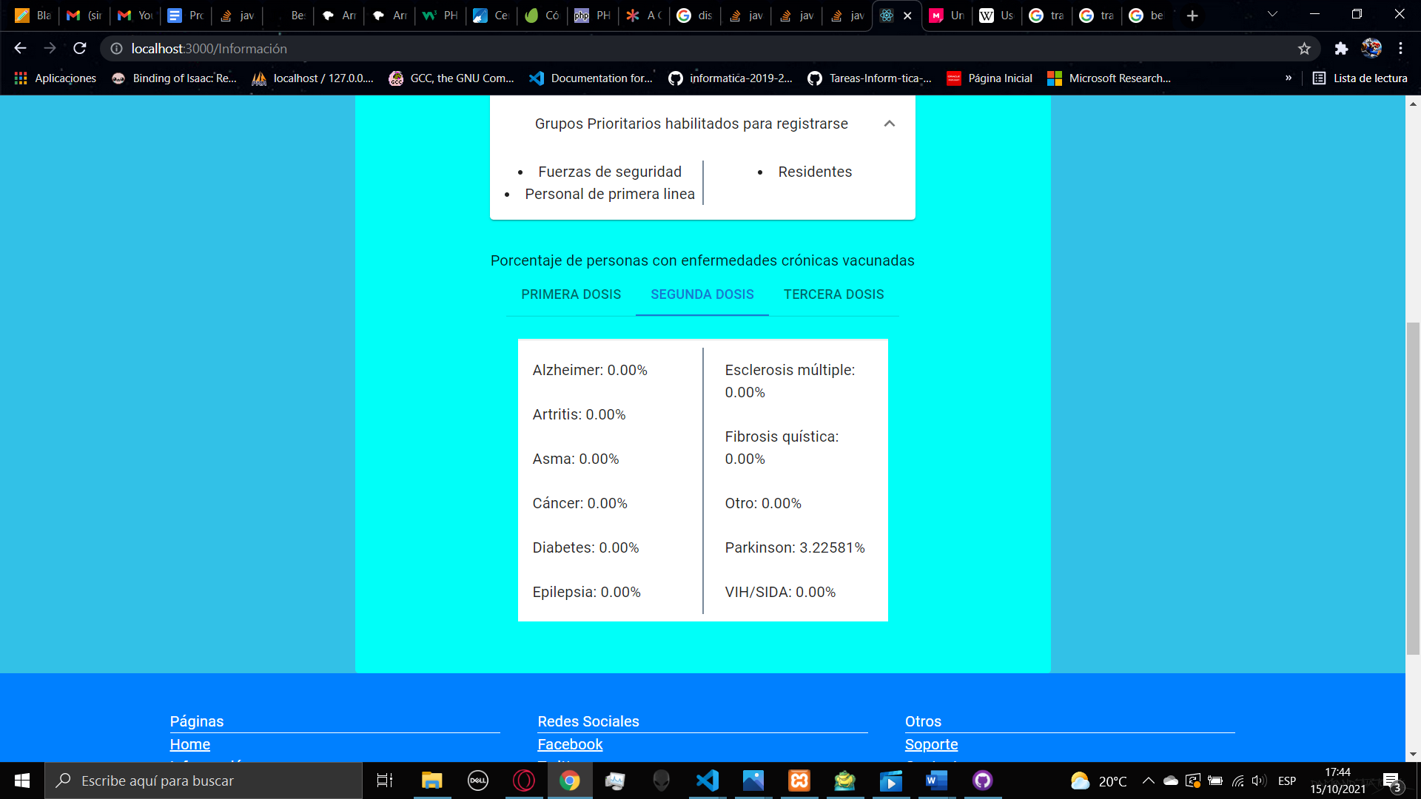

Below the tab menu you can find a field that you can fill with a code given in the process page by generating a pdf file with the data of your process, you can see more about this in item 6.

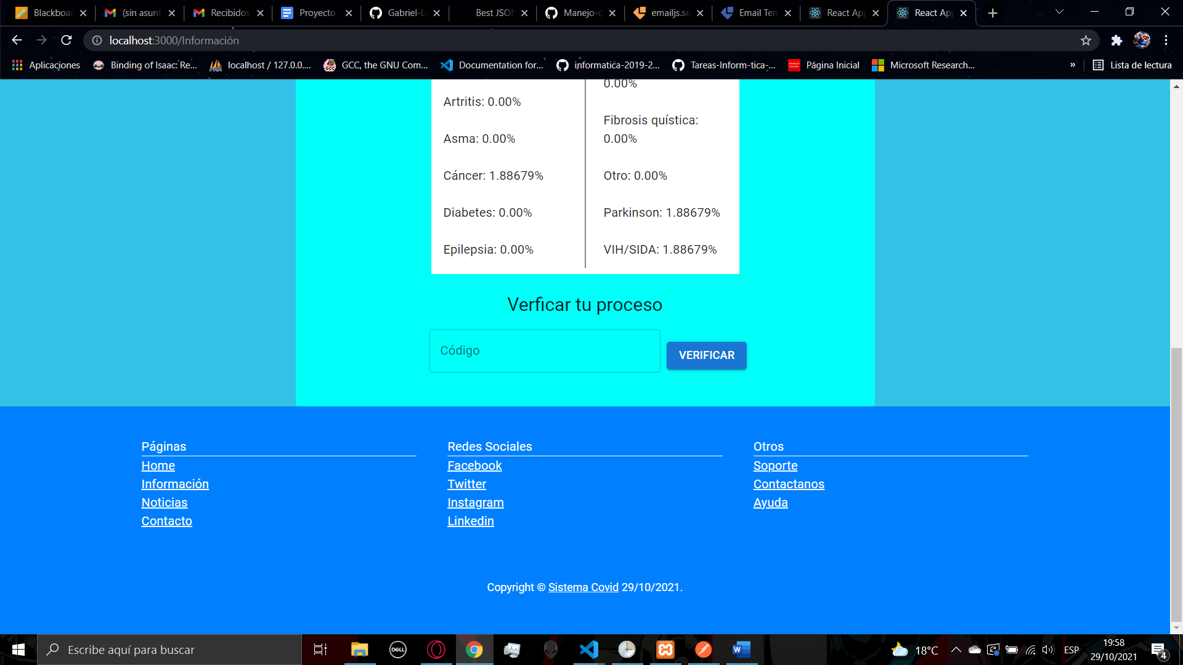

When you insert the 20 digits code, it will appear the same data that appears in the pdf file

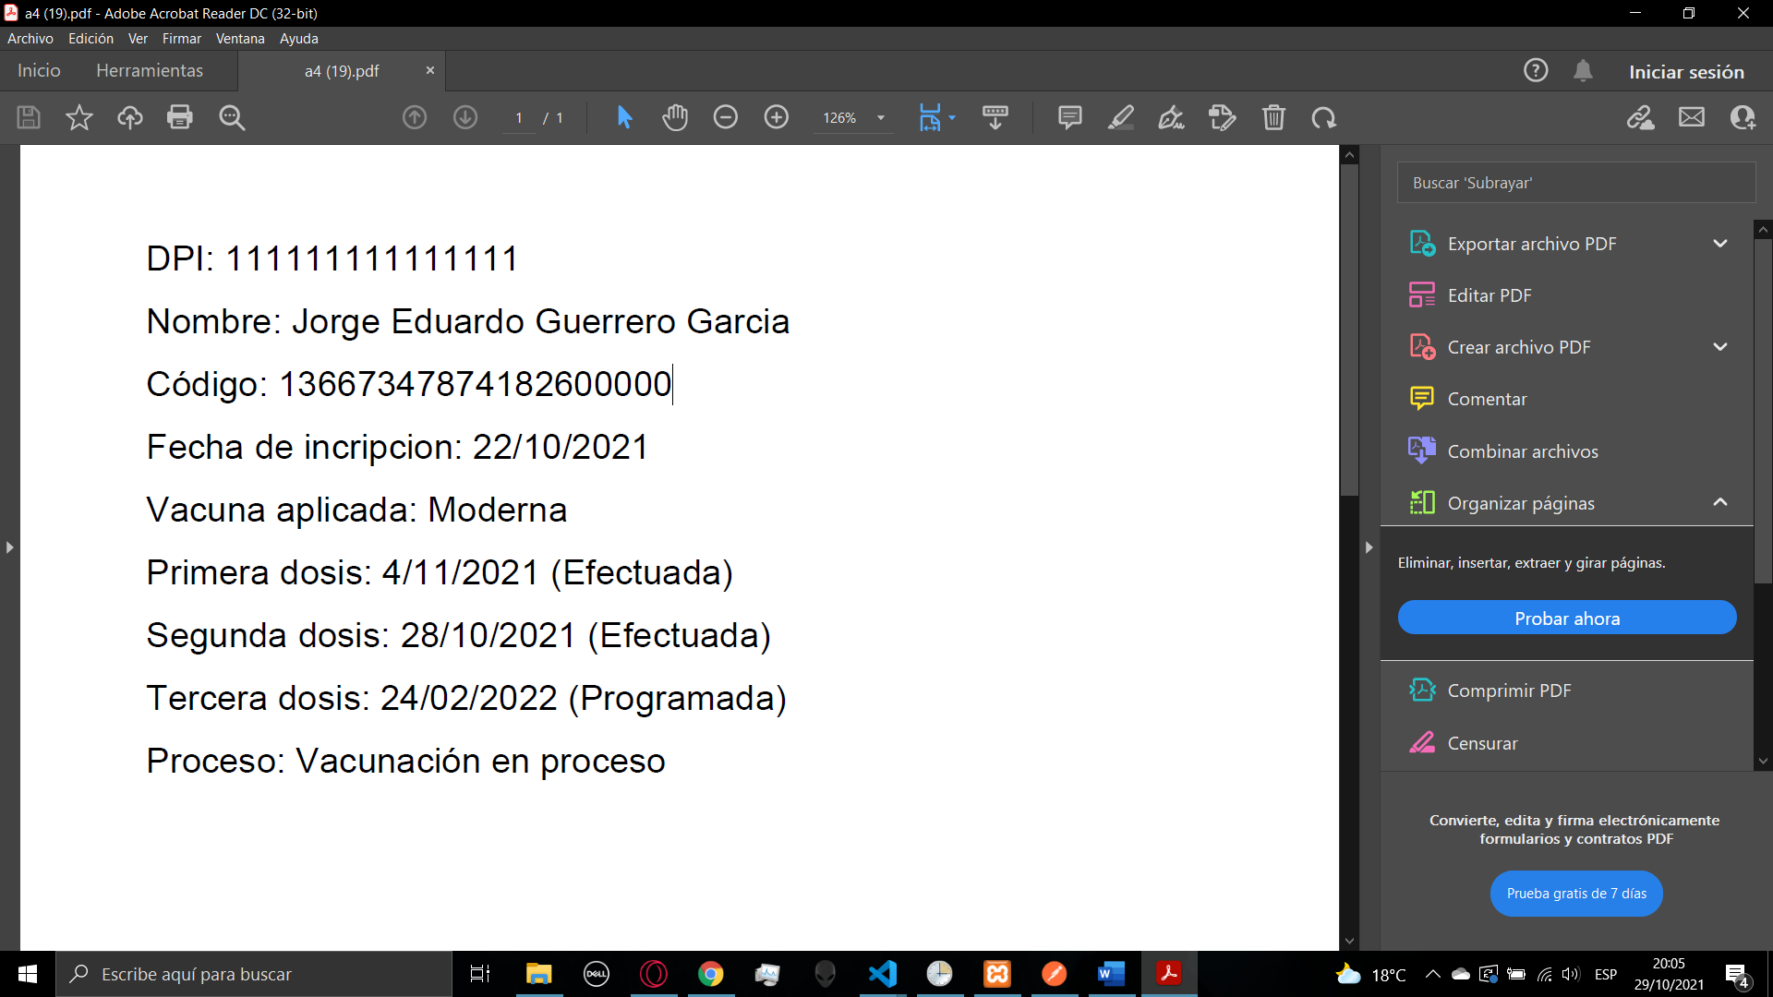

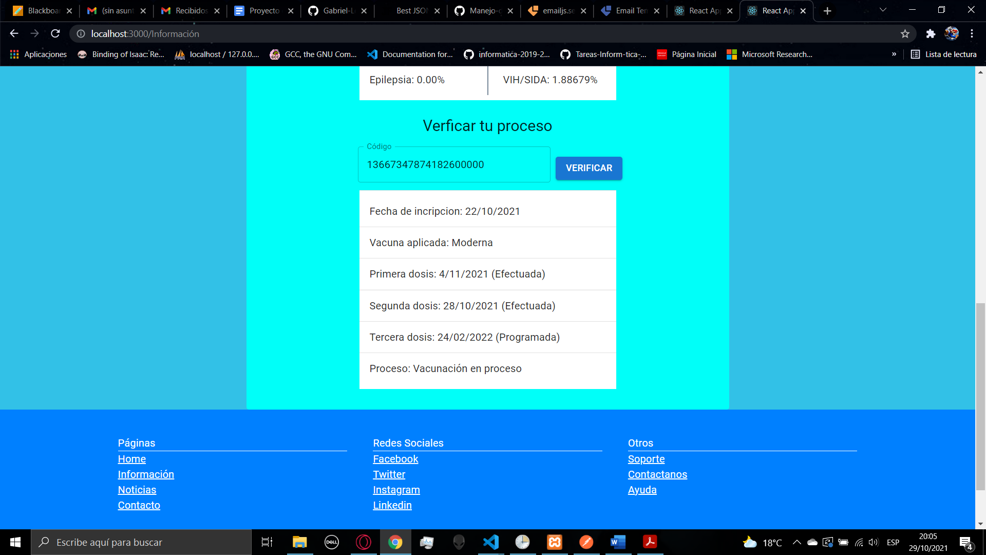

1. **CONTACT**

In the contact page you will find a form to send us information about some topic, you will find some fields that you have to field with some information for contact reasons and at the bottom you will have a big field that you can fill whit you request, after you send it with the button send, we will receive your request and we will start to process it.

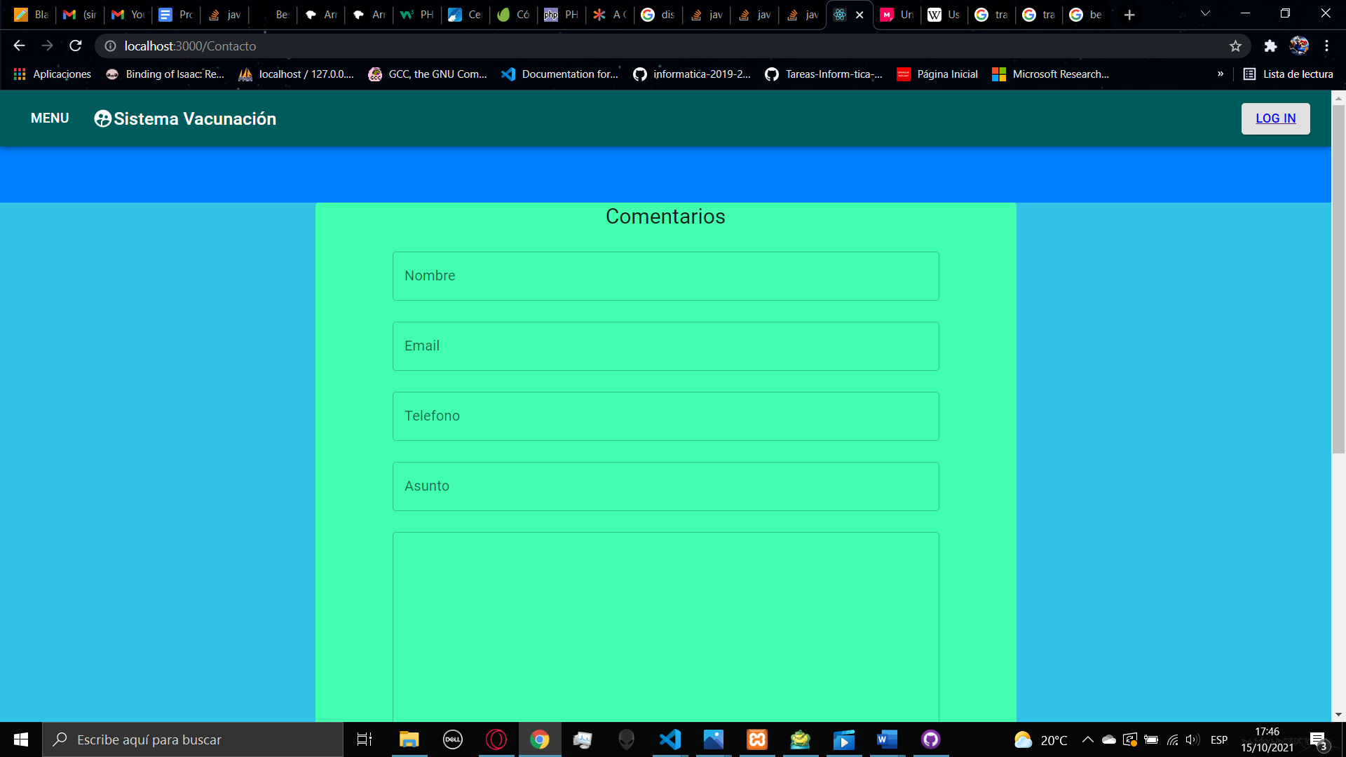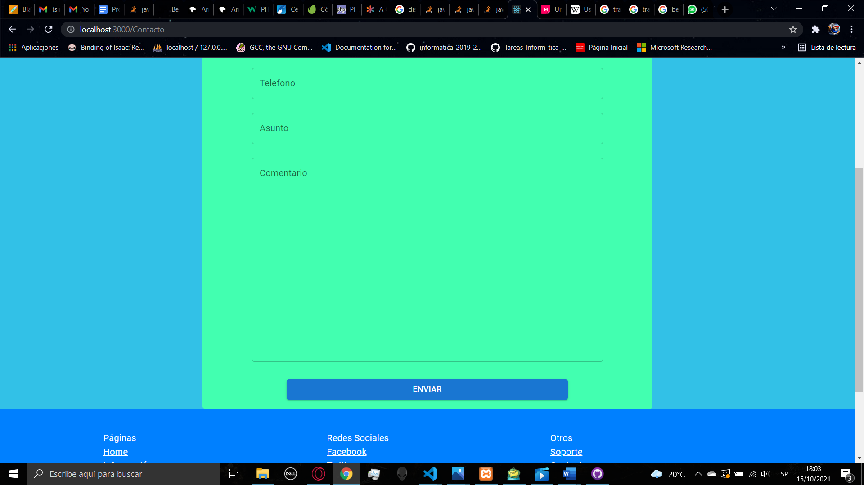

In you don’t fill all the fields when clicking on the button send an alert will appear saying that you need to fill all the pages. After you fill all the information, if the message was sent, an alert will appear saying that the operation was successful

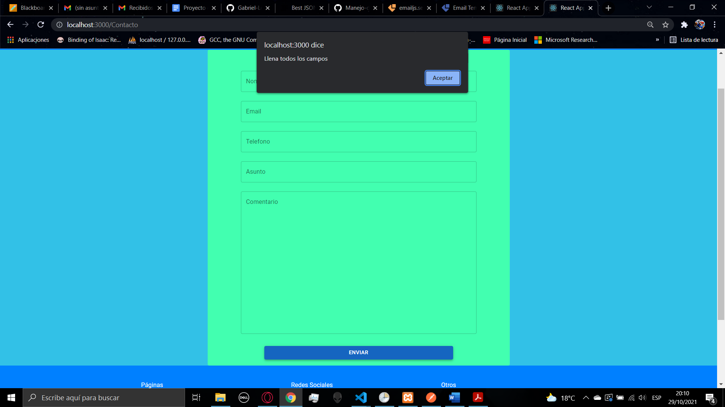

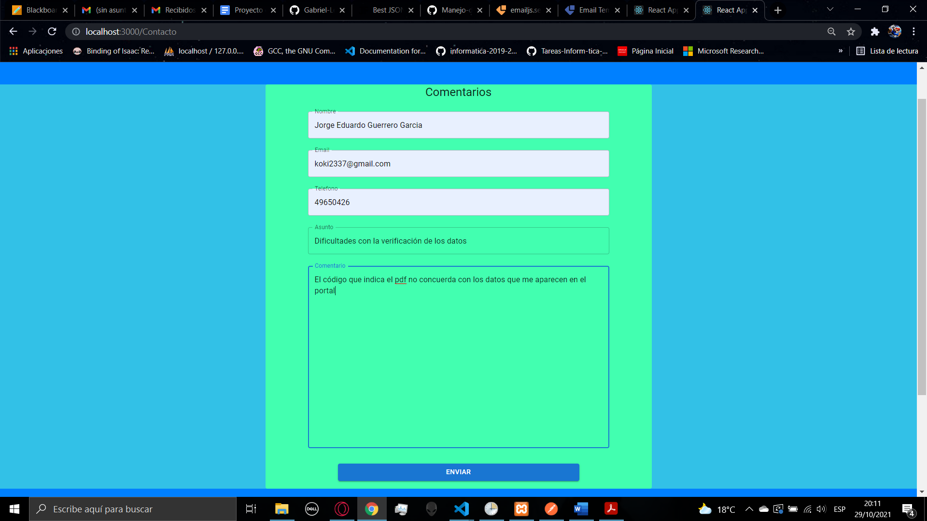

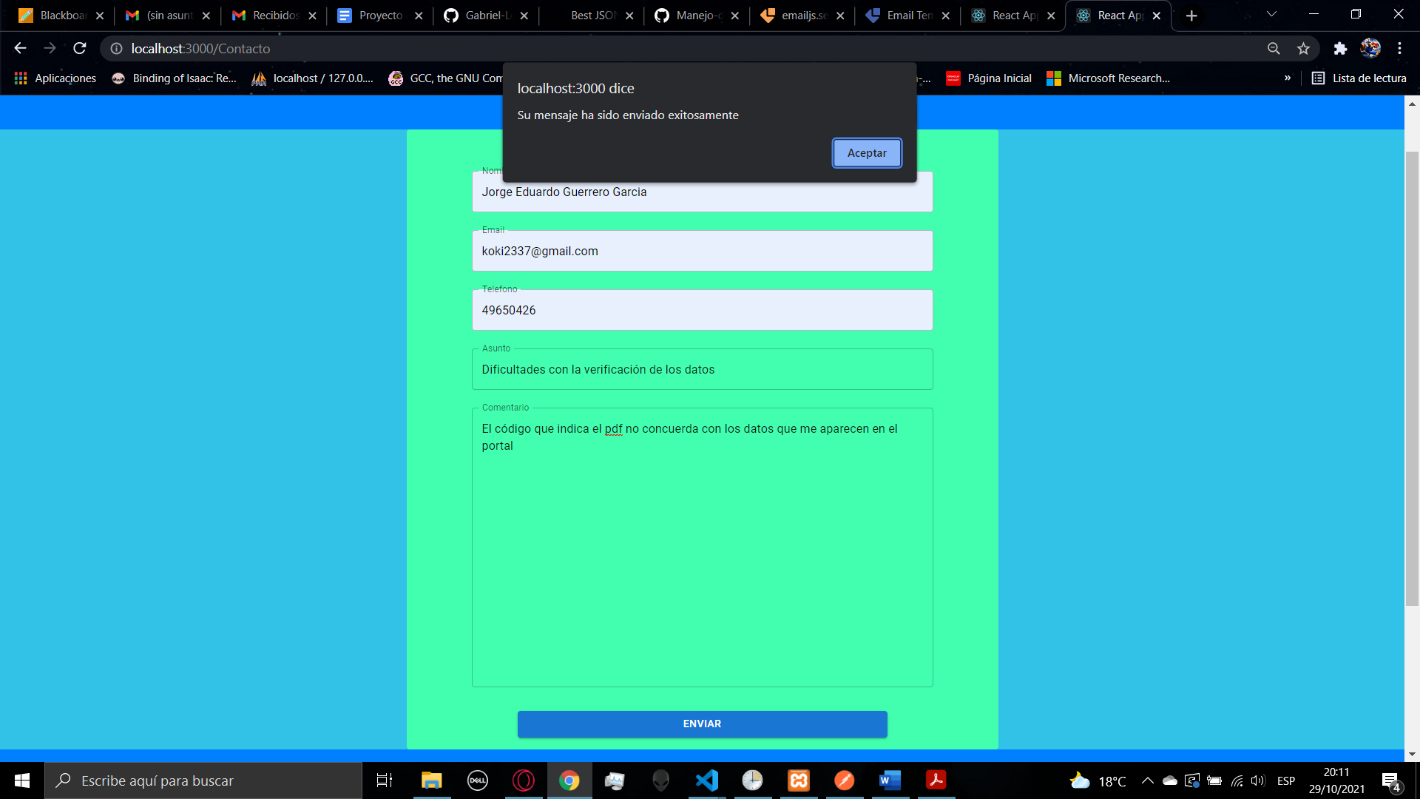

1. **NEWS**

In the news page you will find some articles about recent news with a lot of impact related with the Covid-19 , here you can find an image about the article and at the end of the article you will find a button to learn more that redirects you to the source of the news.

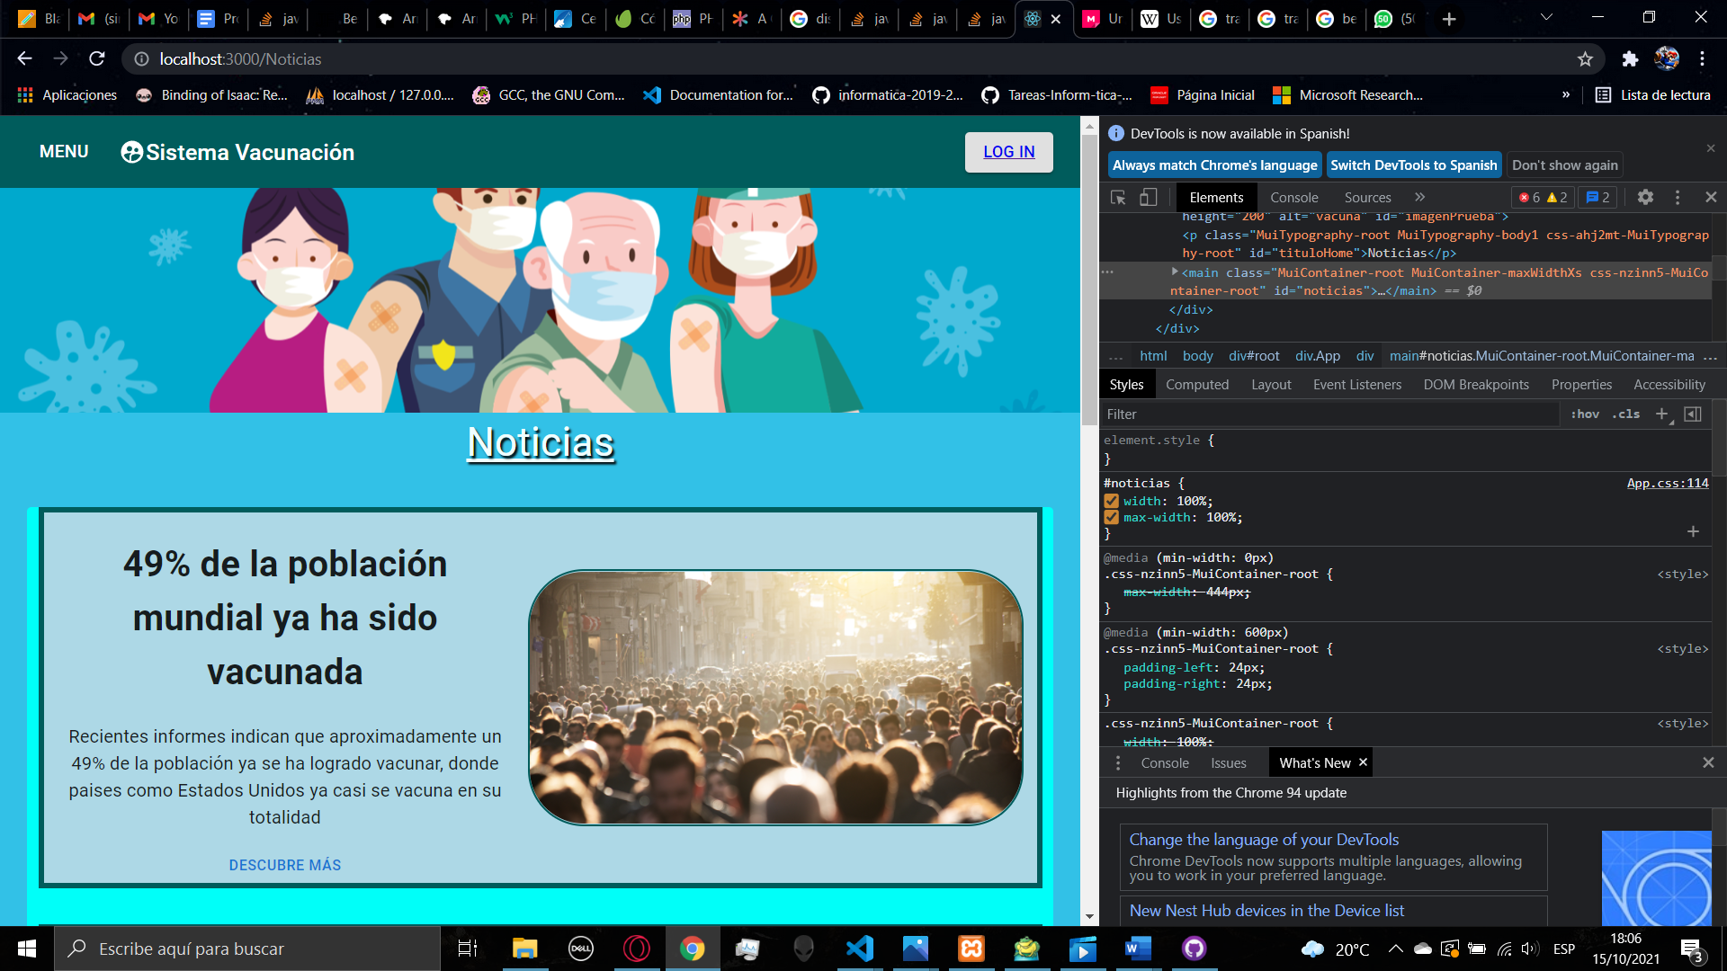

1. **LOGIN/SIGN UP**

After you visit the information page and determine you meet the requirements, in the navbar you will find the Log in button.

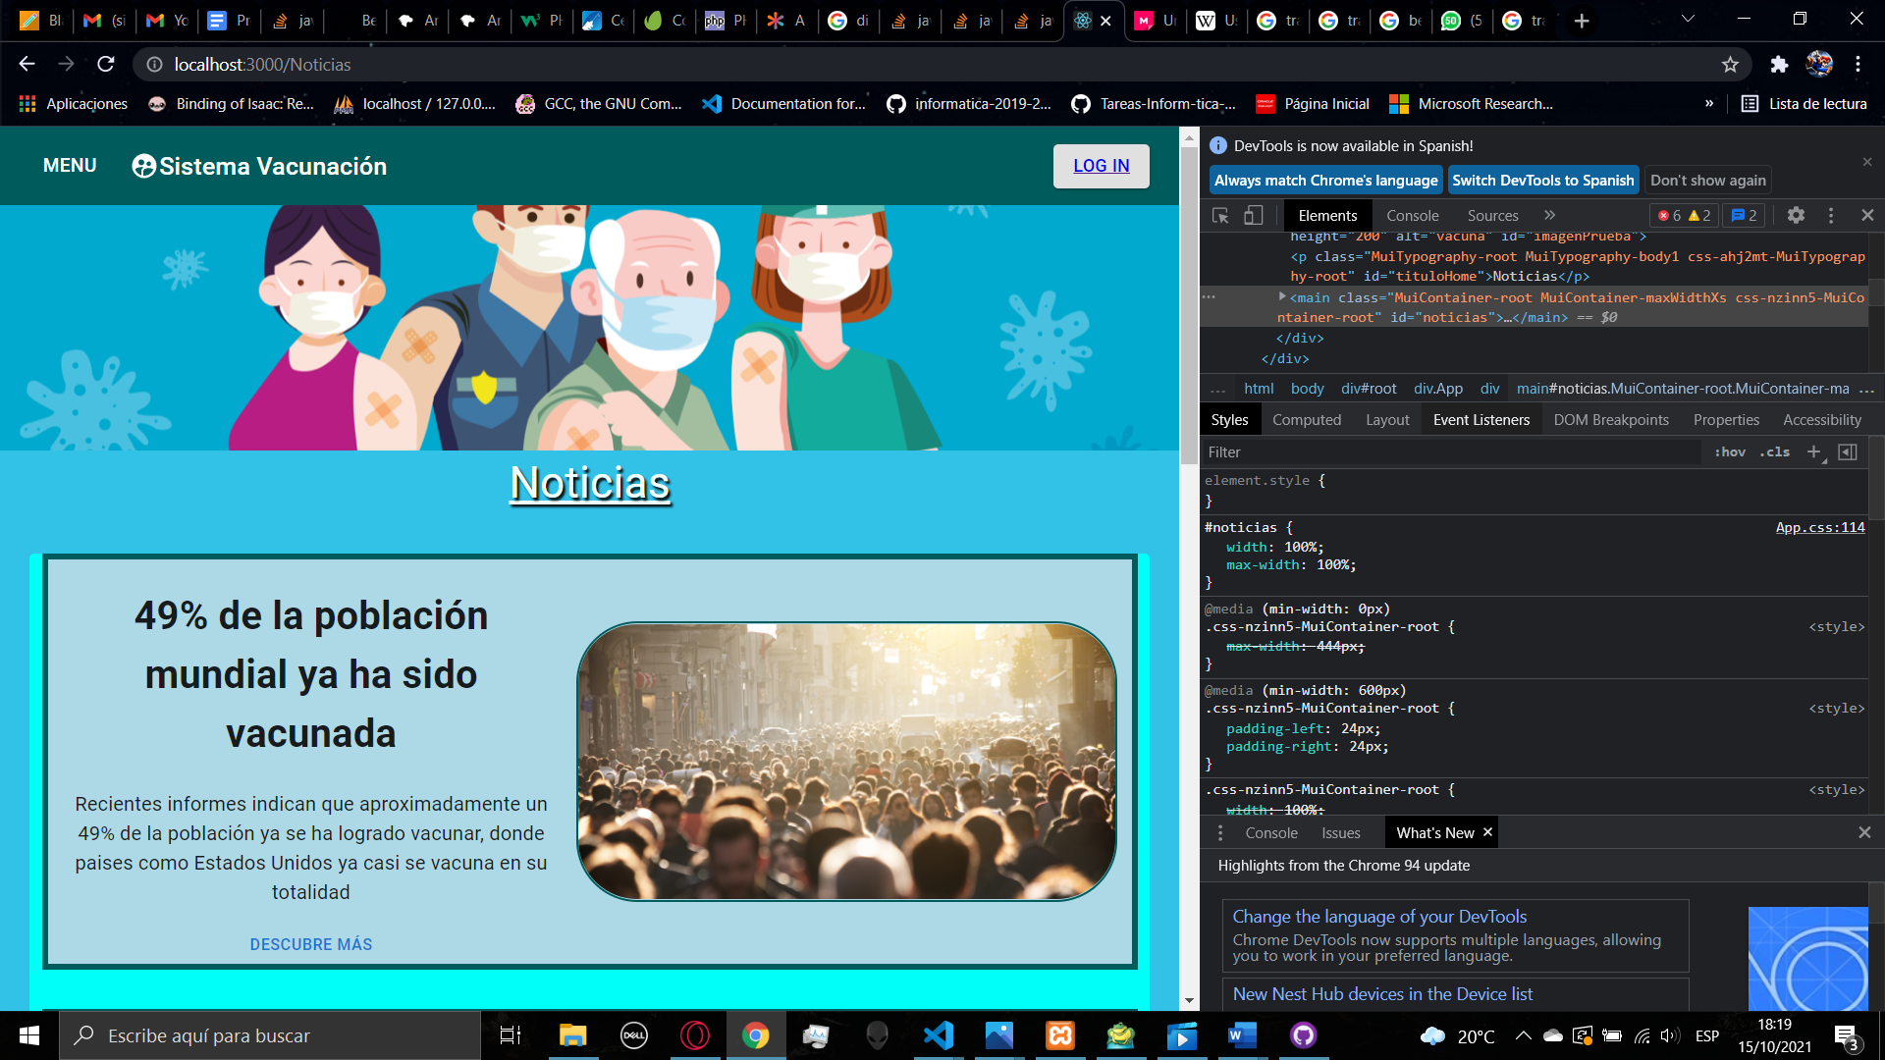

When you click on it you will be redirected to the login page.

In the login page you will have a form that ask you for your DPI and your password, first you must register into the portal, at the bottom of the form you will see that there is a text saying if you don’t have an account, if you click it, you will be redirected to the Sign-up page.

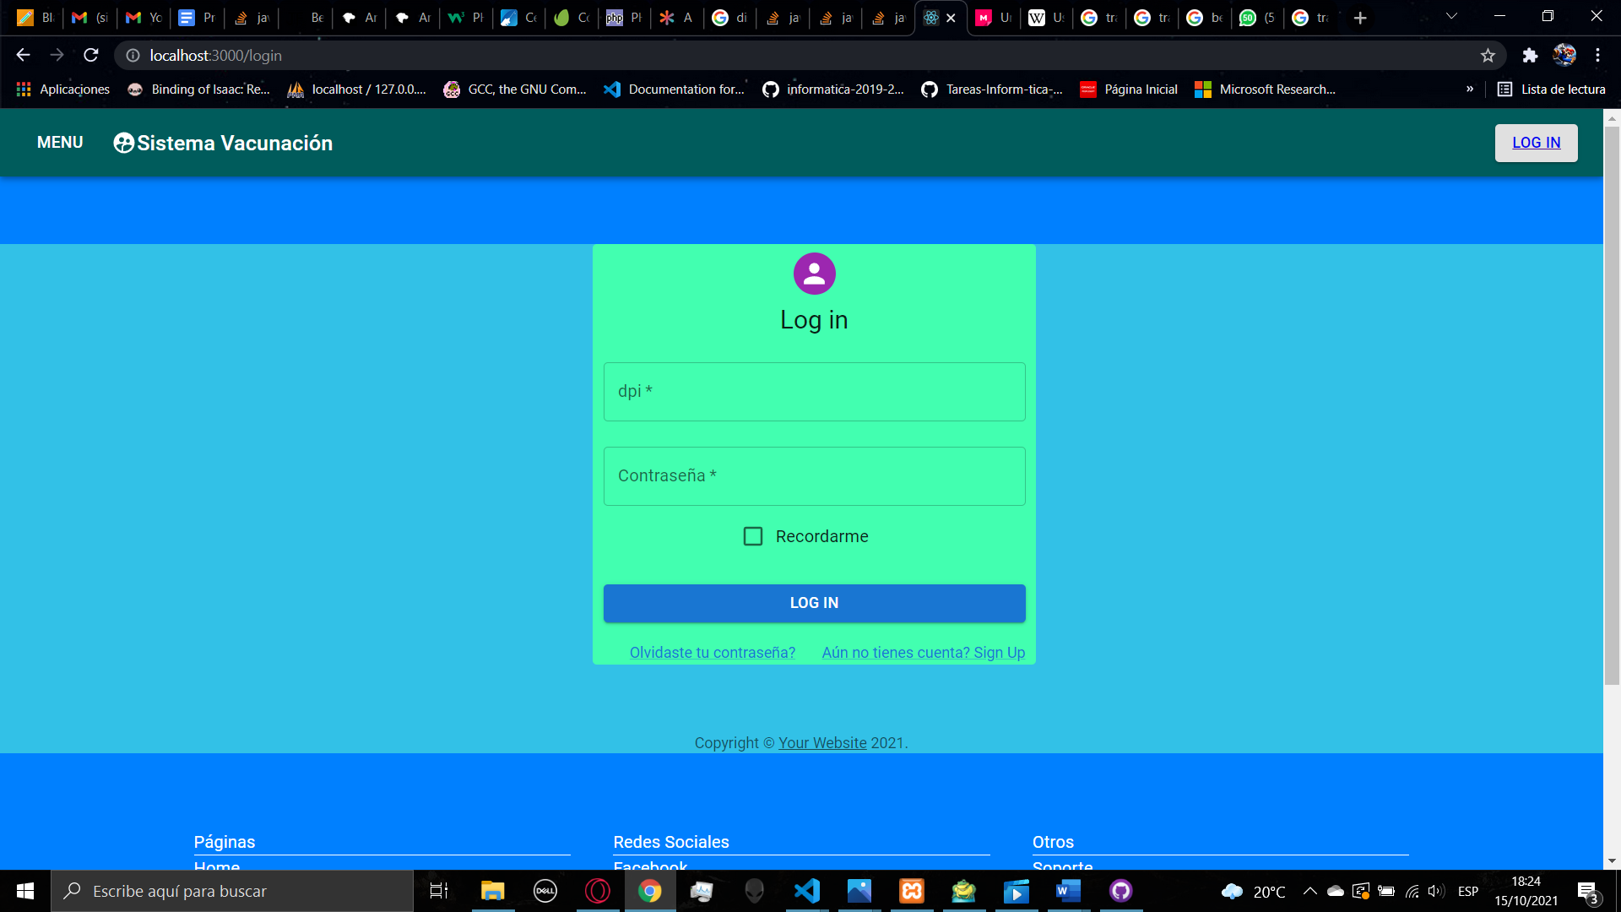

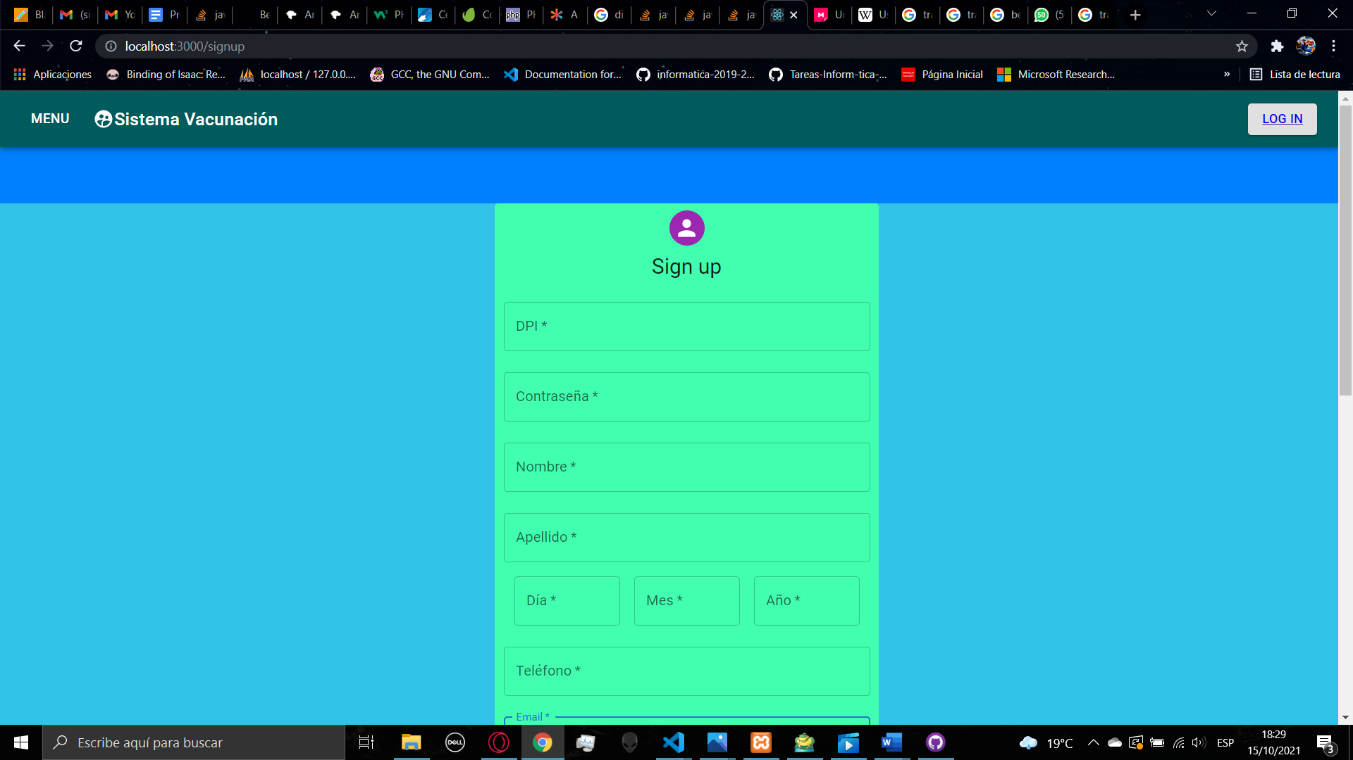

In the sign-up page you will find a form, all the fields are required for the register, you need to fill all the fields with your DPI, your password, name, last name. your birth date, your phone and then you will find 3 list, you have to select the center that you will go for the application of the vaccine, the centers are constantly changing so the centers appearing are the available center for register, you will be not able to register in a center that is not available, then if you have a chronic illness, you can select it, and if you are part of a group that are listed you can select it, these information cannot change, only the phone and the email can change inside the platform, so you have so save your password, when you have filled all the information you can click the Sign Up button, then if you accomplish the requirements, the user will be created an then you will be redirected to the home page. Otherwise, you will stay in the sign-up page. If you create a user in this way, you will be a normal user, so the functionalities are limited

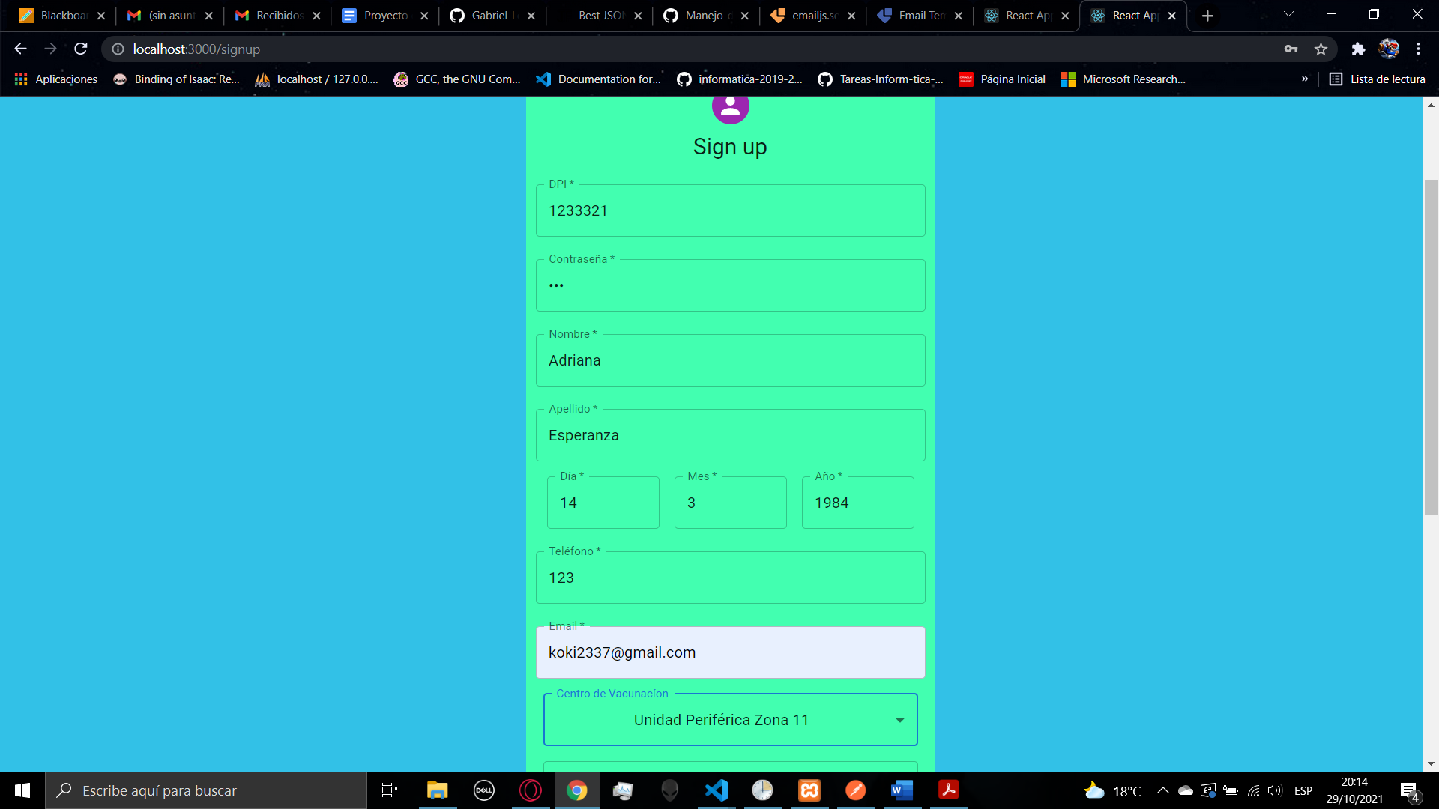

After creating the account, an email will be sent to the email given for the signup.

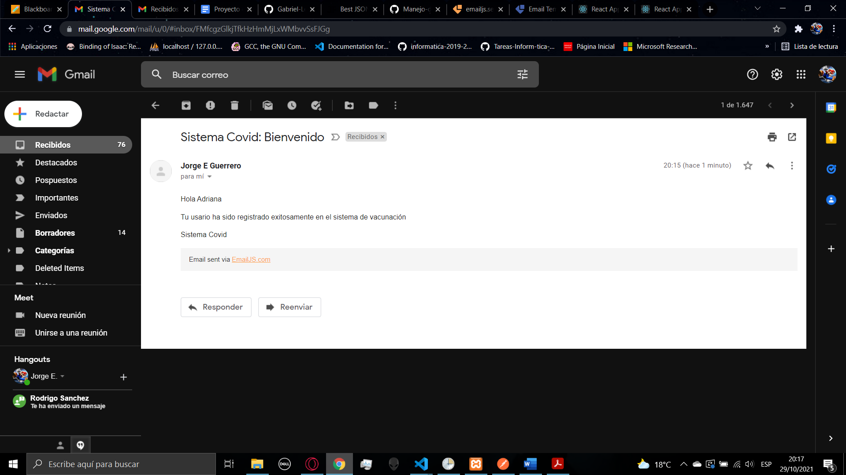

And you will be logged automatically, you will see that the Log In button will change to Log Out, that means that you are logged, if you close the browser the information will stay in your device, to clear your information you must need to log out. When you click on log out you will be redirected to the home page, and you will see that the log out button changed again to log in.

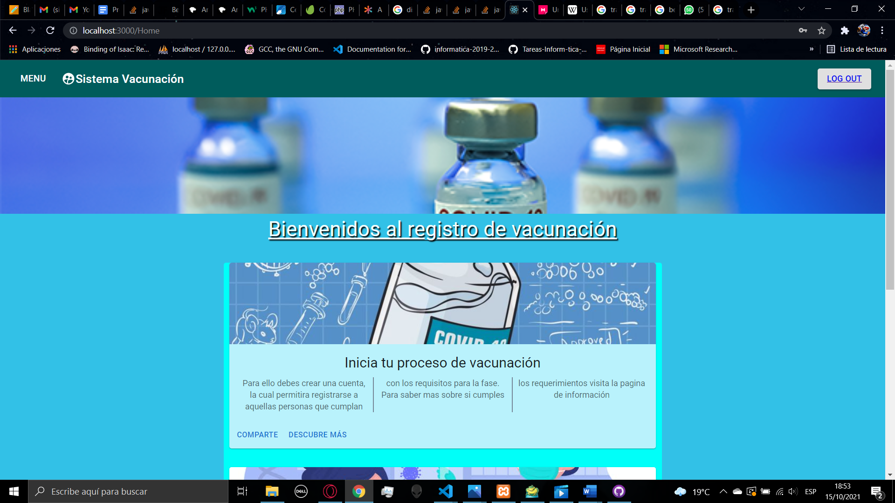

Now you have created an account in the login page you can see again the form, to log in you need to fil the form with your DPI and the password that you have selected, if the password is incorrect you will stay in the page, if the password is correct, you will be redirected to the home page and you will be logged.

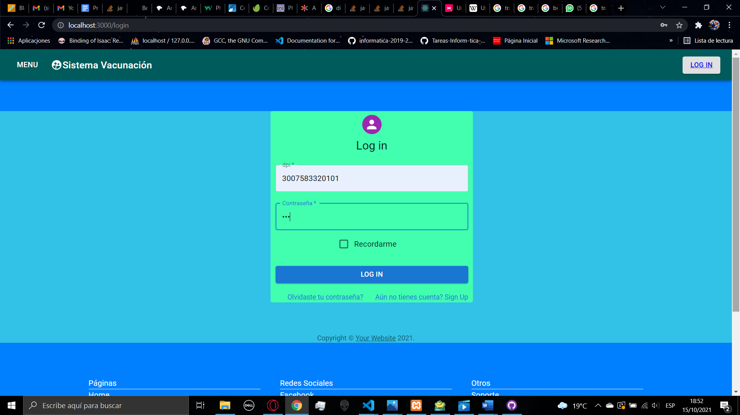

1. **USER**

If you are logged in a normal user account, you will find in the navbar 2 new menus

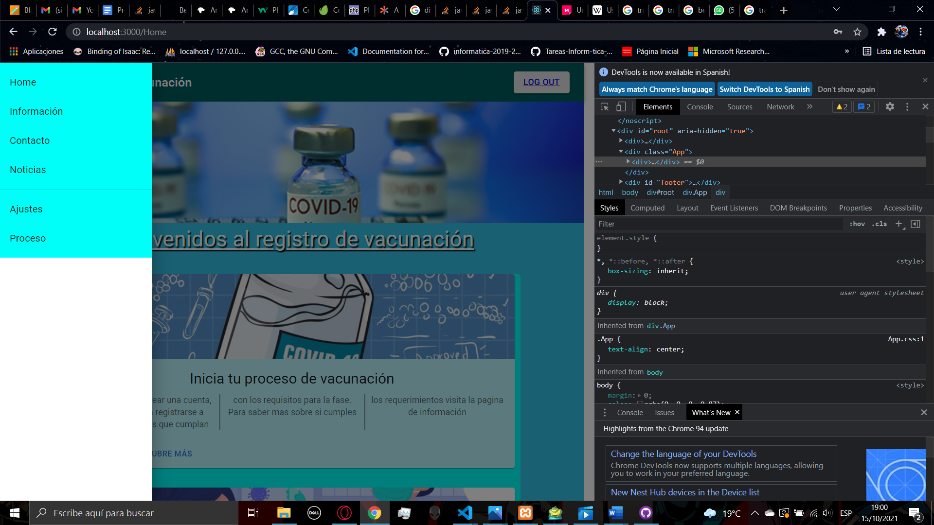

In the settings menu you will find a form that able you to change your email or your phone

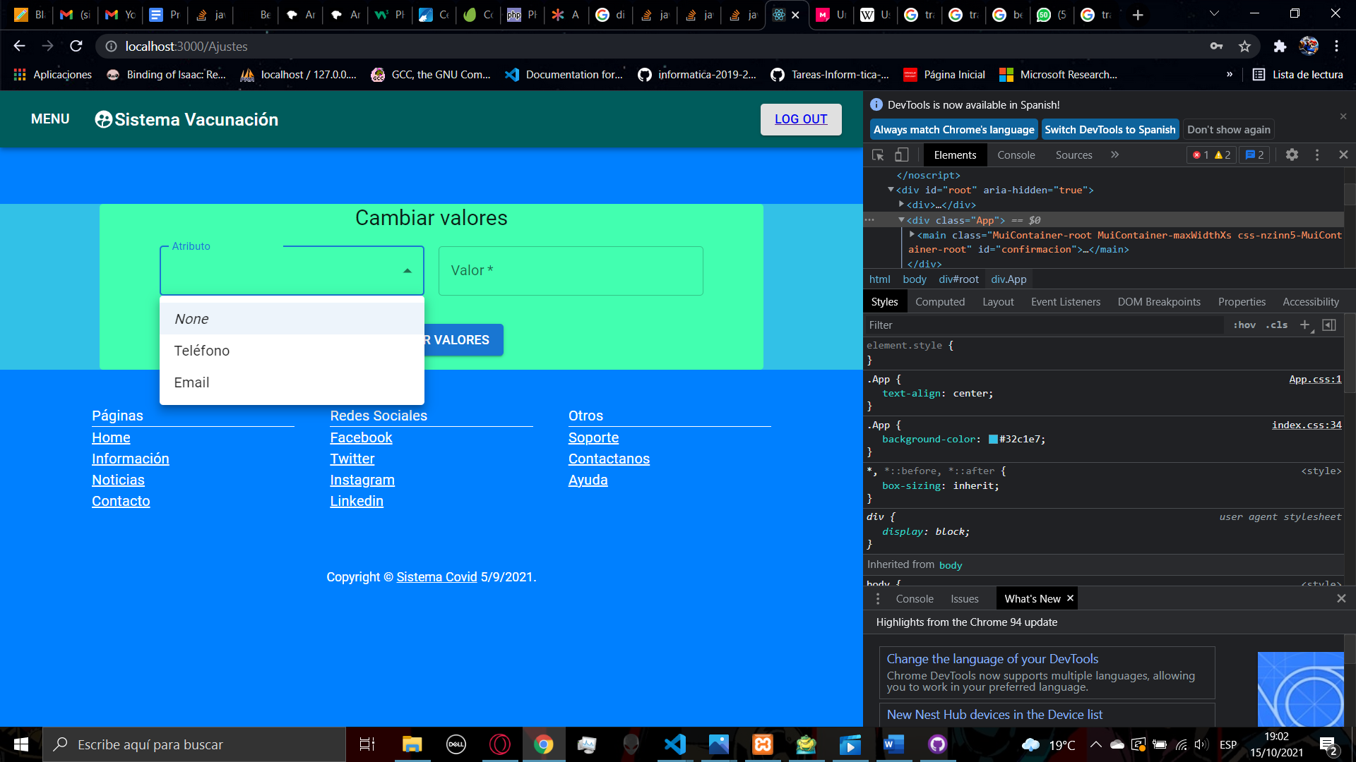

When you select an option, you need to set the value and then you can click the button to change the information.

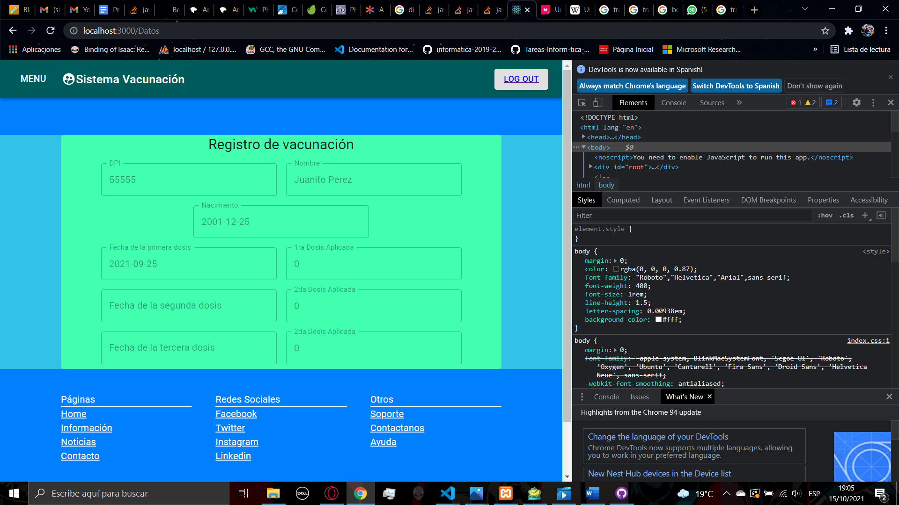

In the process page you will find a table that have some information about the vaccination process, here you can confirm your DPI, full name, and birth date and next you will find the programed dates for the application of the vaccine in the selected center and doses you already have. When a dose is applied, when you enter in the page again the information will be updated.

Under you can also find a button to generate a pdf using the data of your process in this moment

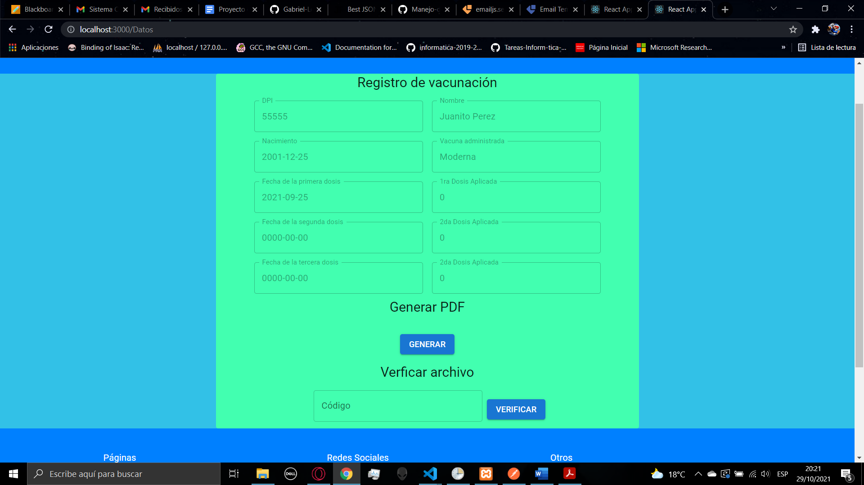

When you click on the button a widow will appear to save the pdf file

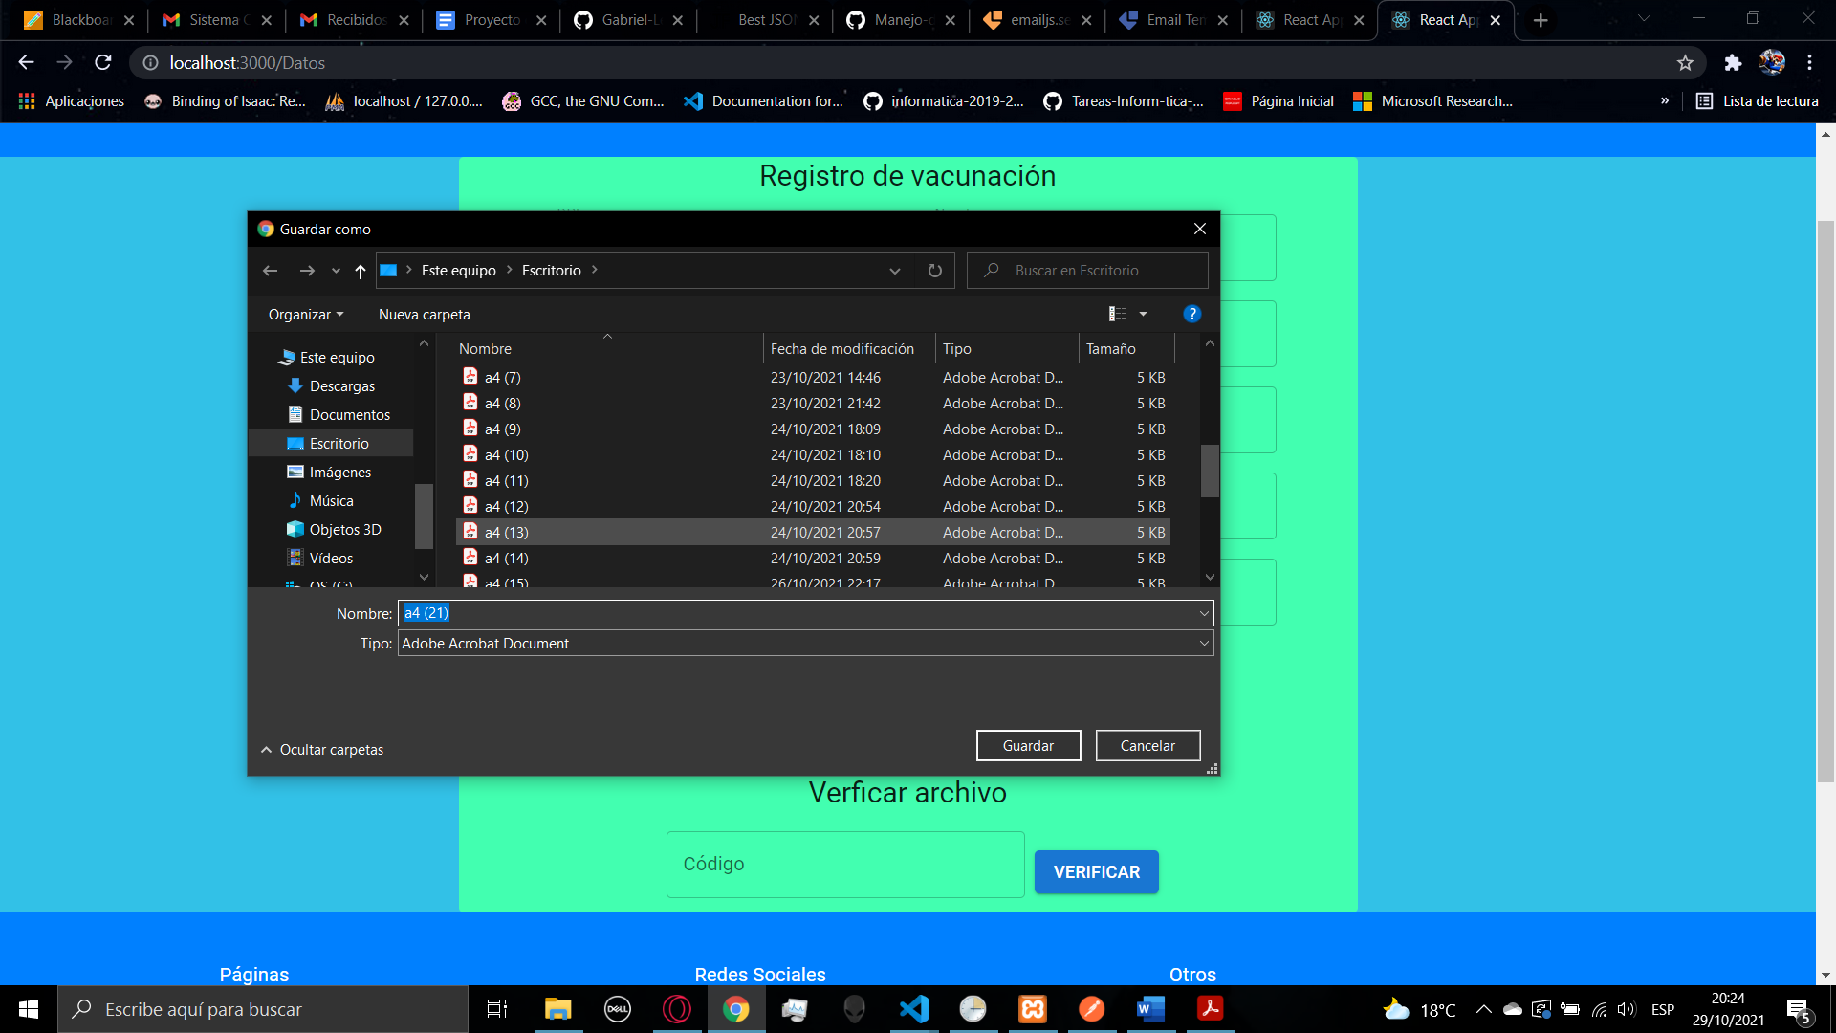

When you open the file you will see the following data

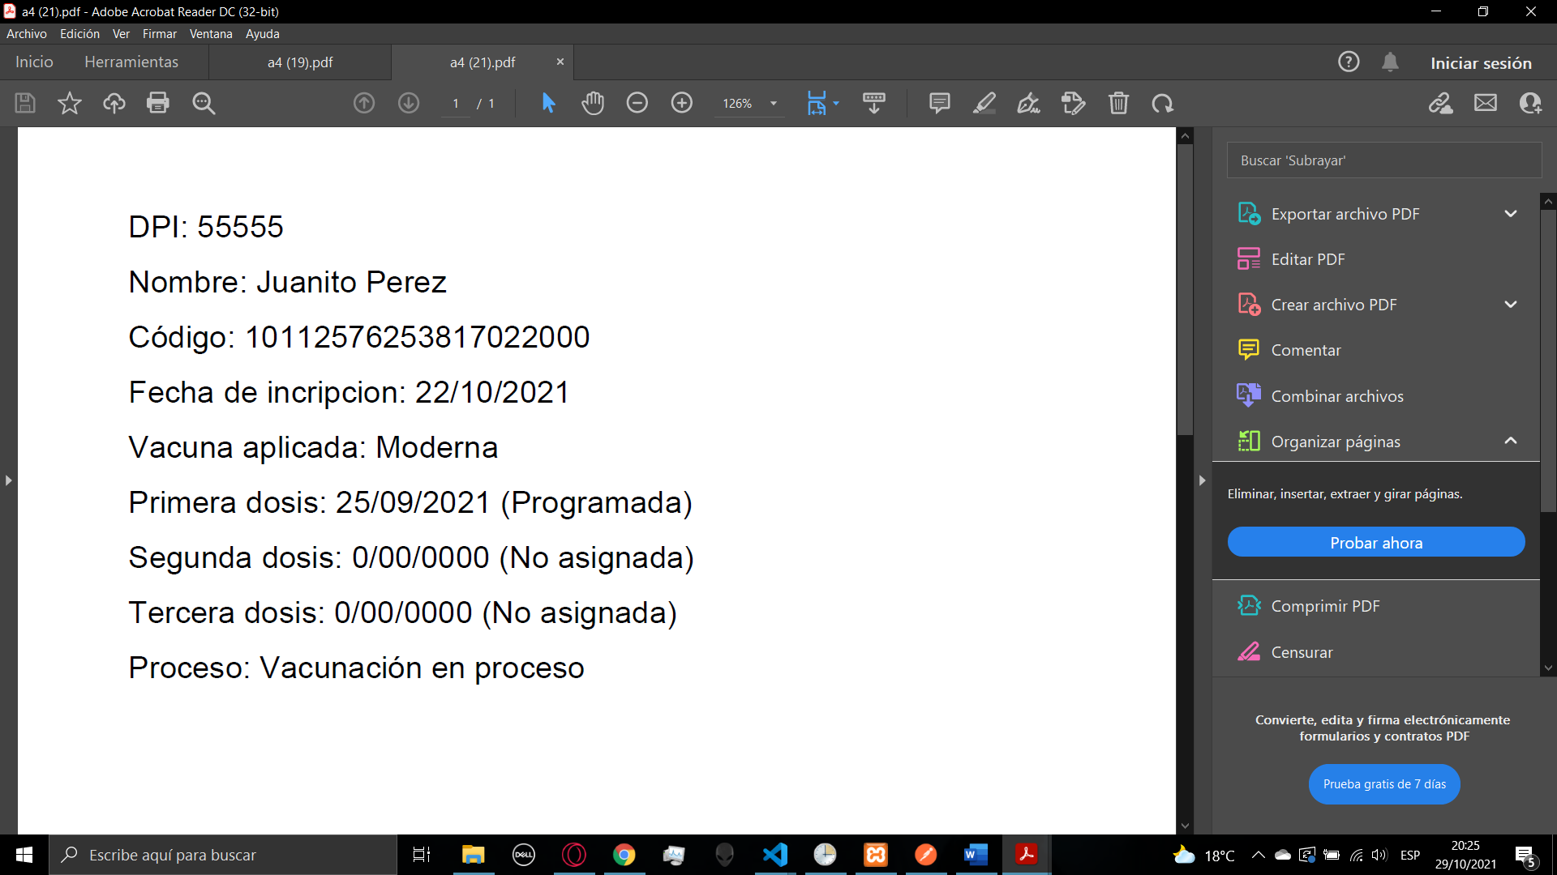

Inside the file you will find your dpi, your full name, a 20 digits code, the moment of the creation of the account and data about the vaccination process. In the case you finished the vaccination process in the file it will appear.

Inside the file you can find a 20 digits code that you can put in a field under the button to generate the pdf, if you fill the field with the code it will appear the same data that is in the file, so every code is unique and you can generate multiple pdf and every pdf will have a different code, after 6 months the code will no longer be valid to access data

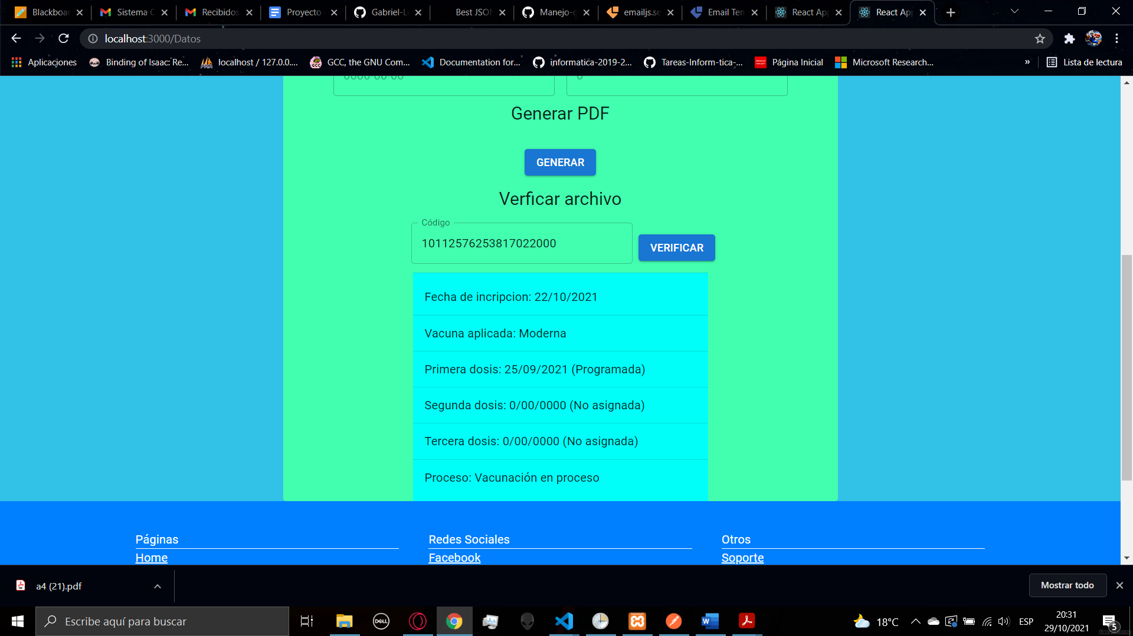

In the process page you can consult about you assigned date for your vaccination, when your vaccination date is one week away, the system will send you a mail to the email given when the account was created or the updated email in the settings menu, you will receive the following mail

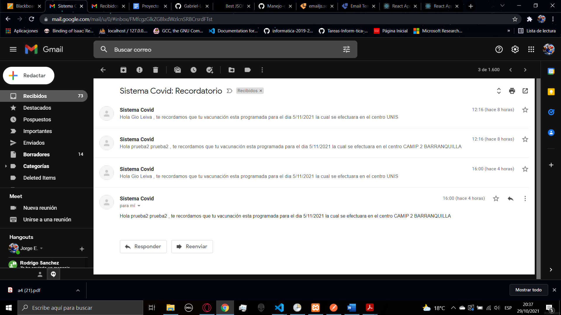

1. **EMPLOYEE**

Only an administrator user can create an employee account, if your have an employee account you will have access to the process and settings pages, and there will be a new page that is the validation page.

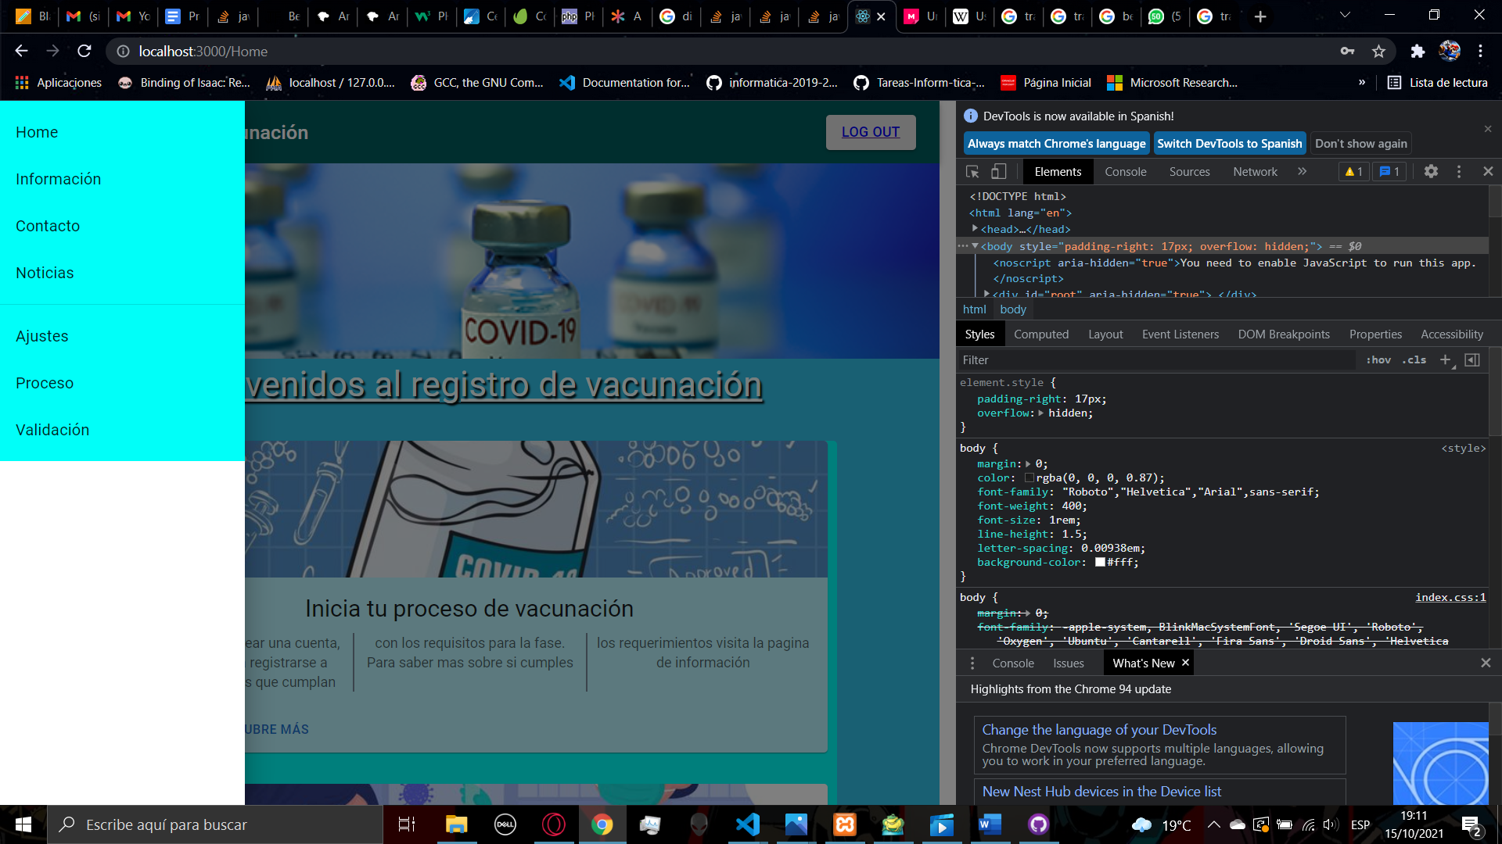

Para estas ocasiones los expertos han implementado un conjunto de prácticas llamadas DevOps las cuales constan de una serie de requerimientos y reglas a cumplir para un buen desarrollo del trabajo en equipo y una buena implementación de la práctica.

1. **VALIDATION**

Inside the validation page you will find a form, in this form you must validate if another person is able to register, you must ask for the DPI and the center assigned, if the vaccination date is in a rage of 7 days and the center is correct the platform will continue with the process.

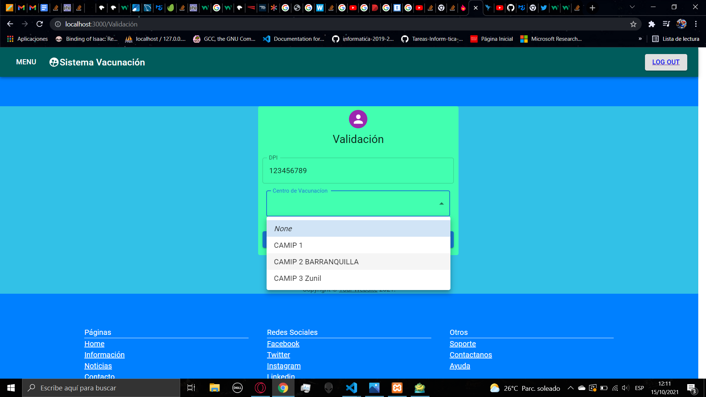

Then if the person don’t have assigned a vaccine, the platform will detect it and redirect you to the assign page, in this page will appear the name of the person that you are validating and the DPI , below there is a list of the vaccines, so you have to select the vaccine that is managed by the center, after assign it you will be redirected to the confirmation page

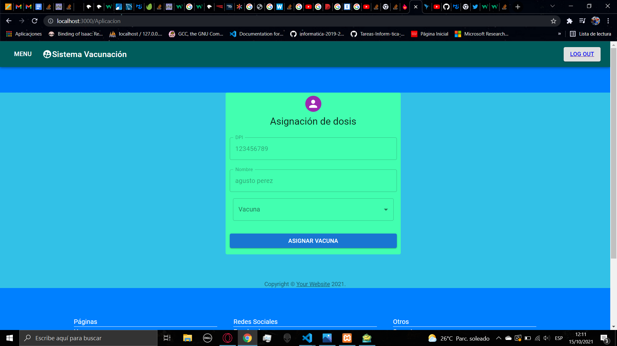 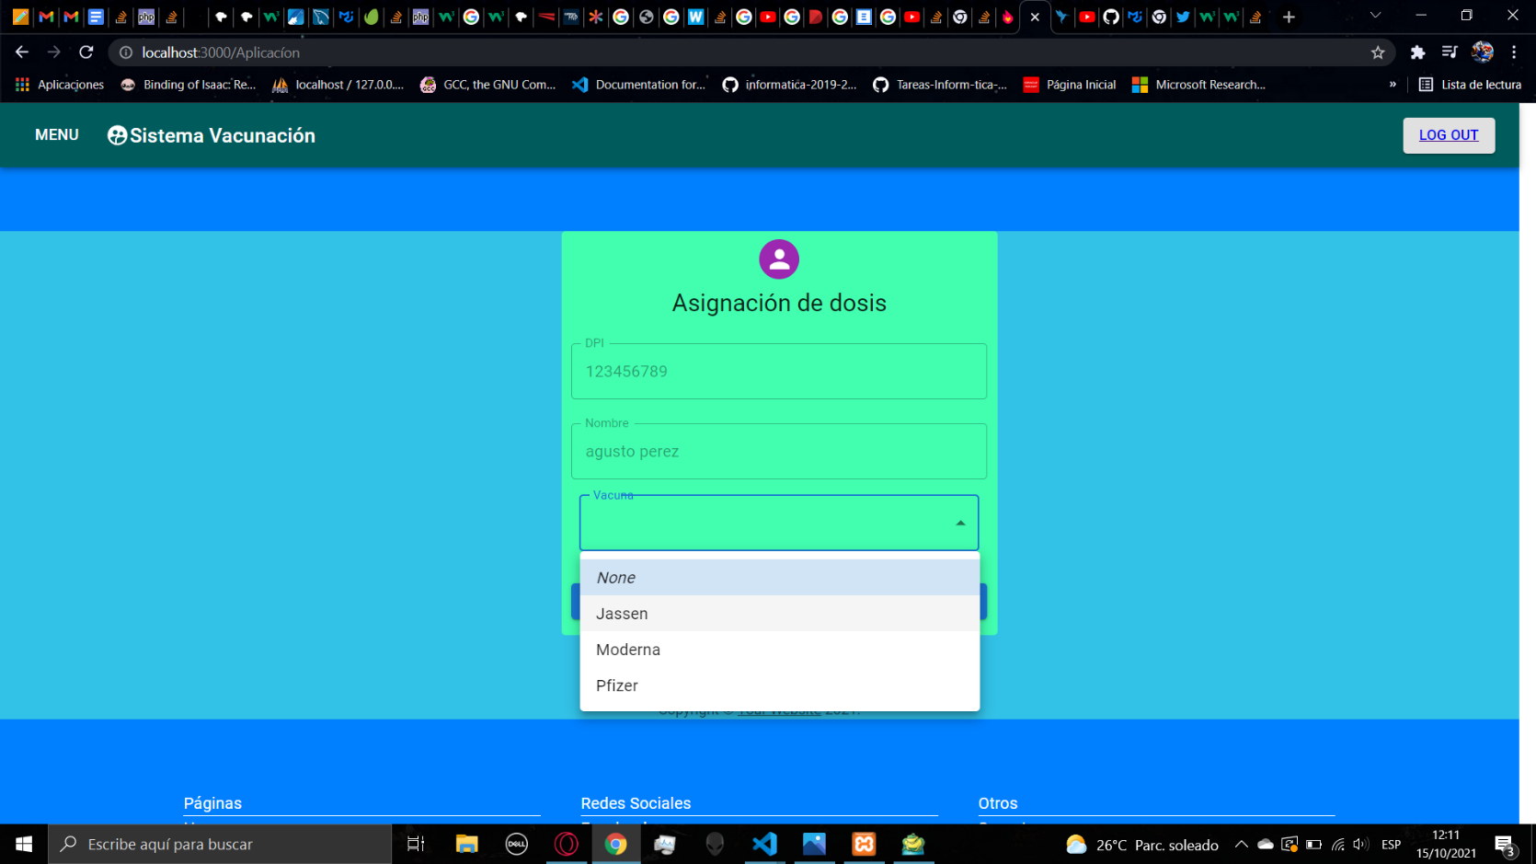

Inside the confirmation page you will find the complete information of the person that you are validating, here you can check if everything is fine and then you can click on dose confirmation to let the person continue with the process

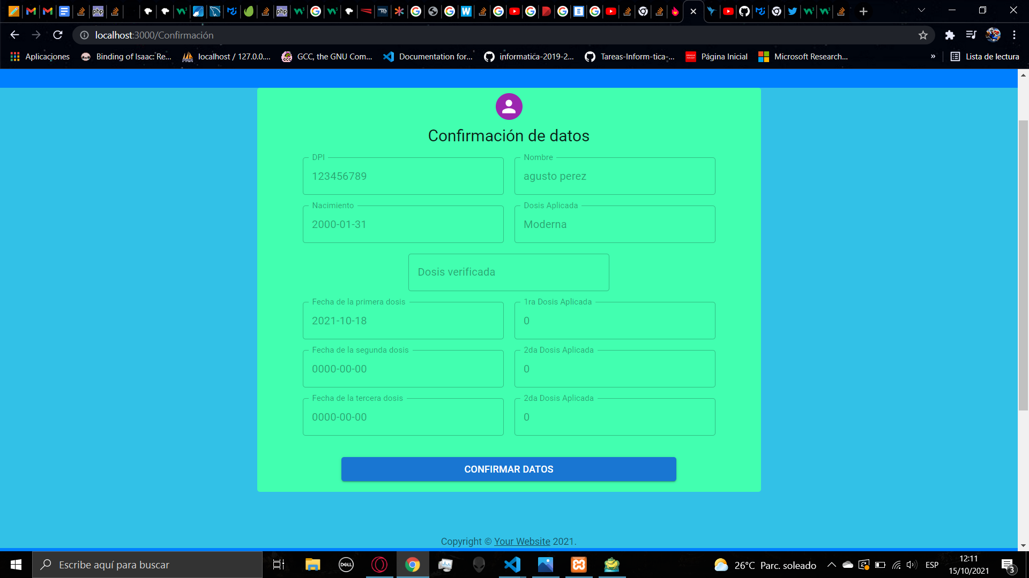

After the confirmation you will be redirected to the validation page to continue validating other people

1. **ADMINISTRATOR**

As an administrator user you will have access to the normal user and employee pages, there will be a lot of new menus. You have access to the administration, content, habilitation, center, and vaccine pages

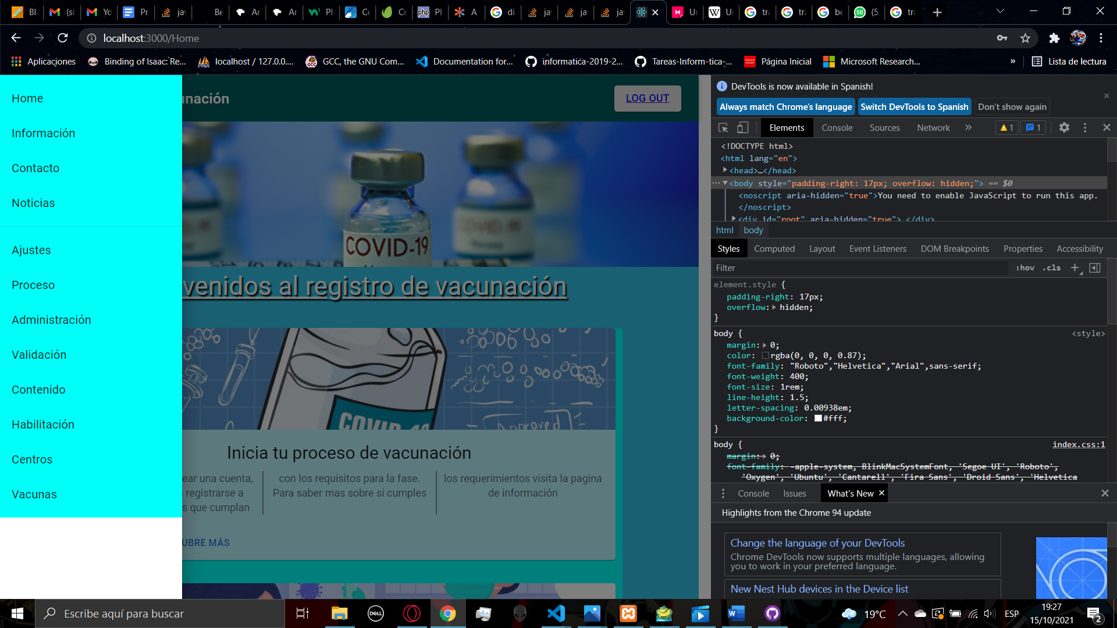

1. **ADMINISTRATION**

First, we have the administration page, inside the page you will find a lot of functionalities, the first one is to change the user type of one account, for changing an account we need to fill the DPI and then select the user type that you want to assign, you can also assign the administrator privileges, then you can click on change privileges and a confirmation will appear

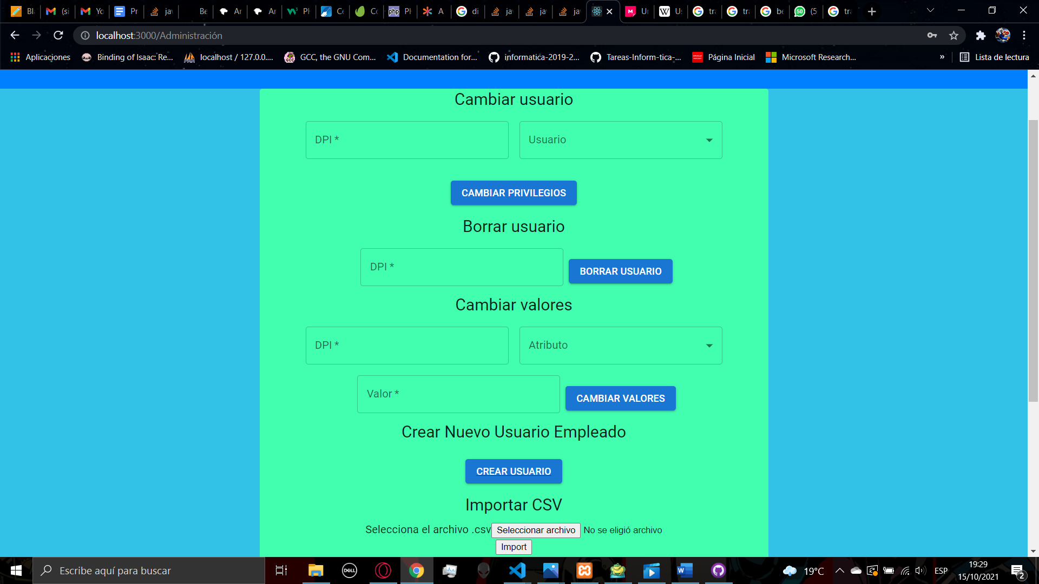

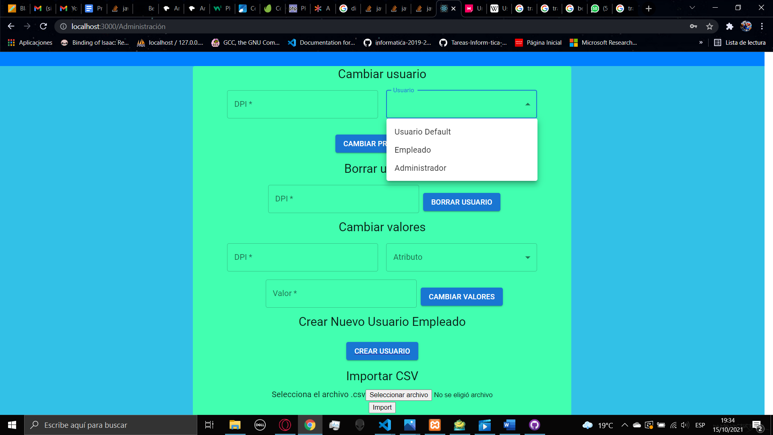

The second functionality is to delete a user, so we need to fill the DPI of the user that is going to be deleted. Then you click on the button delete user and a confirmation will appear



The third functionality is to change some value of a user, first you must select a user, then you must select what value you going to change, after selecting the attribute you want to change you can fill the value, then you can click the button change values and you will receive a confirmation



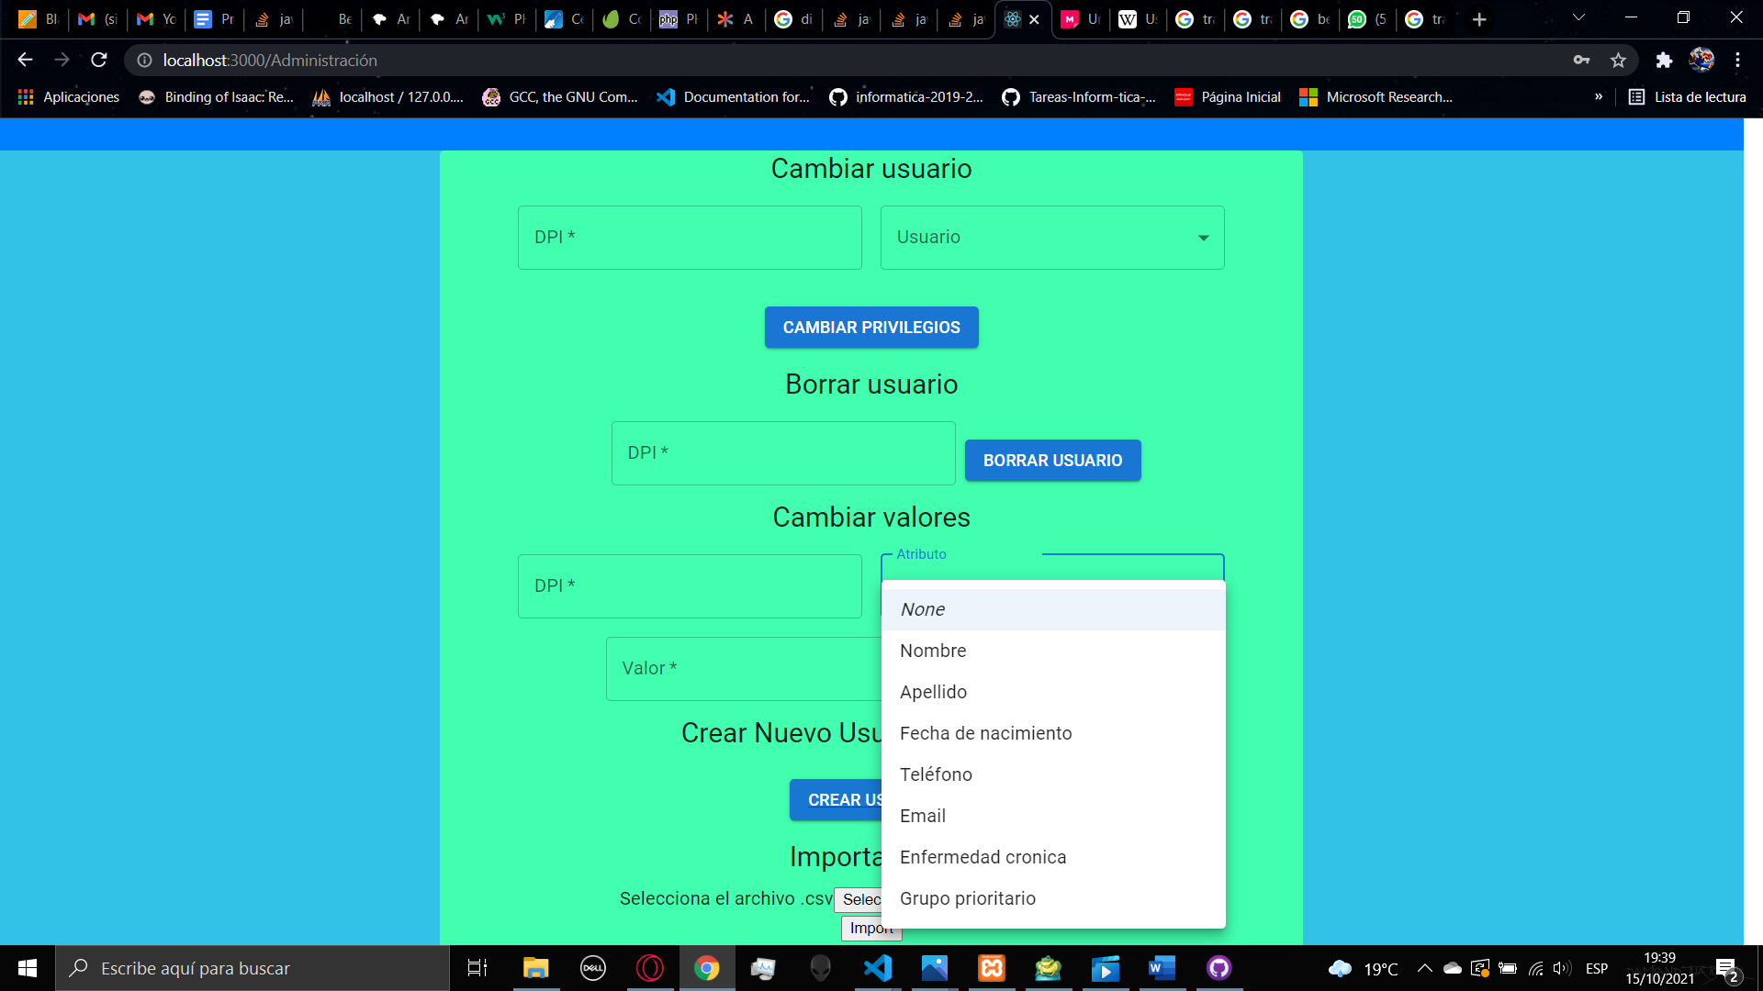

The fourth functionality is the creation of a new employee user when you click the button you will be redirected to a signup form, after you fill the form, if the creation of the account was successful you will be redirected to the administration page.

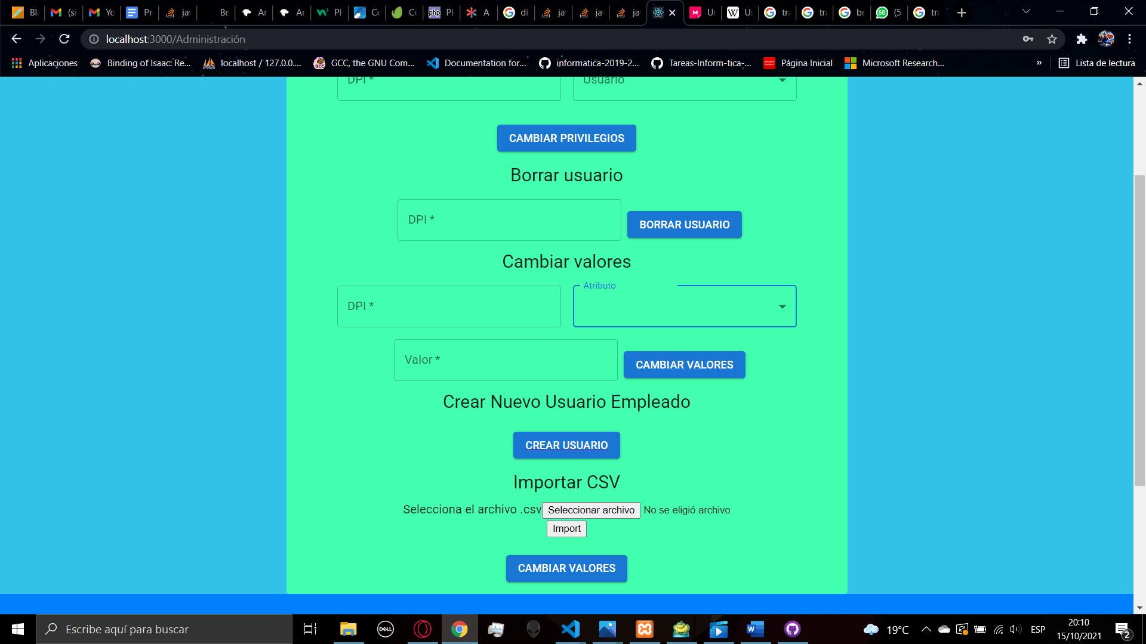

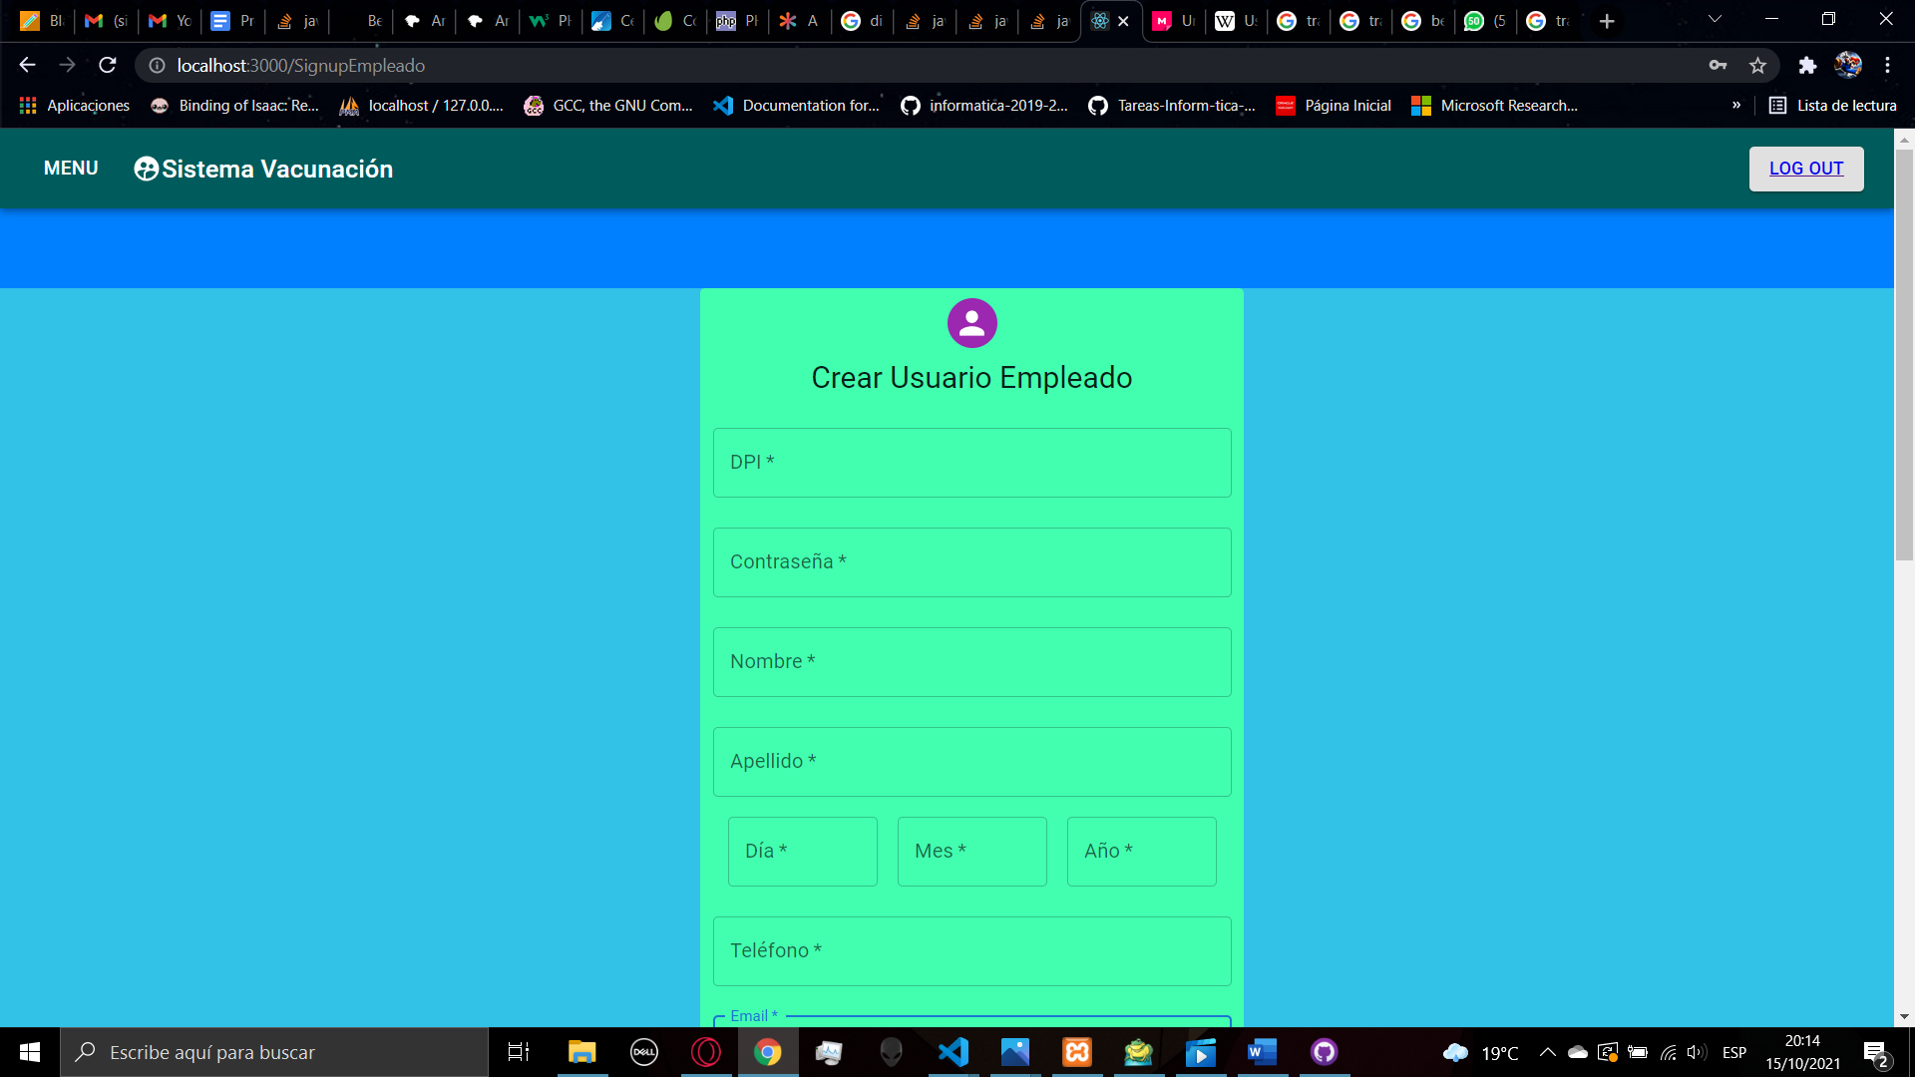

The last functionality is to import a CSV file to create a lot of accounts importing that file to the data base, her you have a button to load a csv file, when you click the button to select a file, a window of the file explorer will appear so you must select a file, then it will appear the name of the file, after loading it you can click the button import

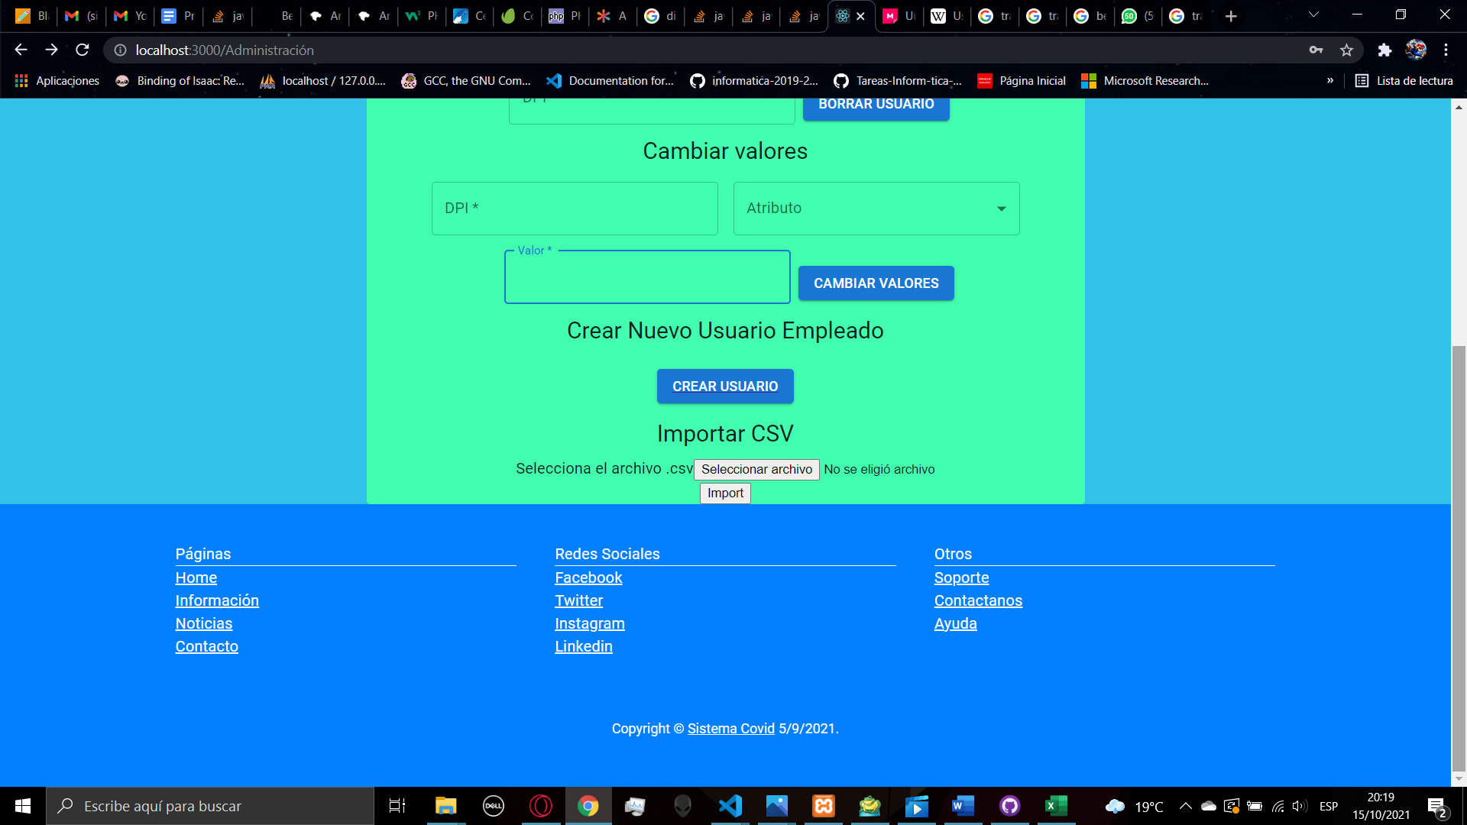

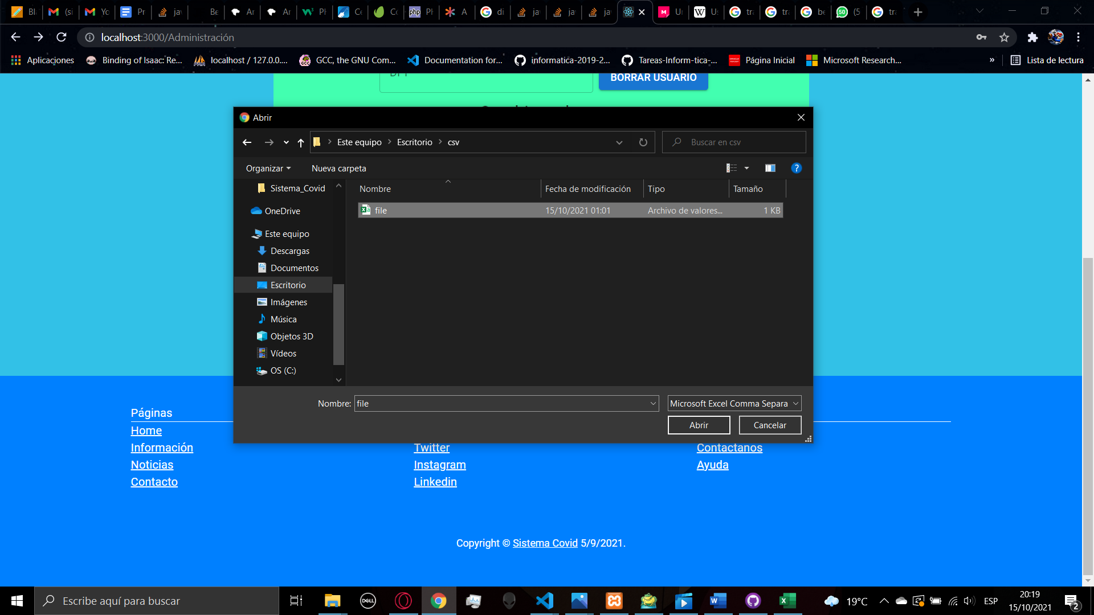

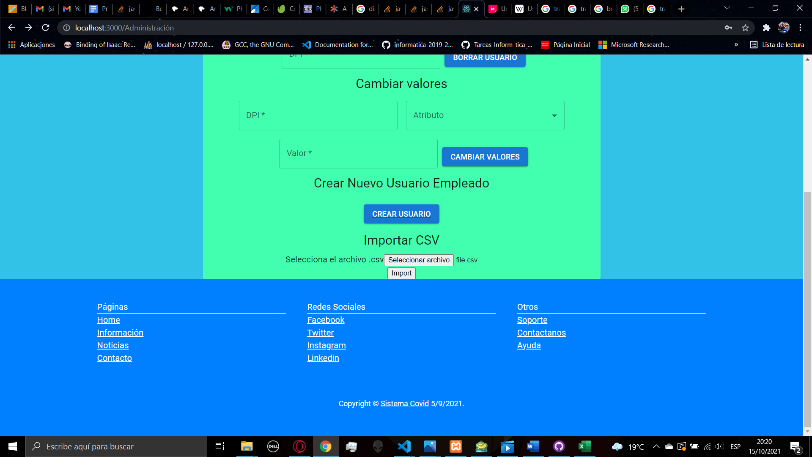

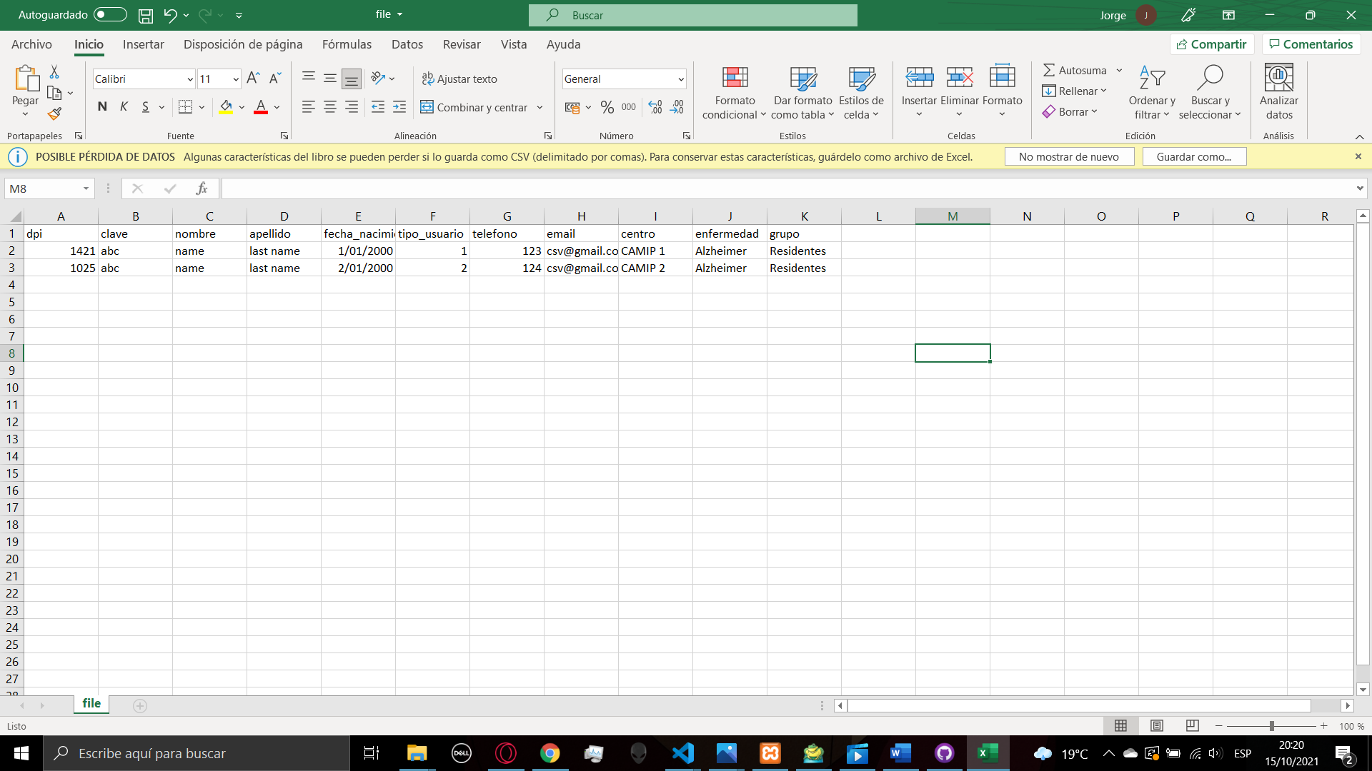

The csv file needs to have the follow structure to correctly load the file and import the user

1. **CONTENT**

In the content page you will find again a lot of functionalities, the first one is to import an image into the server to then manage the content of the news page. First you need to click the button to select a file, the window of the file explorer will appear so you must select an image and then will appear the name of the file next to the button, then after you confirm the file, you can click on the button send image to load the image into the server.

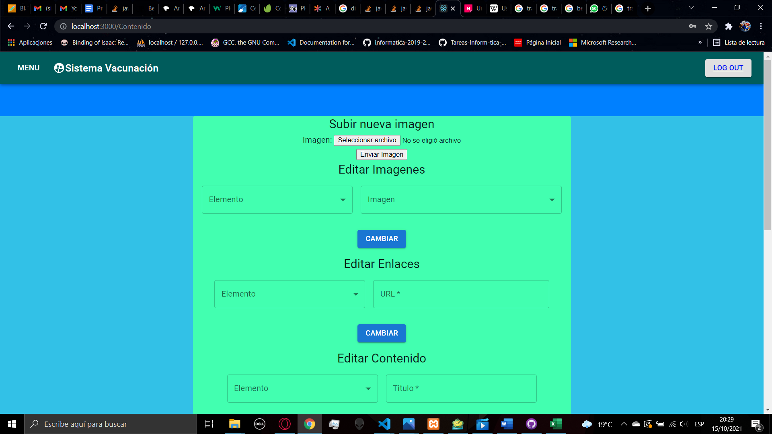

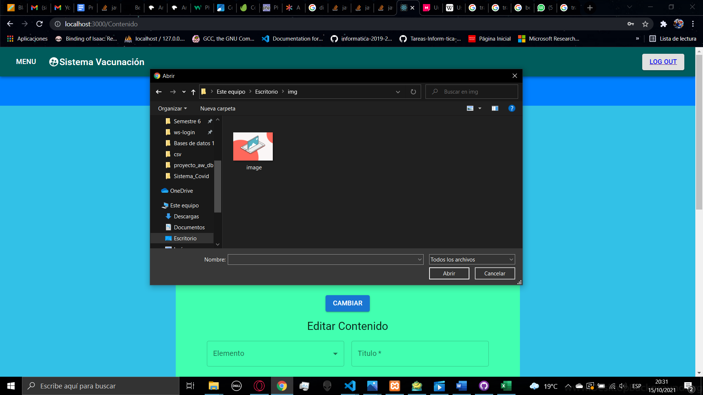

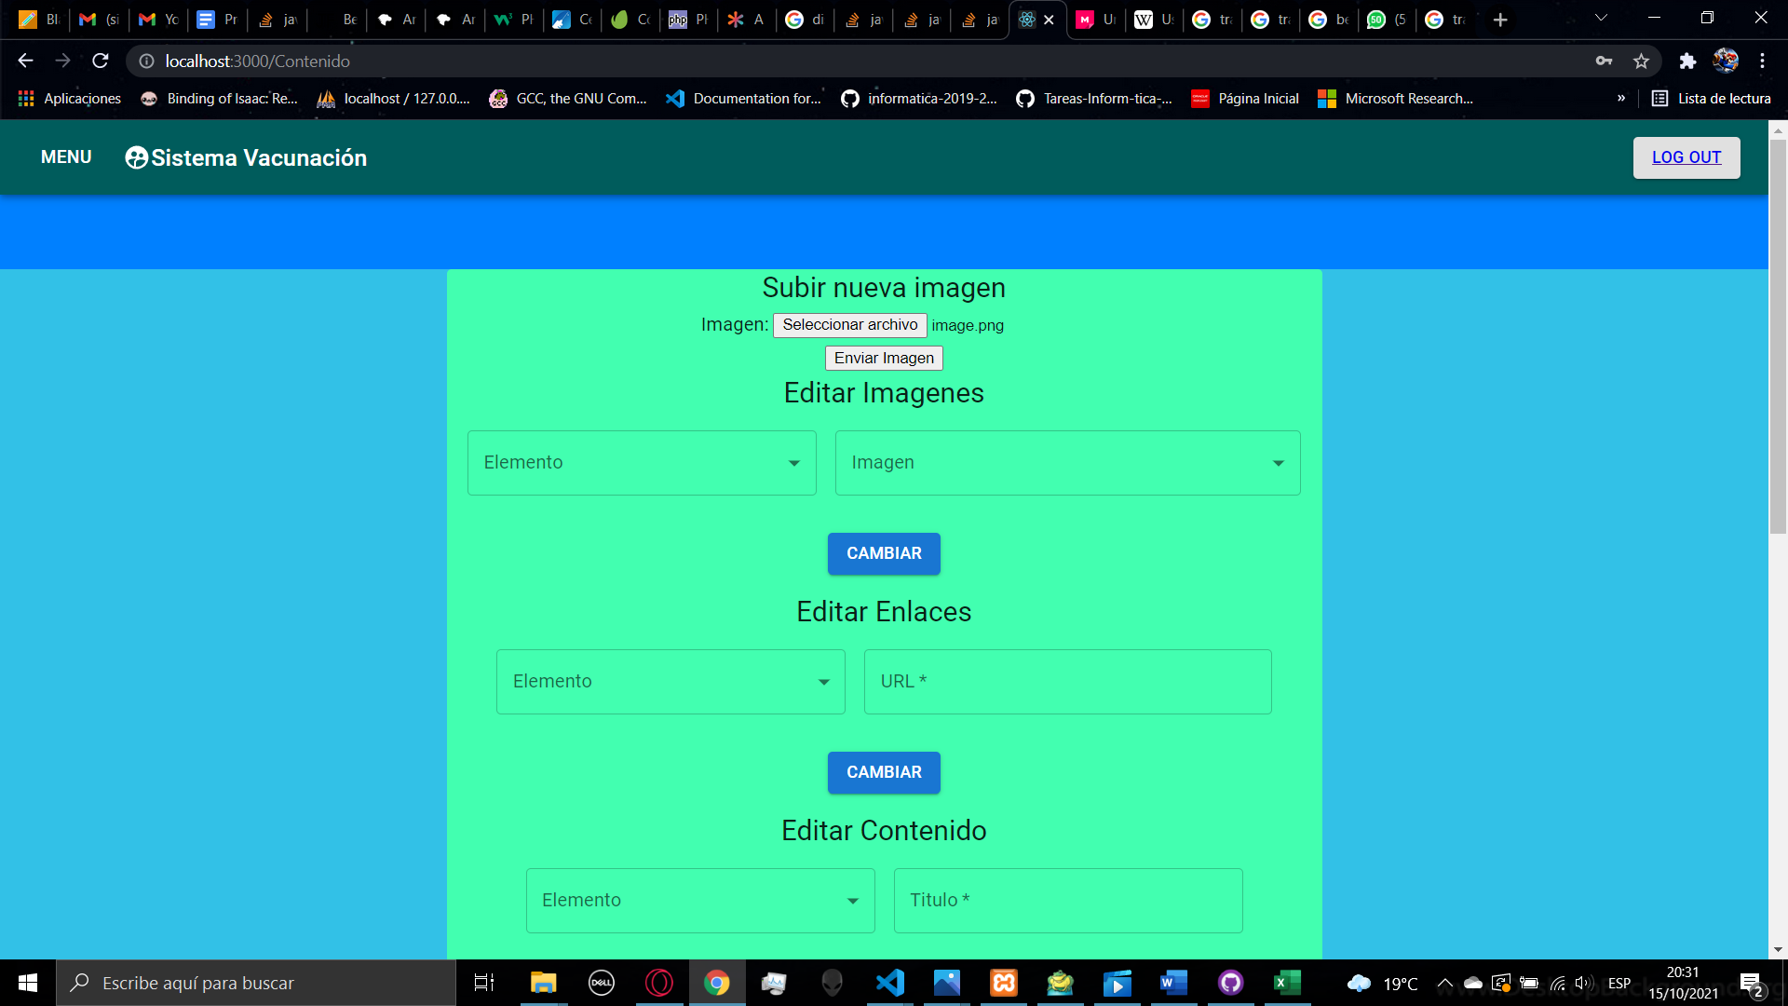

The second functionality is to change the images on the news page, first you need to select the item you want to change, there are 4 items, the main image, and the image for the 3 news in the portal, after selecting the item you will be able to select an image, after you load an image into the server, it will appear in the list so you can select it, then you can click the button change to apply it.

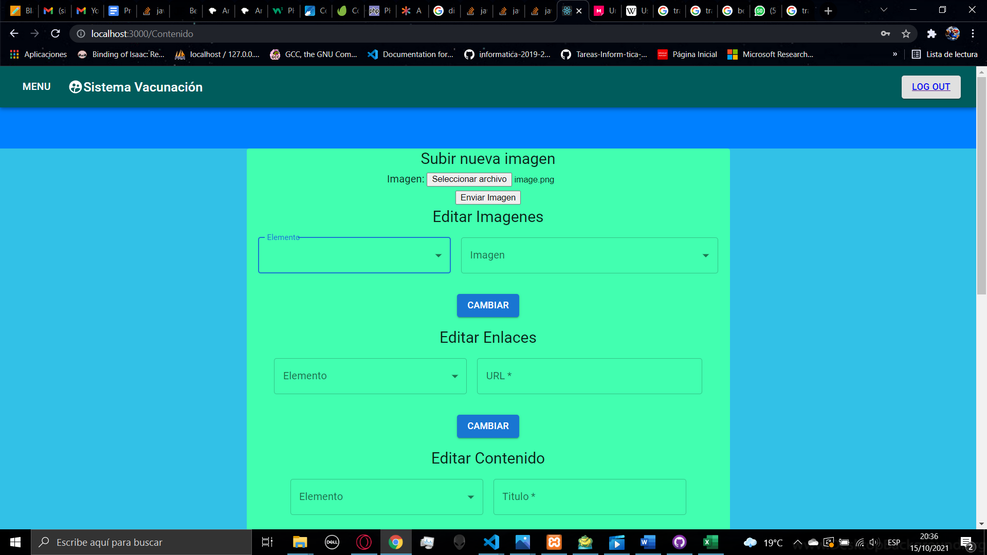

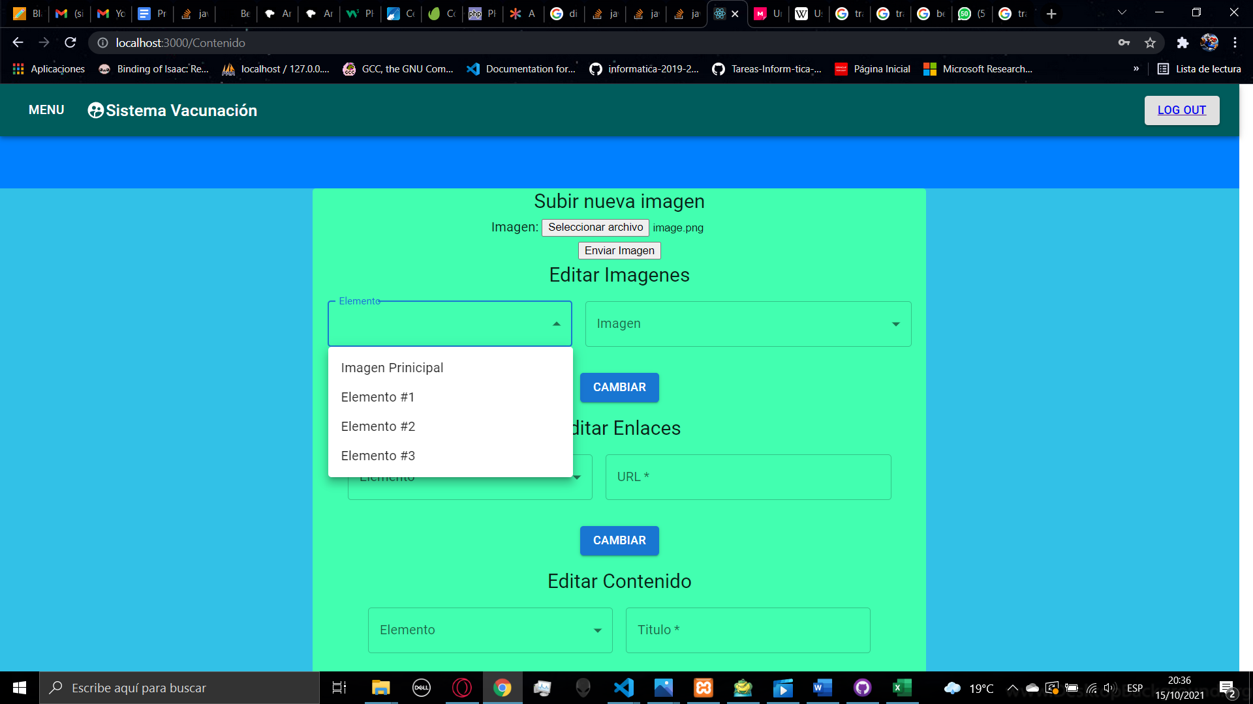 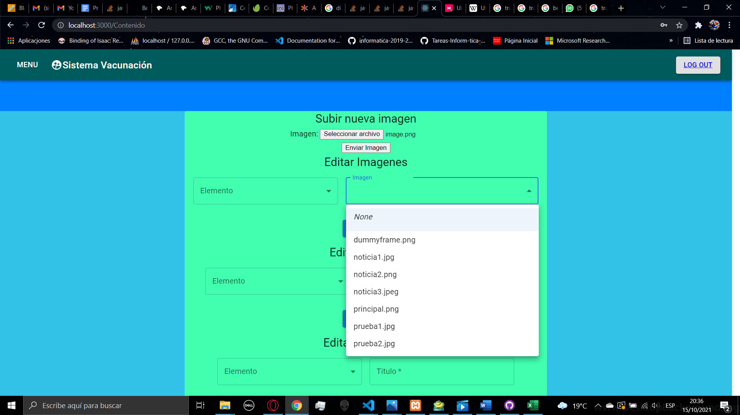

The third functionality is to change the URL of the links inside the news to learn more, first you must select the element of the list, you can select one of the 3 news, and next you fill the URL you want to show. After filling the value, you can click the button change.

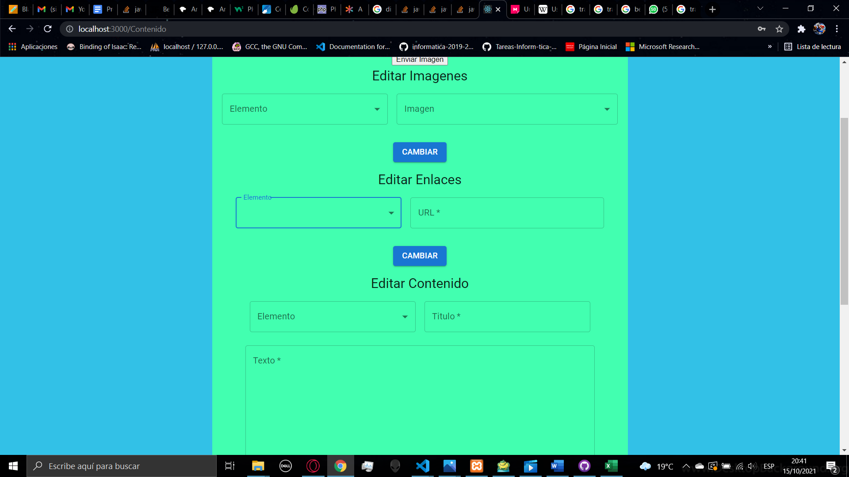

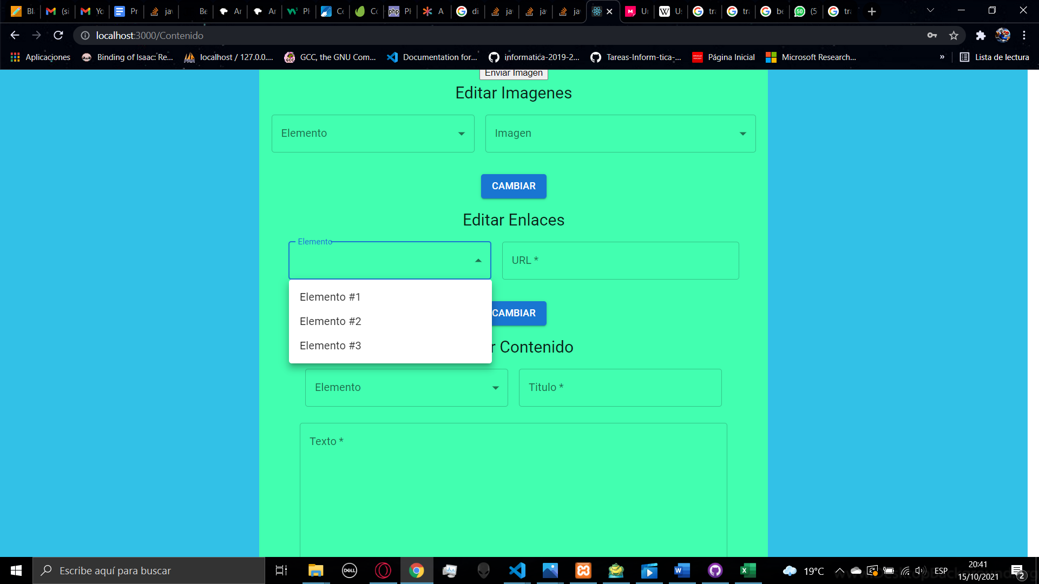

The last function is to change the text of the news, first you must select the element you want to change, after that you can fill the title of the news and below you have a field to put the text of the news, after filling the text and the tittle, when clicking on the button change, the changes will be applied.

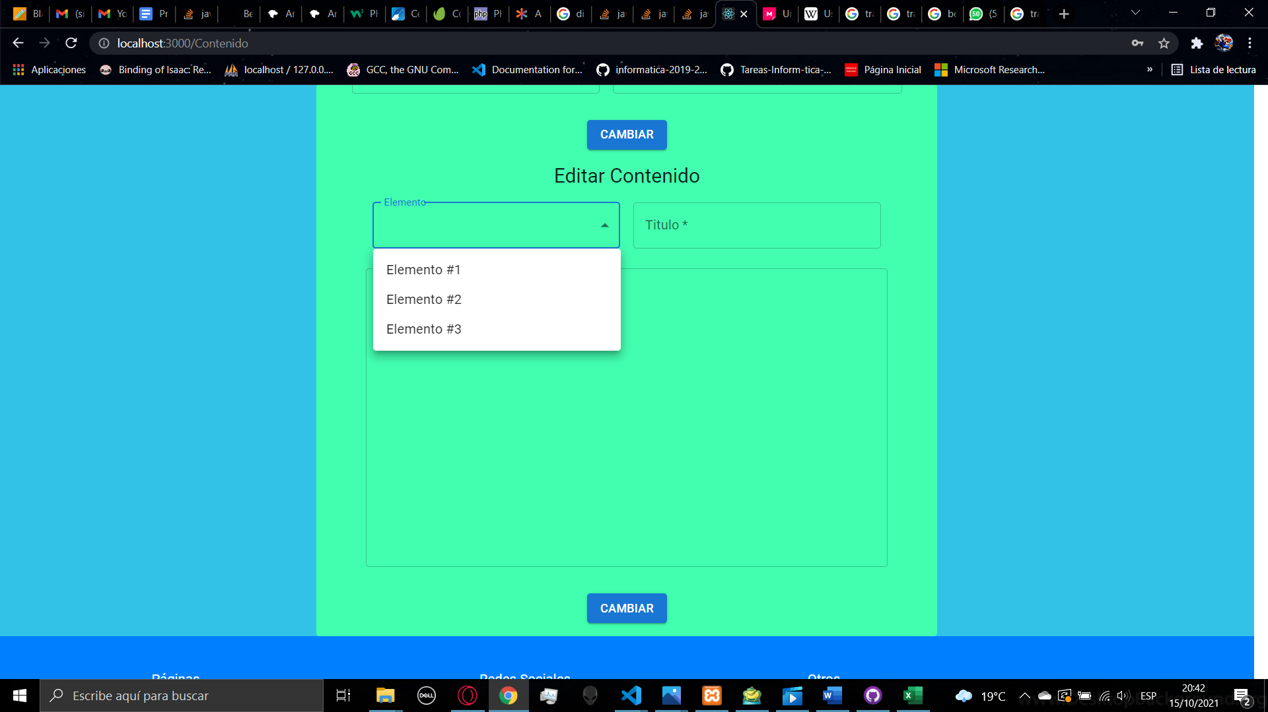

1. **HABILITATION**

In the habilitation page you can manage who is going to be able to start the vaccination process, in the first functionality you can select a chronic illness from a list and then you can select if enable or disable the register of people with that chronic illness, then you can click the button change to apply the changes.

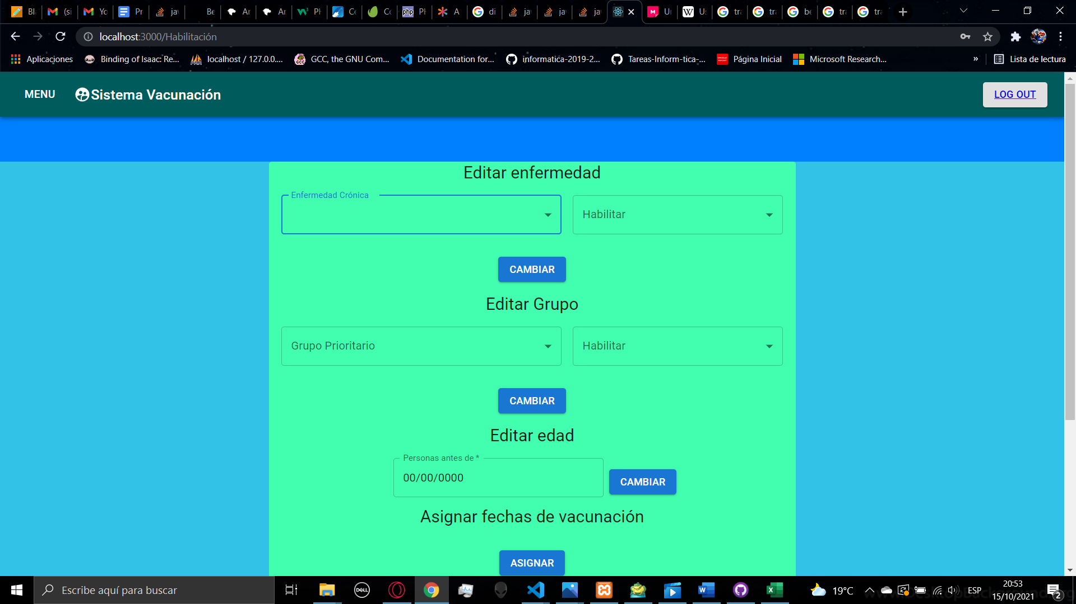

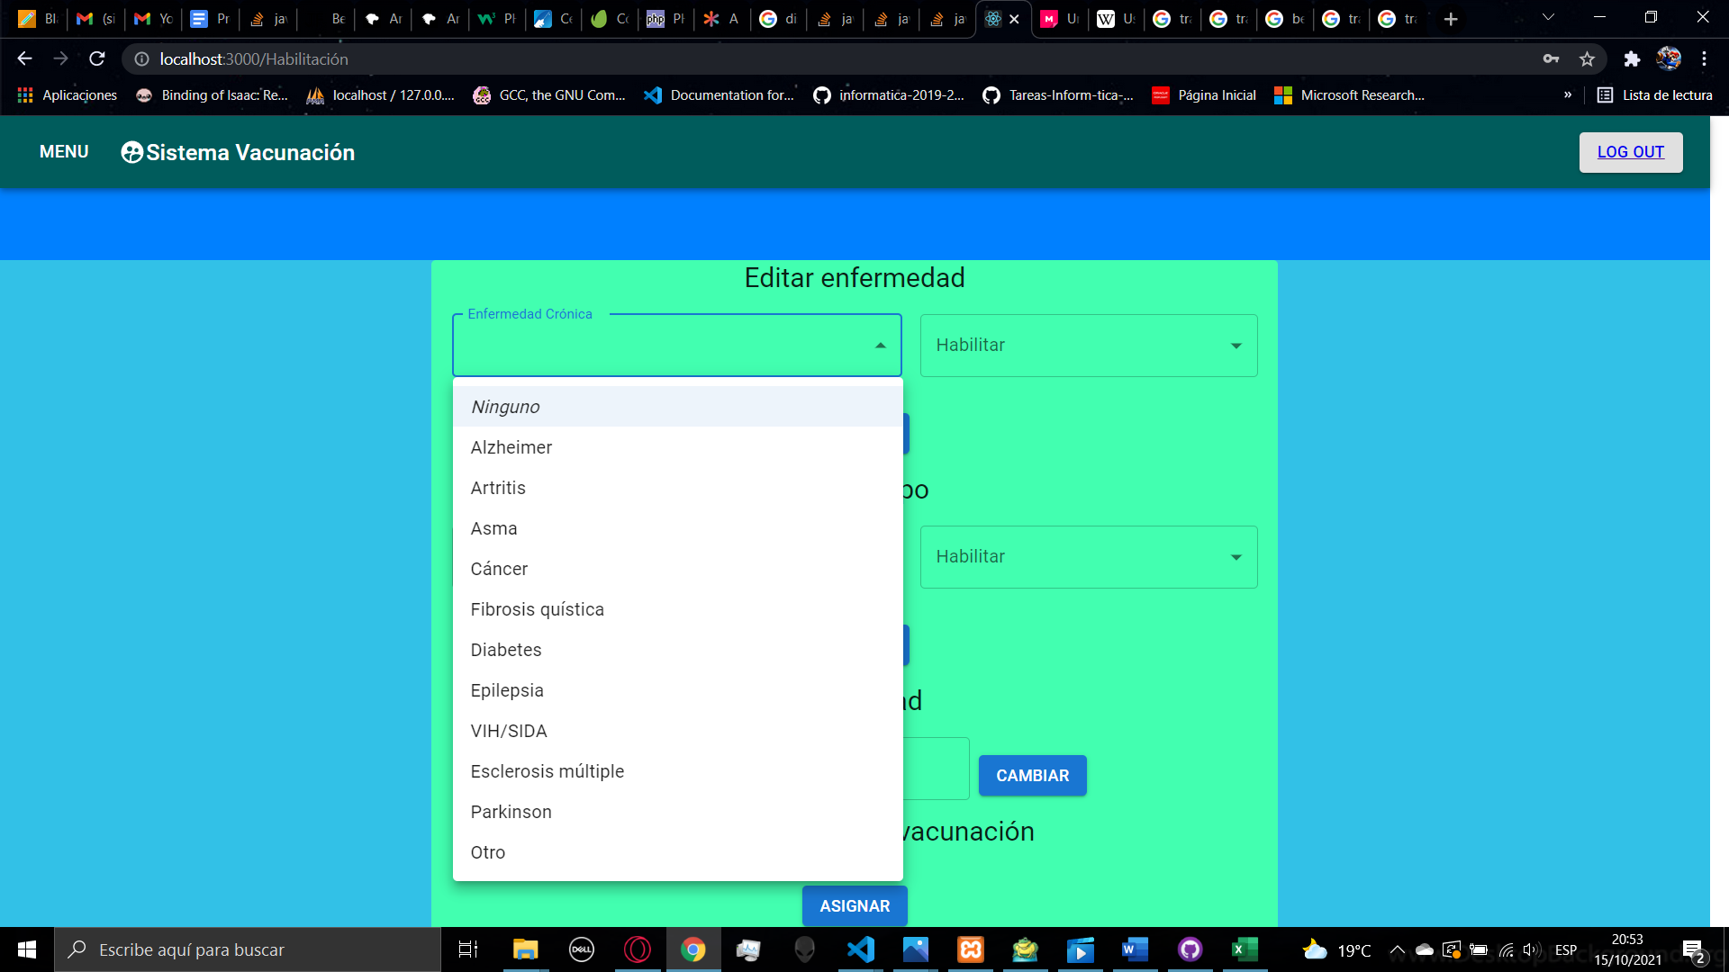

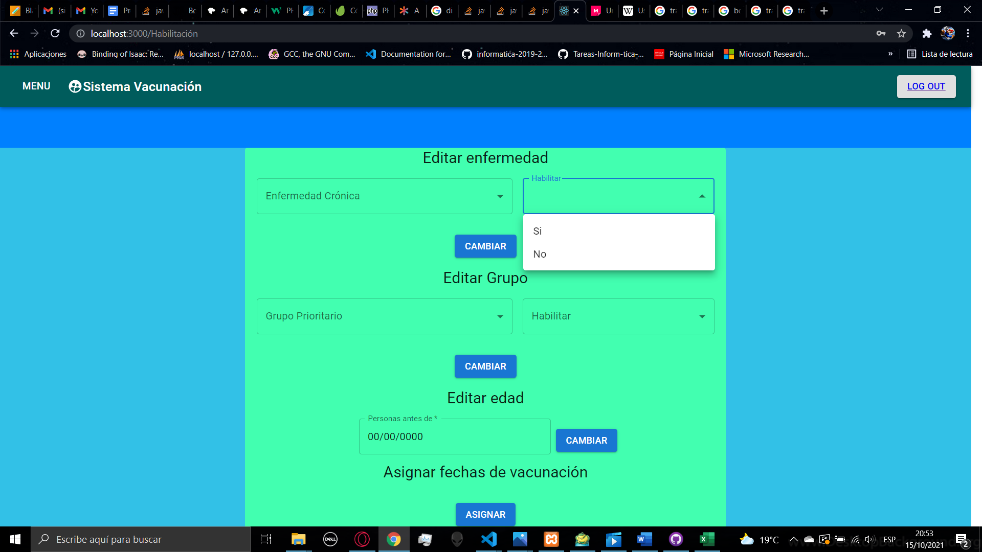

The second functionality is the same as the first one, you can select a group to enable or disable the extraordinary register, then you must click the button to apply the changes

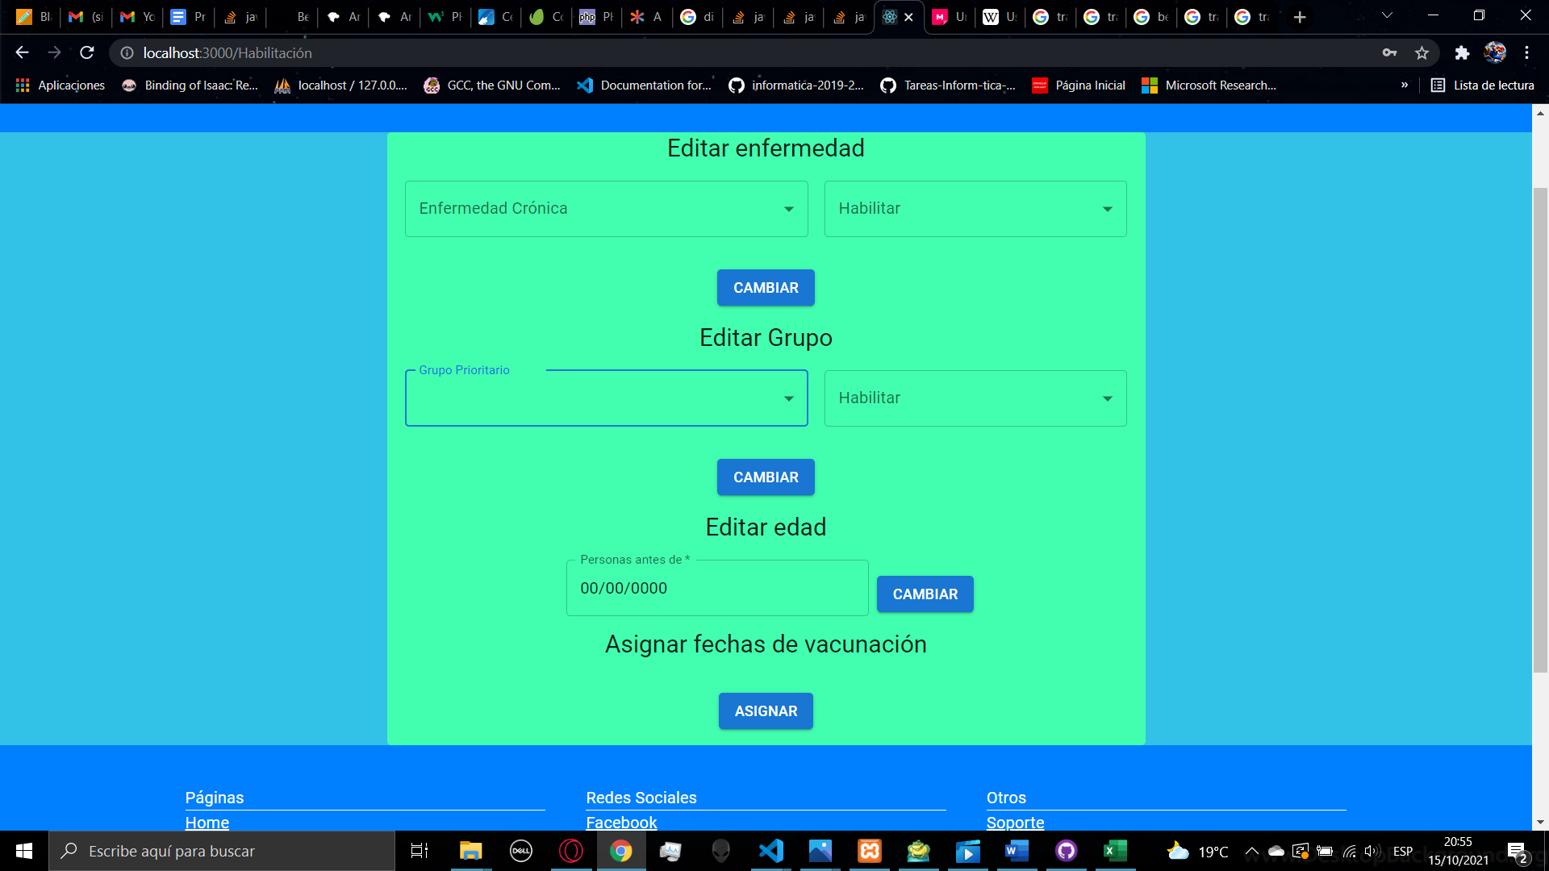

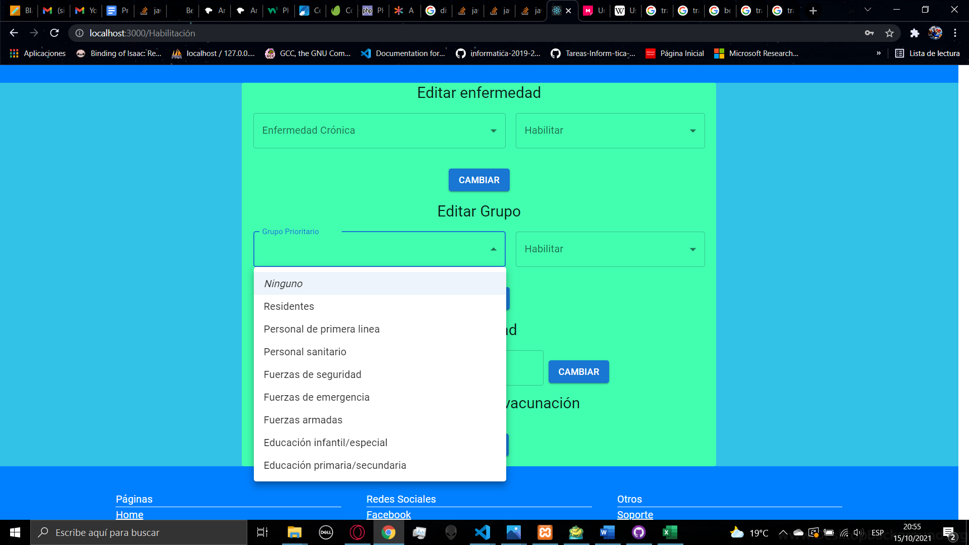

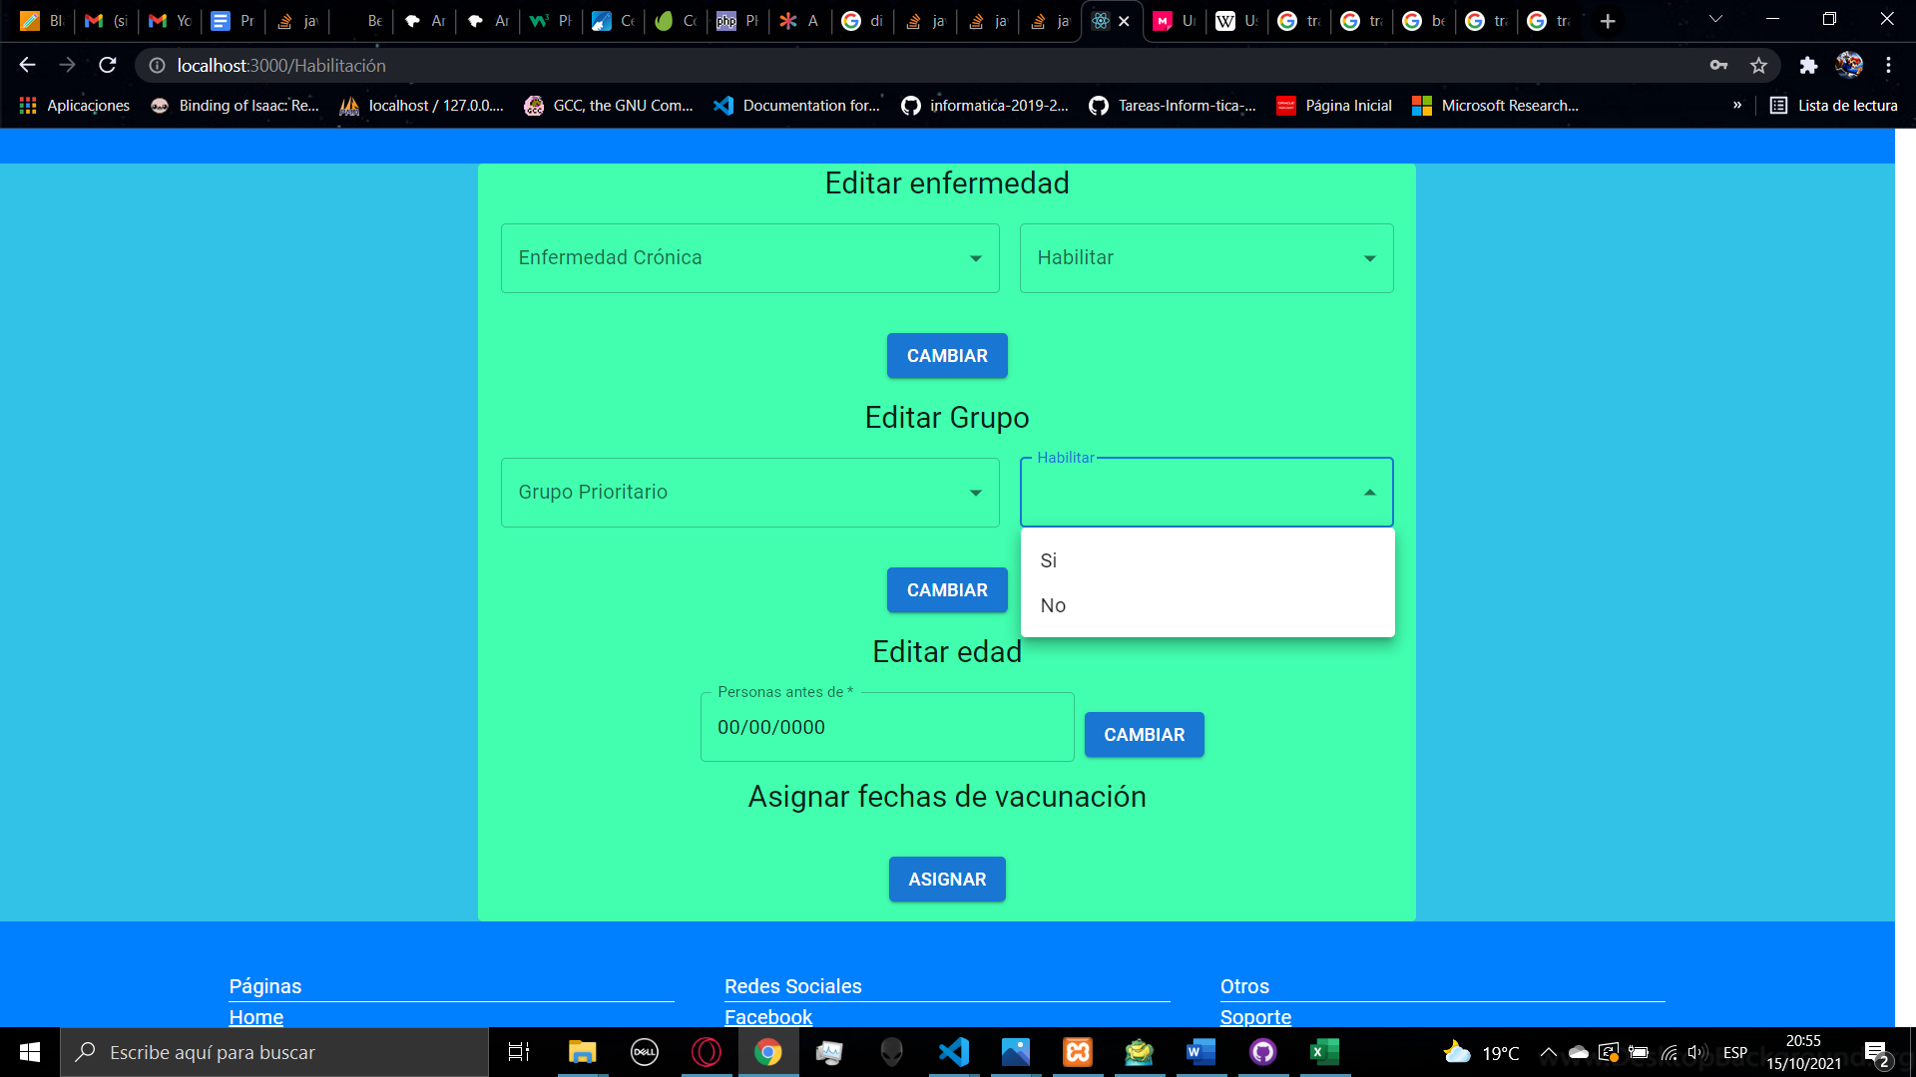

The third functionality is to change the date parameter that is use in the register of a new account, to set a new date you need to fill the field, the structure for the date is dd/mm/yyyy, then you can click on the button change to assign the date.

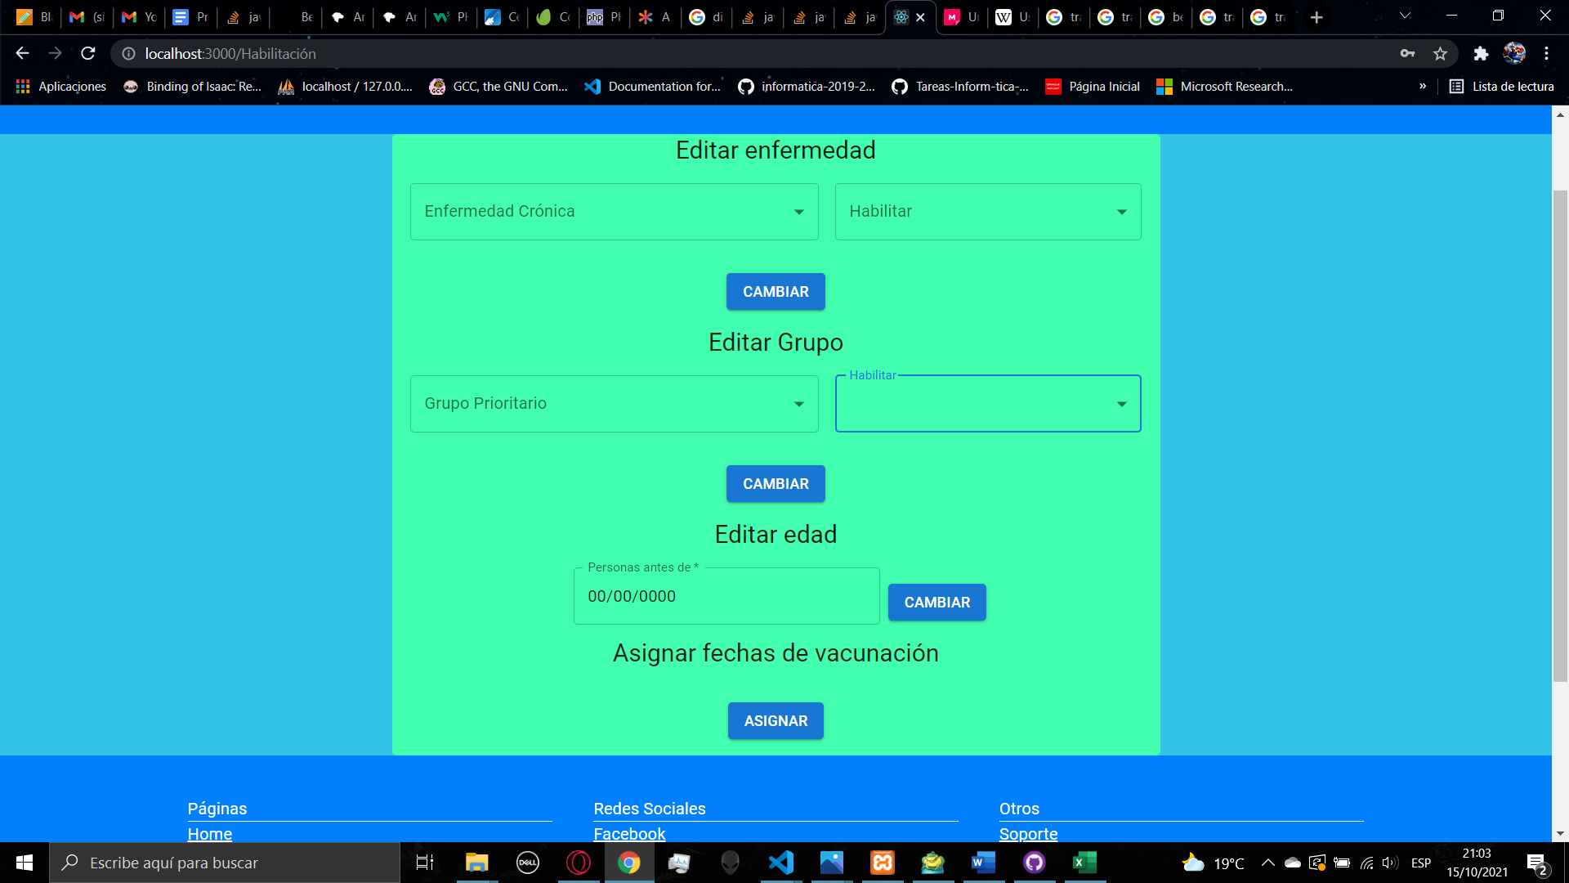

At the bottom you will find a button for assign the vaccination dates, if you click the button you will make a call to the database to assign the vaccination date for all the people who has registered since the last assign, the assign process is manual, so you are able to determine when to assign the dates, you can also manage the assignation per each center in the centers page.



1. **CENTERS**

In the centers page you are able create and edit the centers for the application of vaccines, the first functionality is to create a new center, first you have to enter the new center name, then you can select if the center will be available or not to the people, this can be changed later, then you have to select the days for the assignation for the vaccine, each center will have different assignation, and then you can select the daily capability of the center. When you click the button, the center will be created, it cannot be deleted.

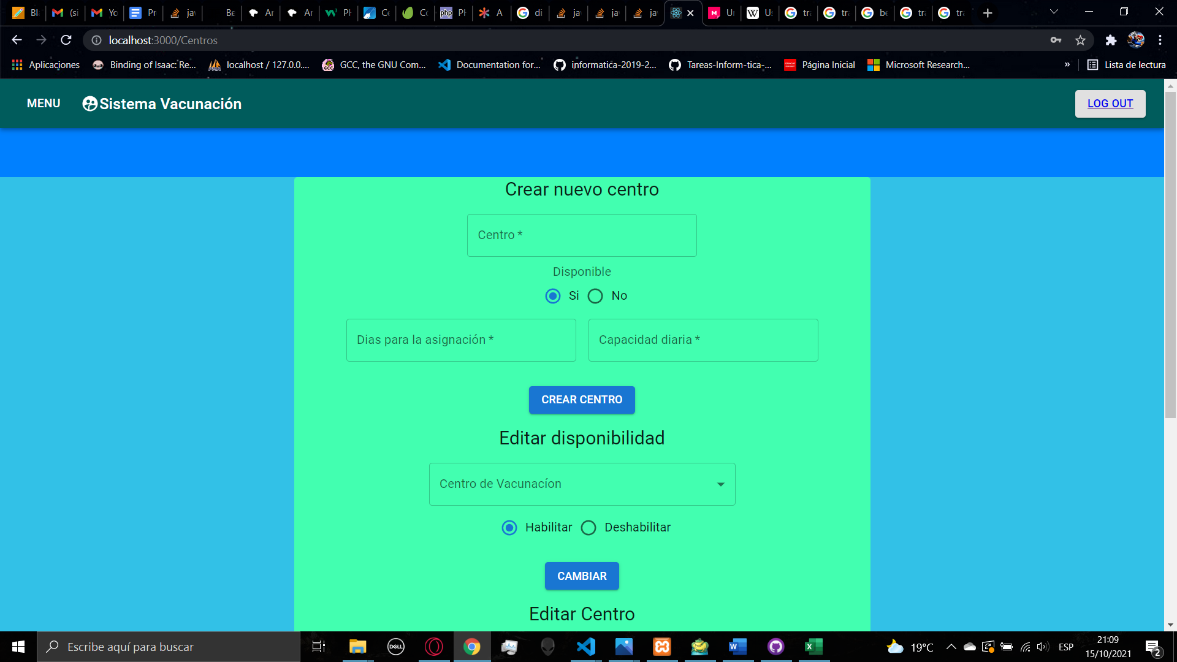

The second functionality is to change the availability of a specific center, after the creation of the center, it will appear in the list, after the selection of the center you can click on the one of the buttons to enable of disable that center, to apply the changes you click on the button change.

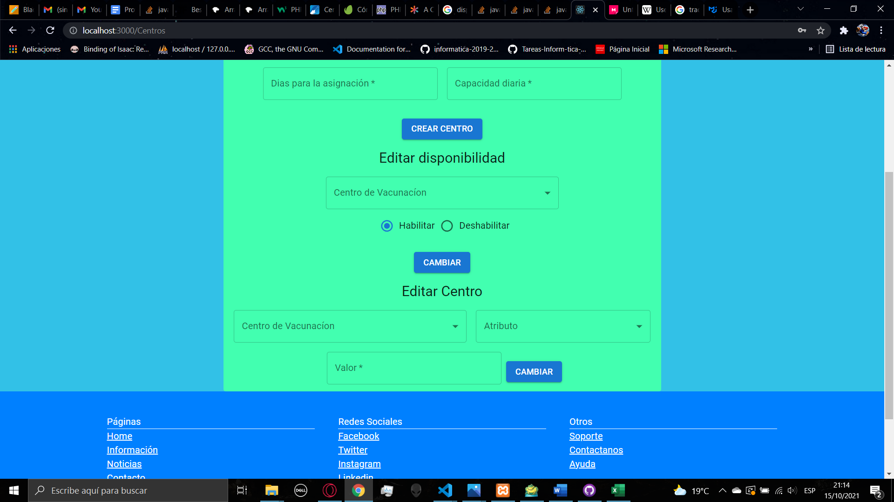

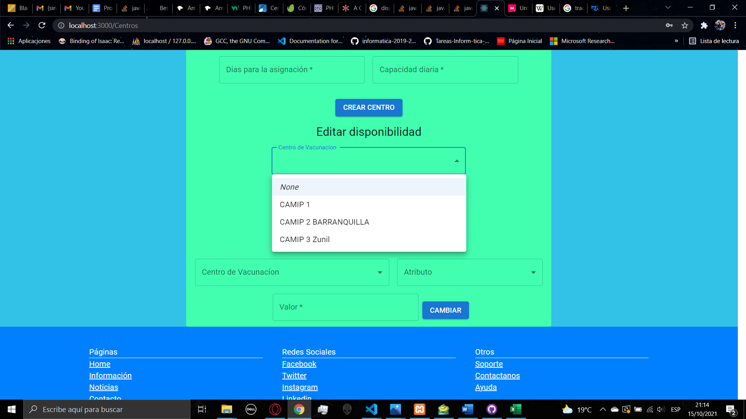

The last functionality is to edit the center, you can select a center of the list and then you can select if you want to change the days for assignation of the vaccine or the daily capability, after selecting that you can enter the number and then click the button to apply the changes

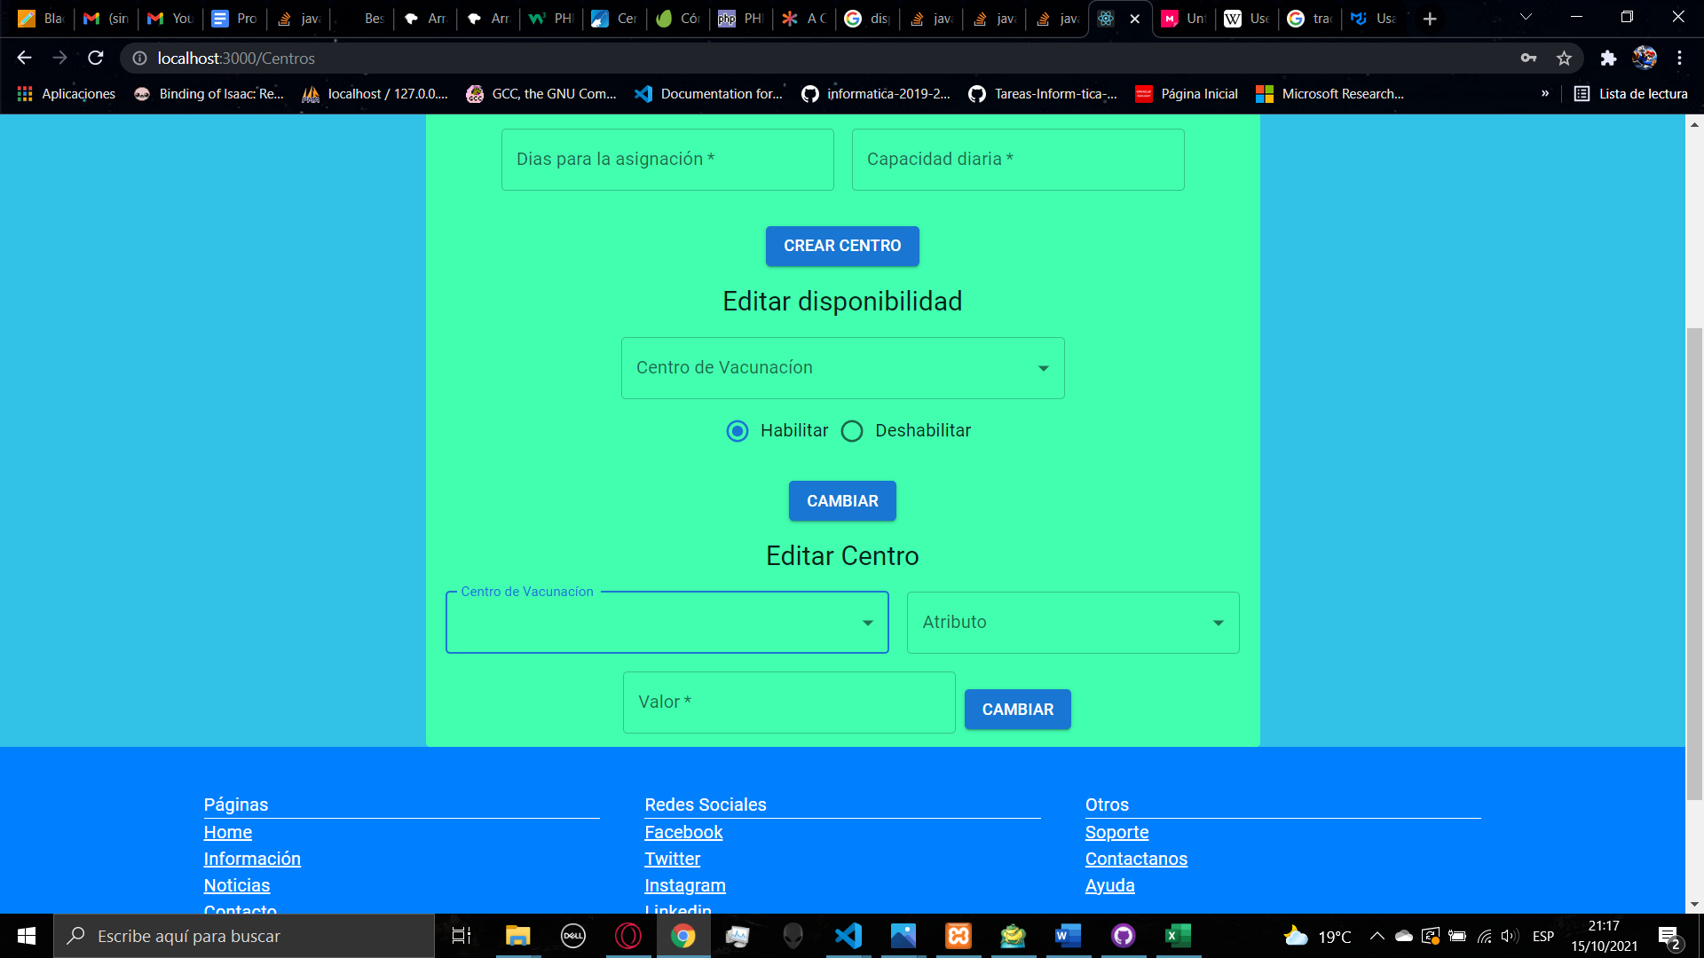

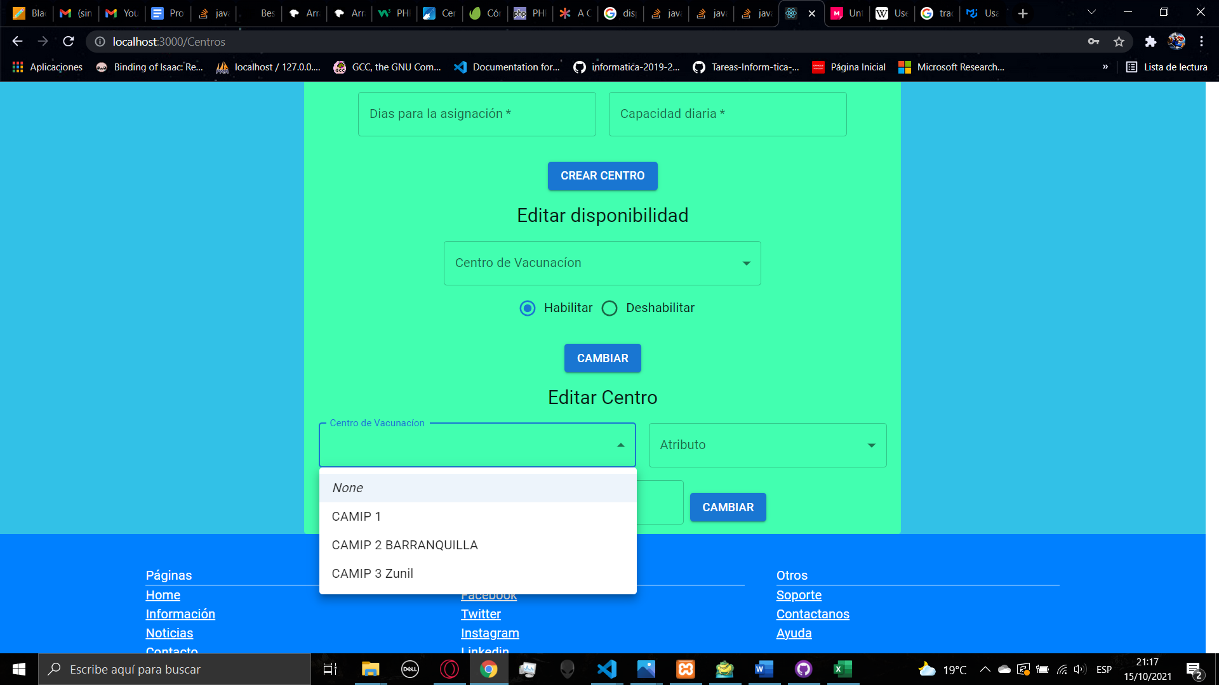

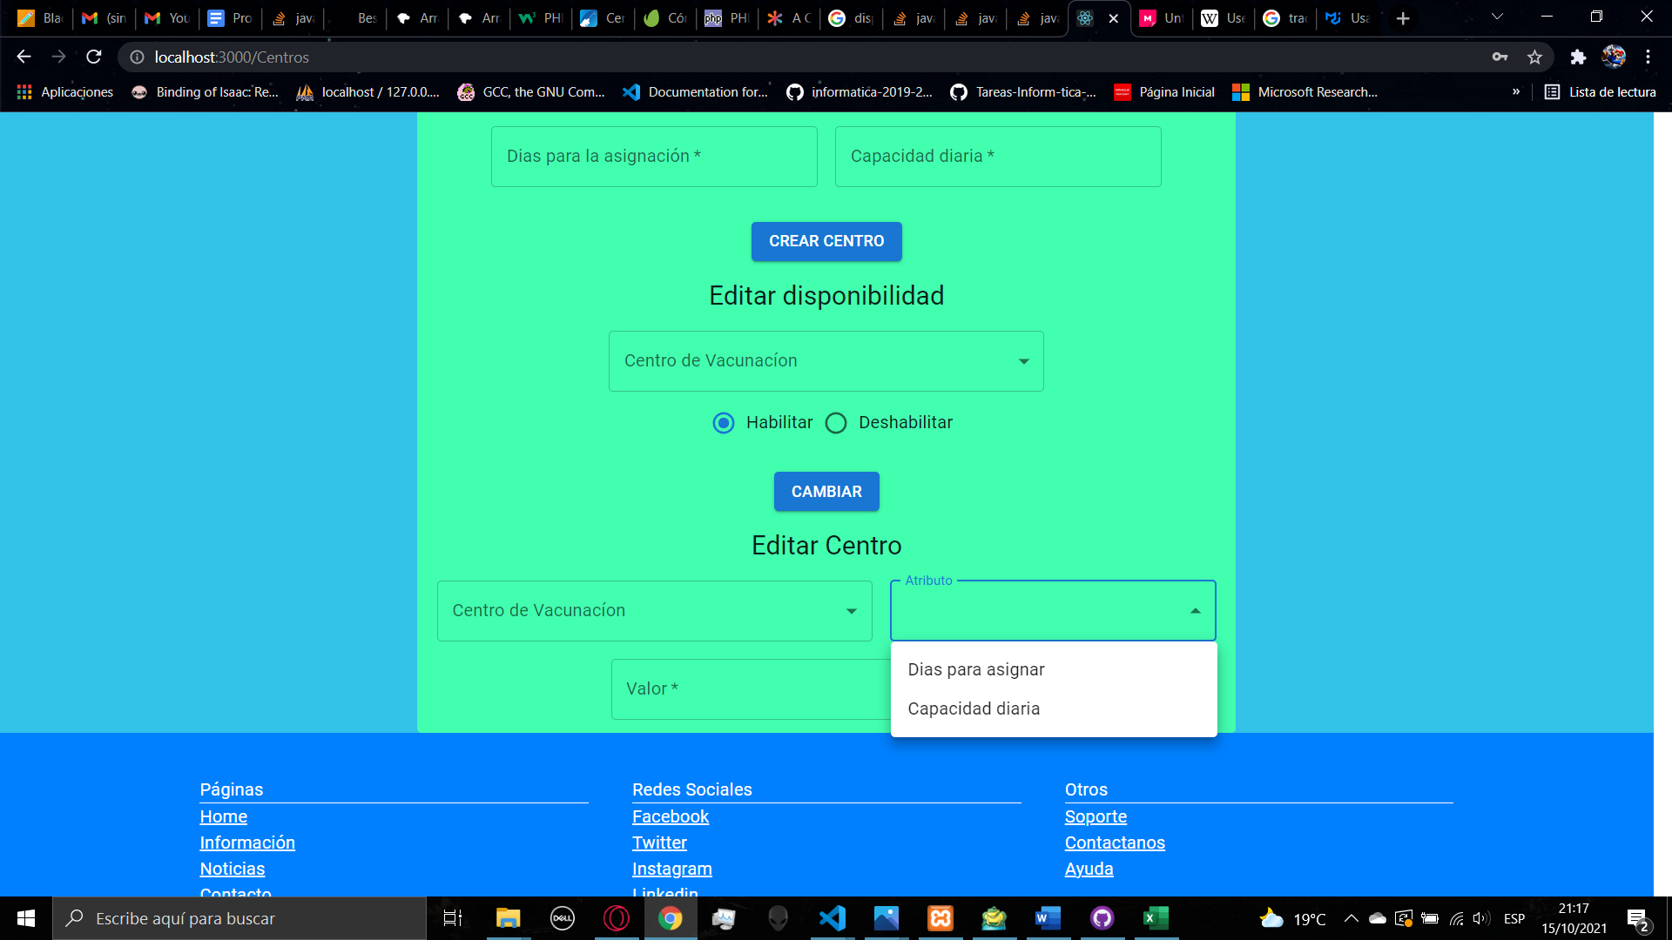

1. **VACCINES**

In the vaccines page you can page you are able create and edit the vaccines, in the first functionality you can create a new vaccine, first you need to set the name, you can select if the vaccine will be appearing in the assign page list, then you select if the vaccine will be able, then you have the doses number, you have to select a number between 1 and 3, depending on the number of doses you need to fill the days to stablish the date for the second and the third dose. After filling al the data, you can click the button to create the vaccine

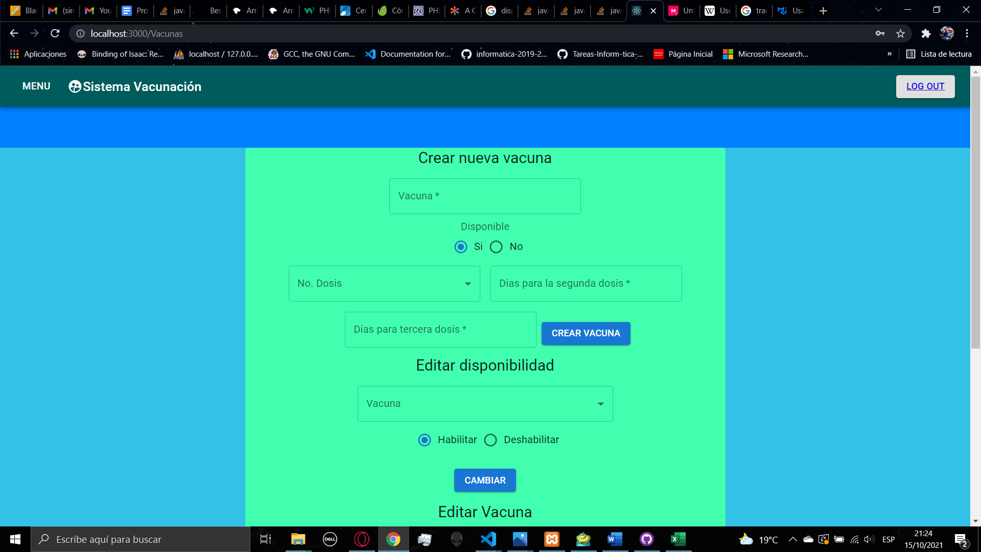

In the second functionality you can edit the availability of a specific vaccine, after creating a vaccine it will appear in the list, you can select one vaccine and select the availability for the assign page, to apply the change you must click on the change button

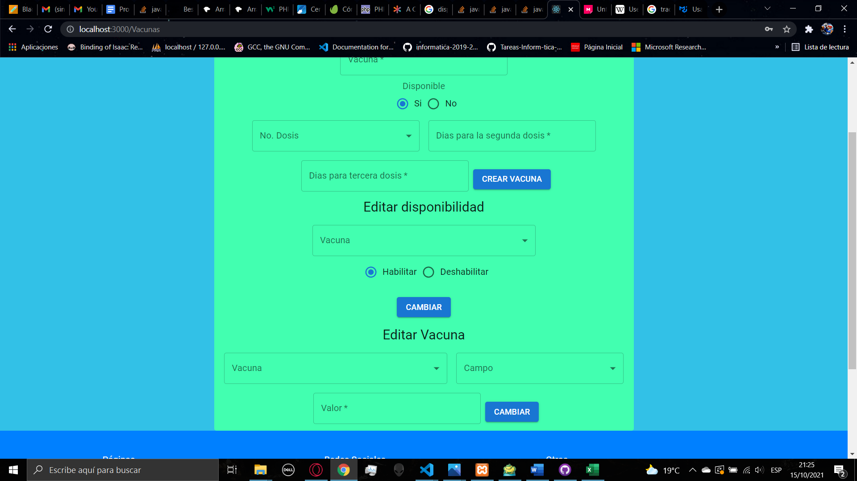

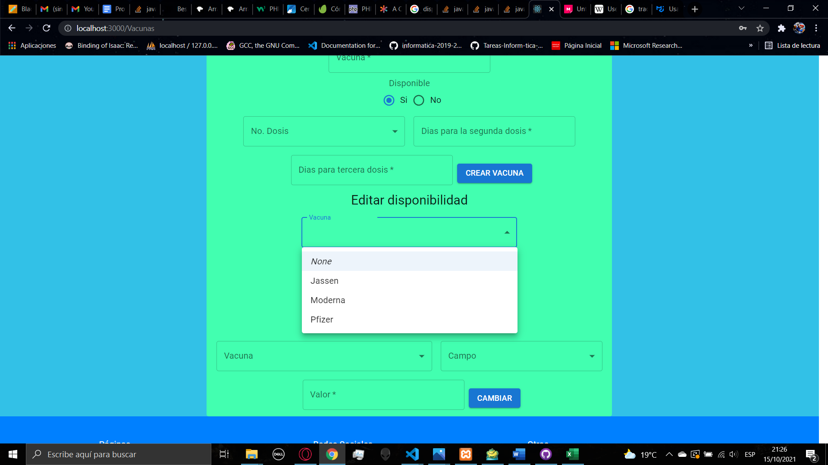

In the last functionality you can edit a specific vaccine, you select the vaccine from the list, then you must select the parameter you want to change, you can edit the number of doses, the days for the second and the third dose. After selecting the parameter, you fill the field and then click the button to apply the changes.

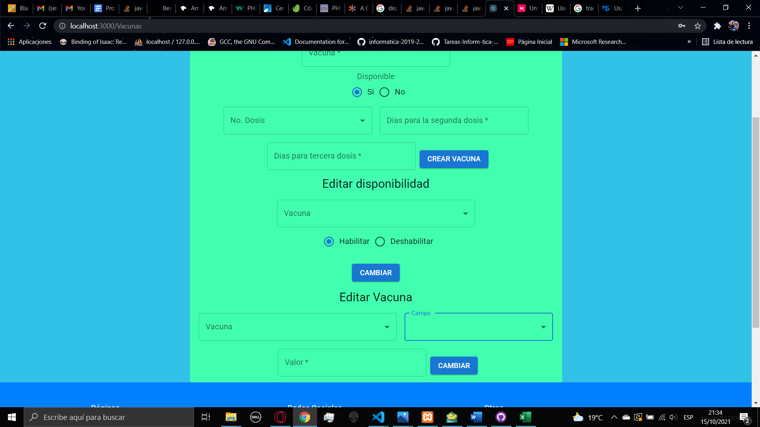

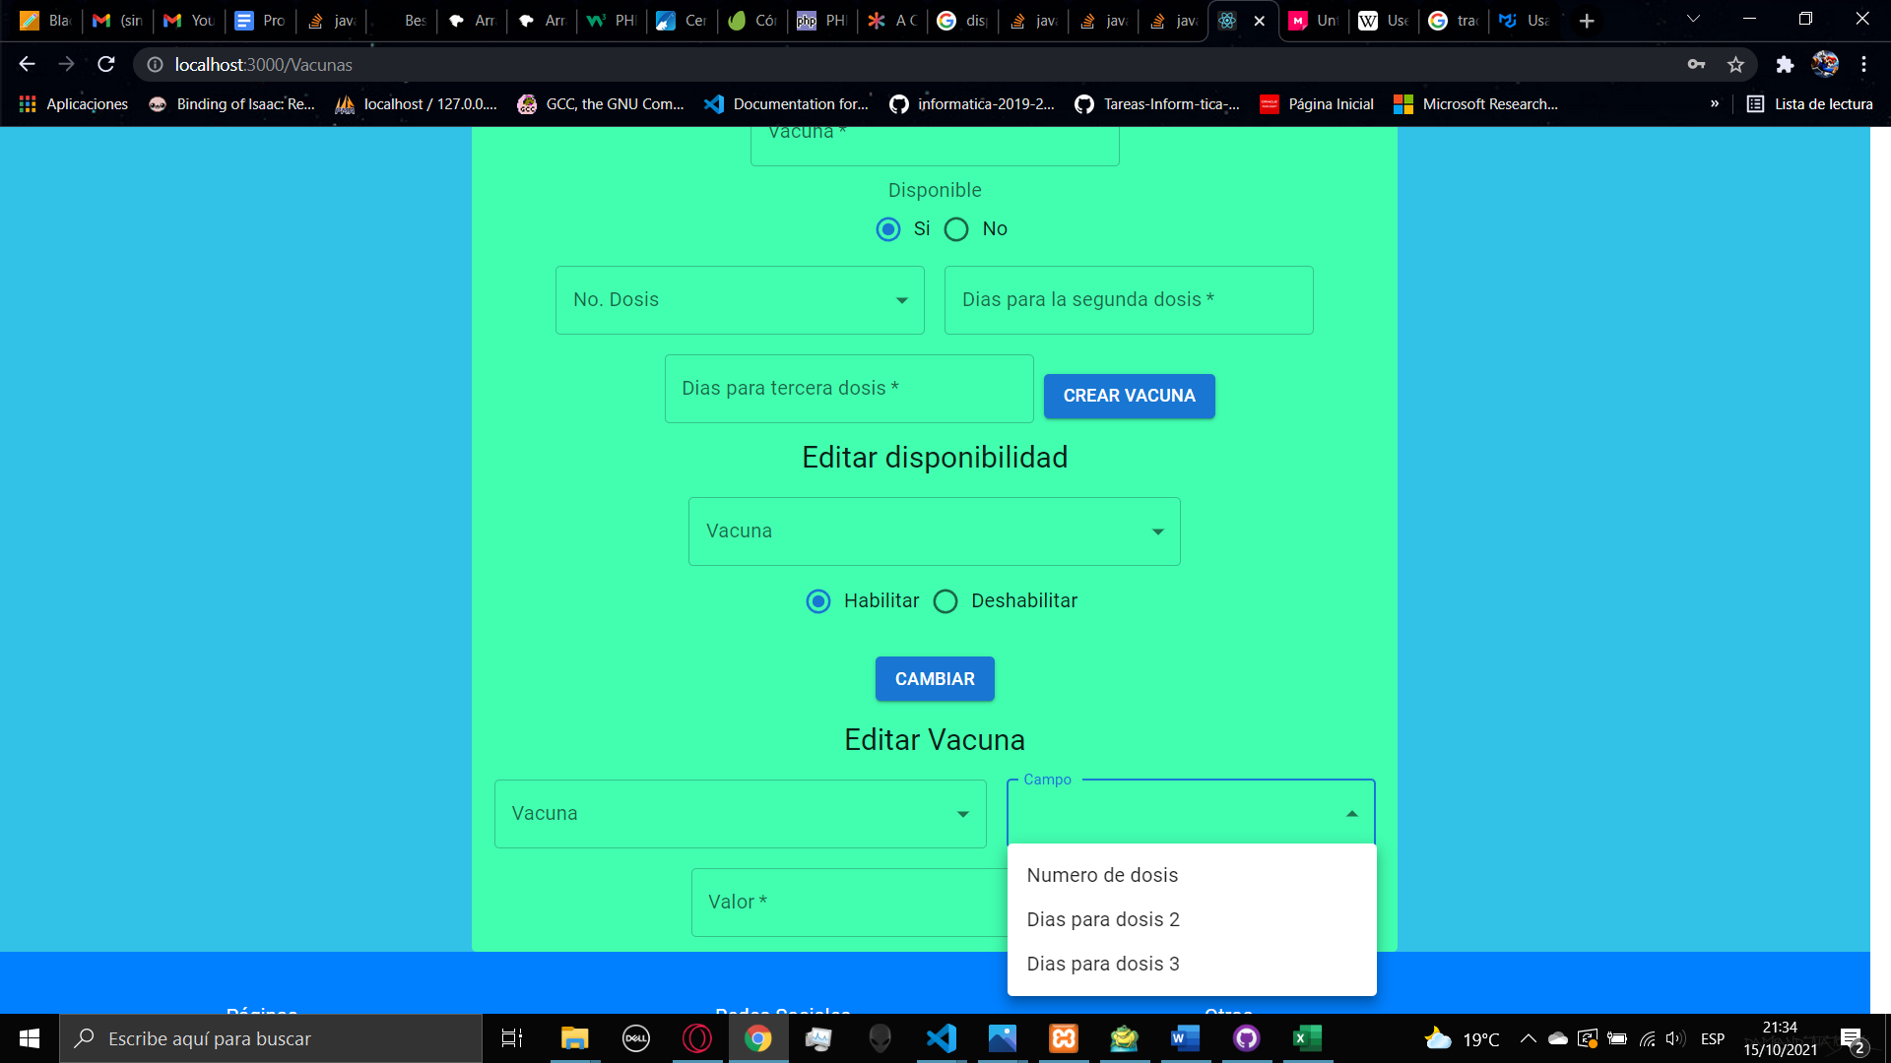

1. **REPORTS**

In the reports page you are able to generate reports in an excel file, in the page there are different options of reports. The fist one is to obtain all the people vaccinated between two dates.

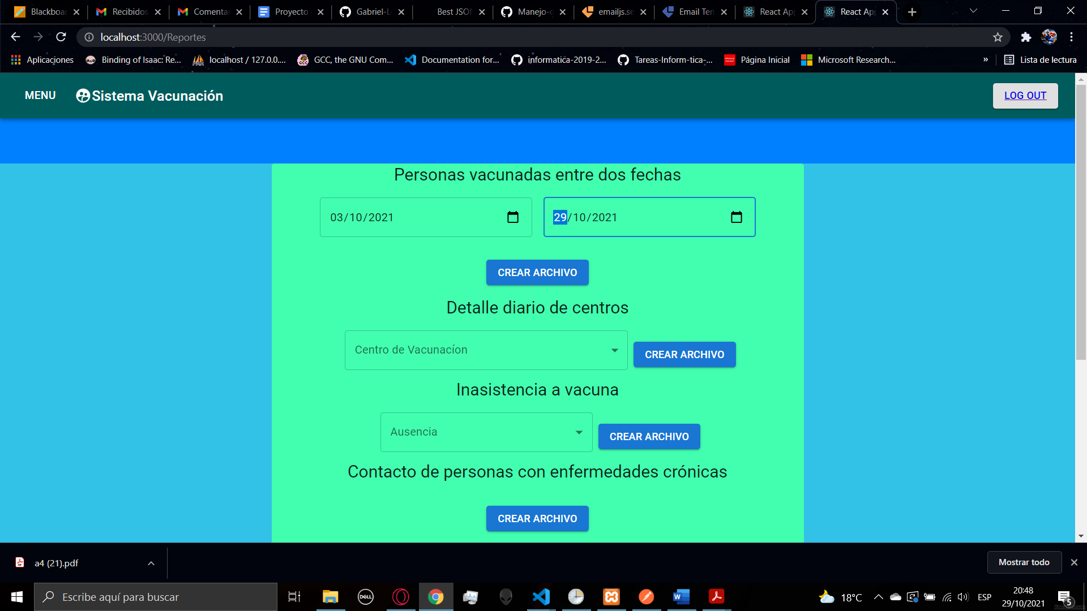

When you have selected both dates and you click on the button create file, if the request has generated any result, a button will appear to download that file, this will apply for the rest of the reports.

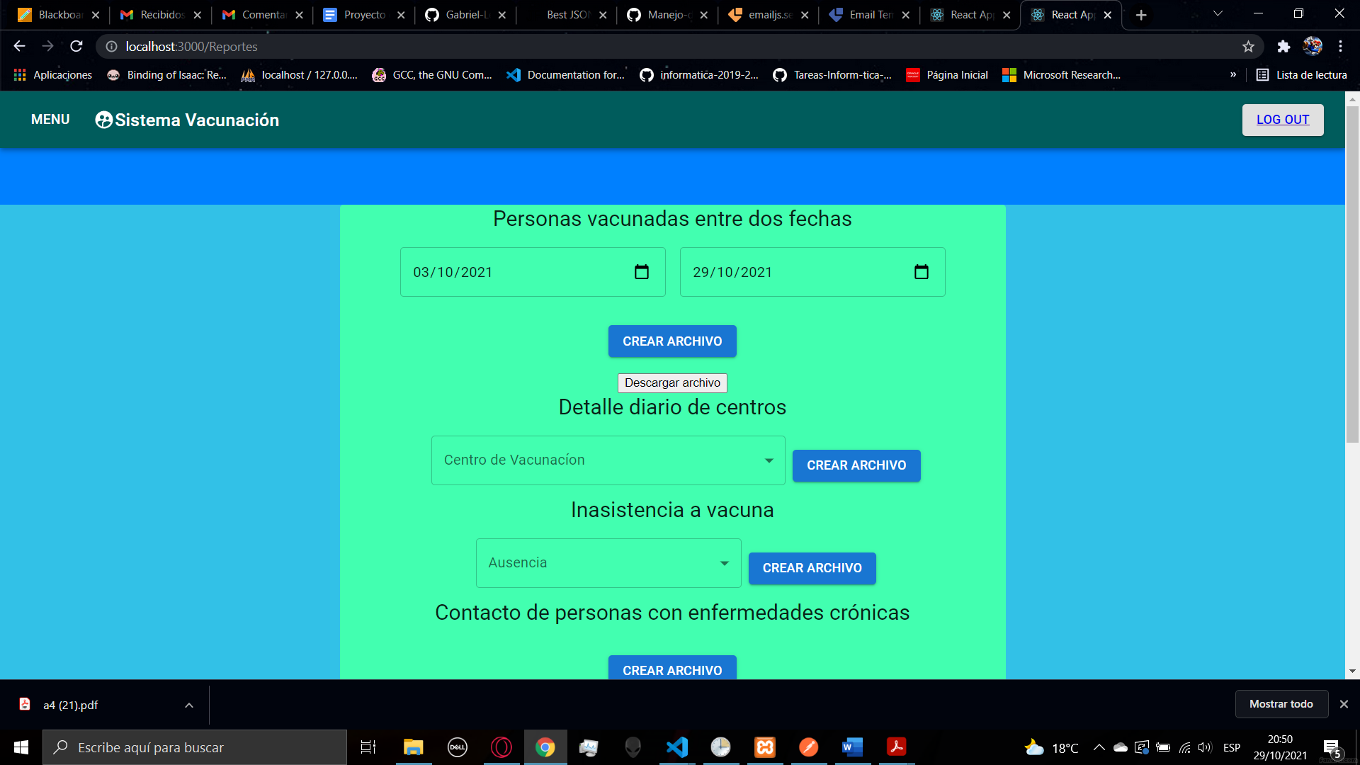

When you click on the button to download the file, a window will appear to save the excel file.

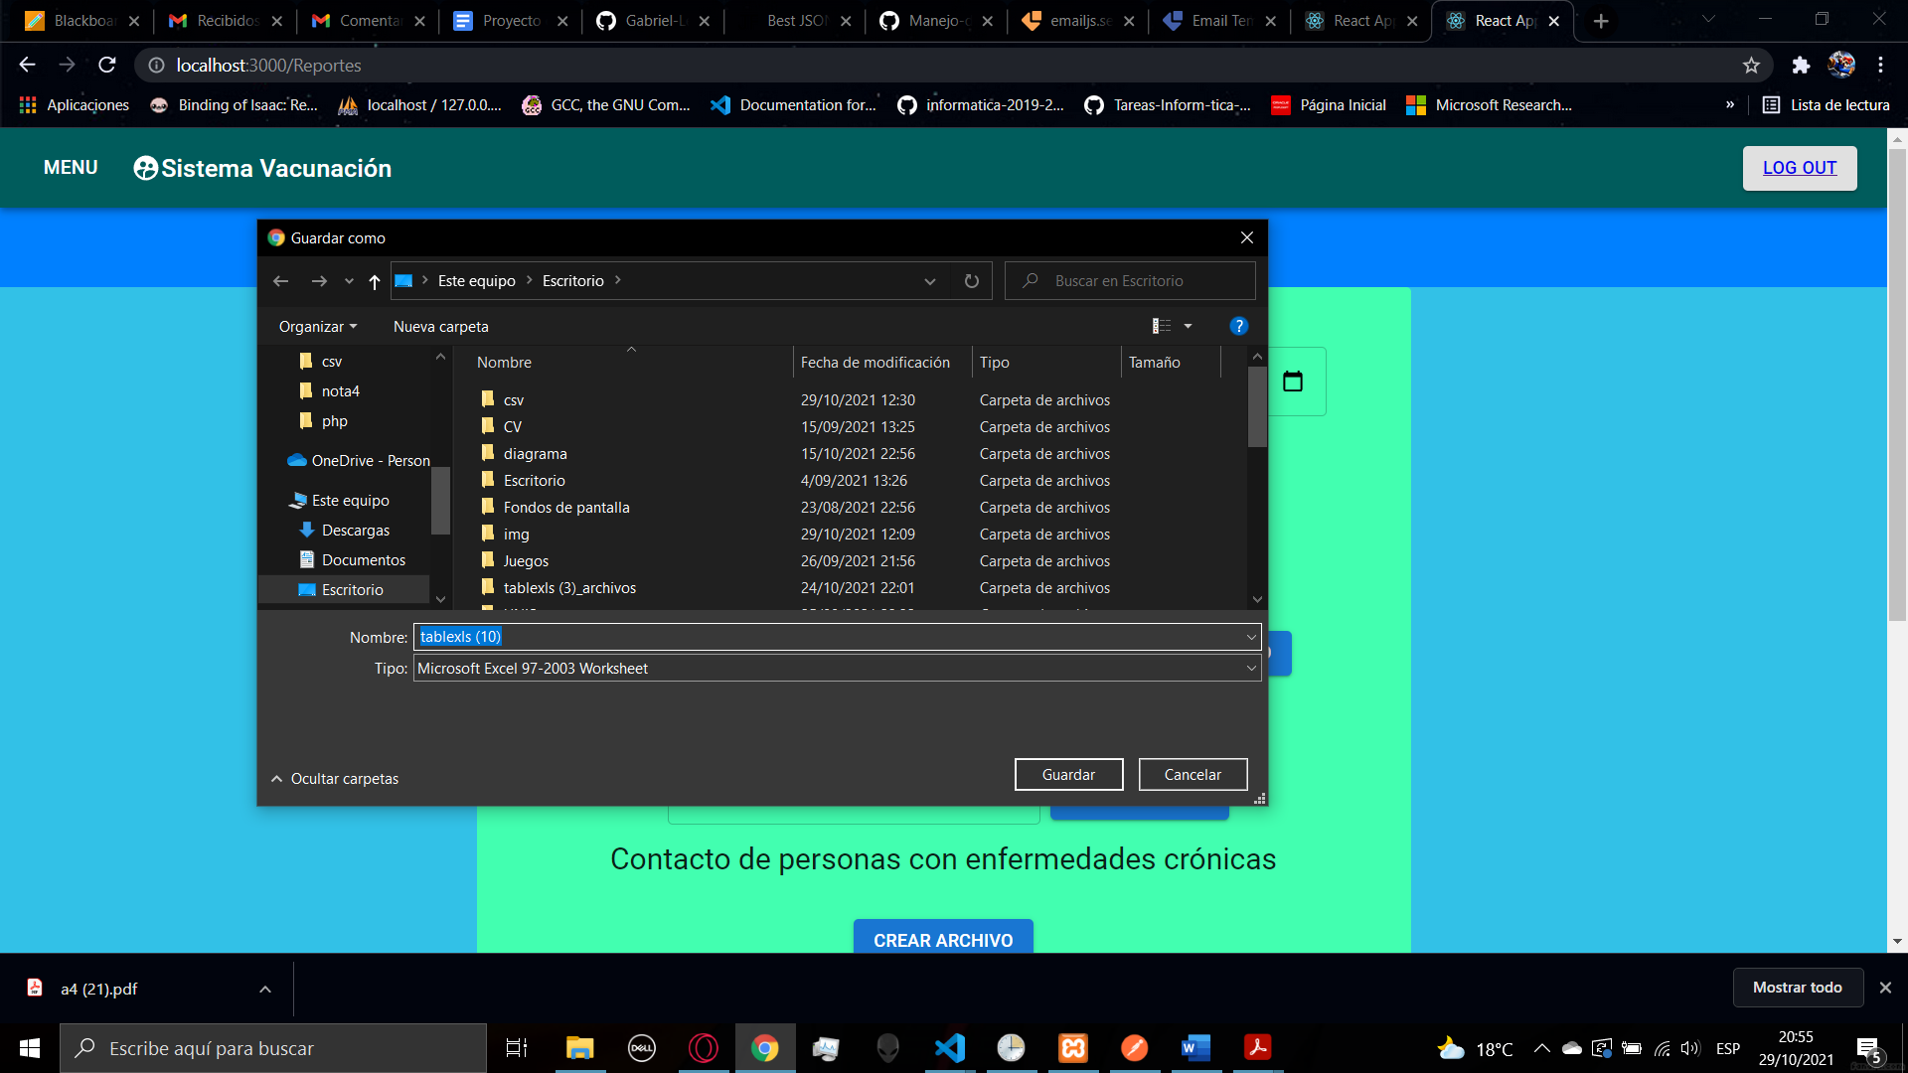

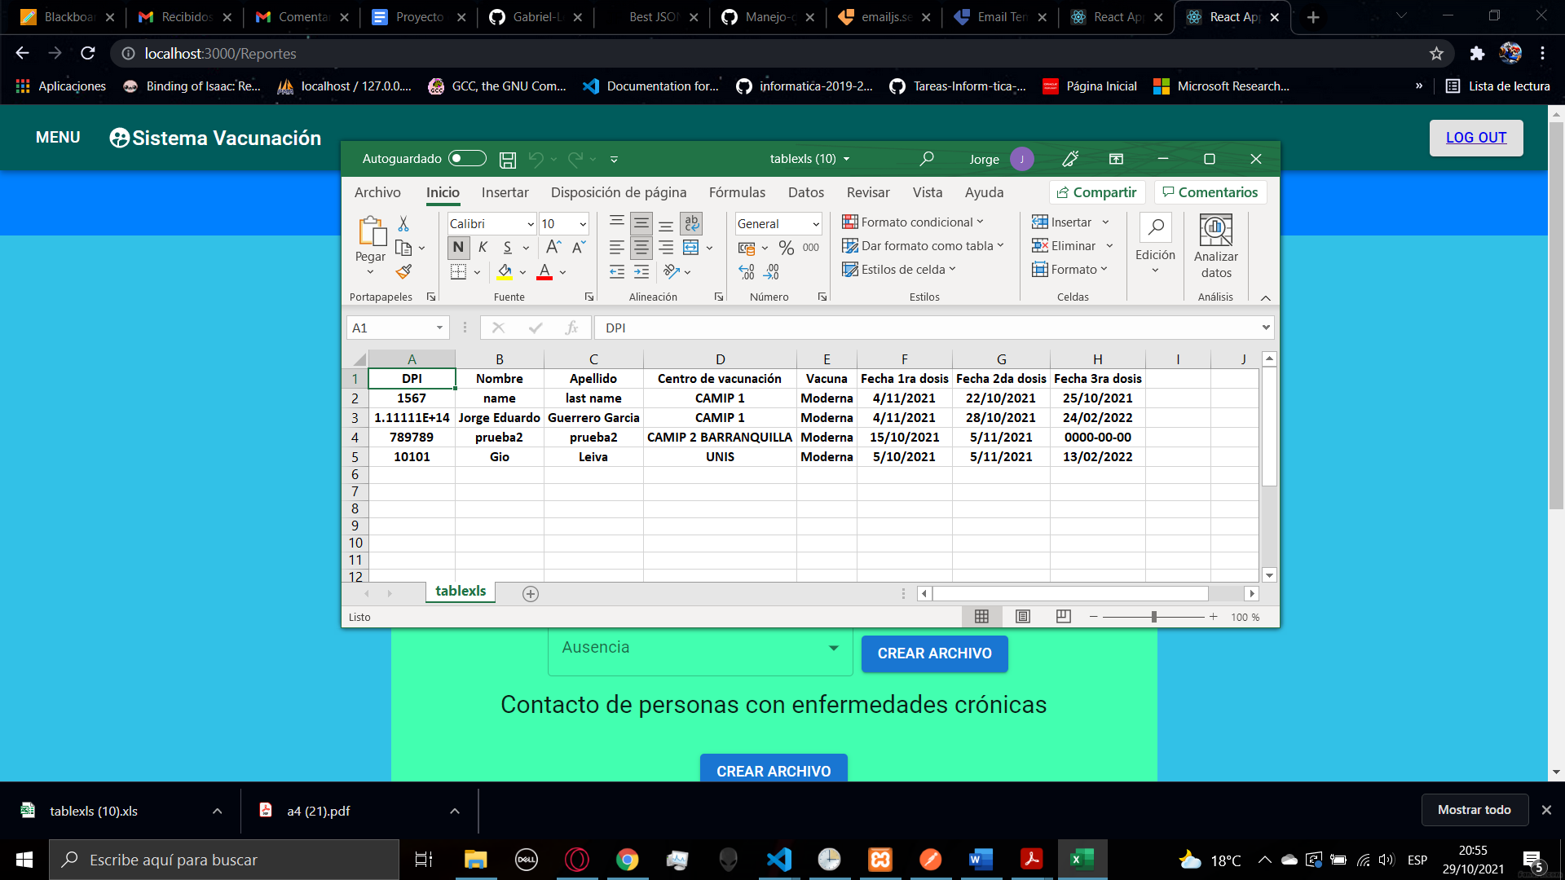

For the second report you are able to get all the information about the daily details of an specific center, there will be a list of all the centers an after generating the file you can download the file

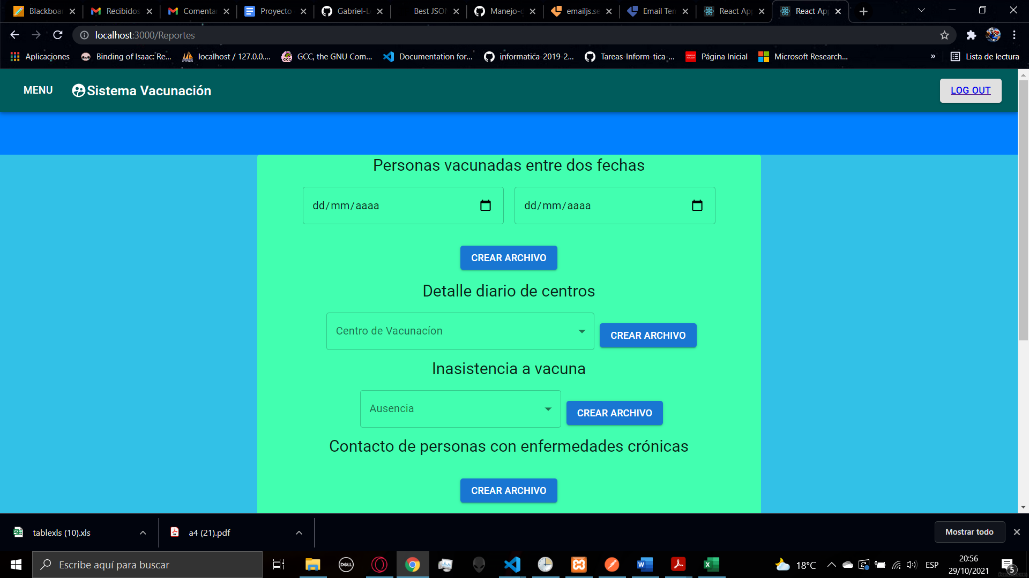

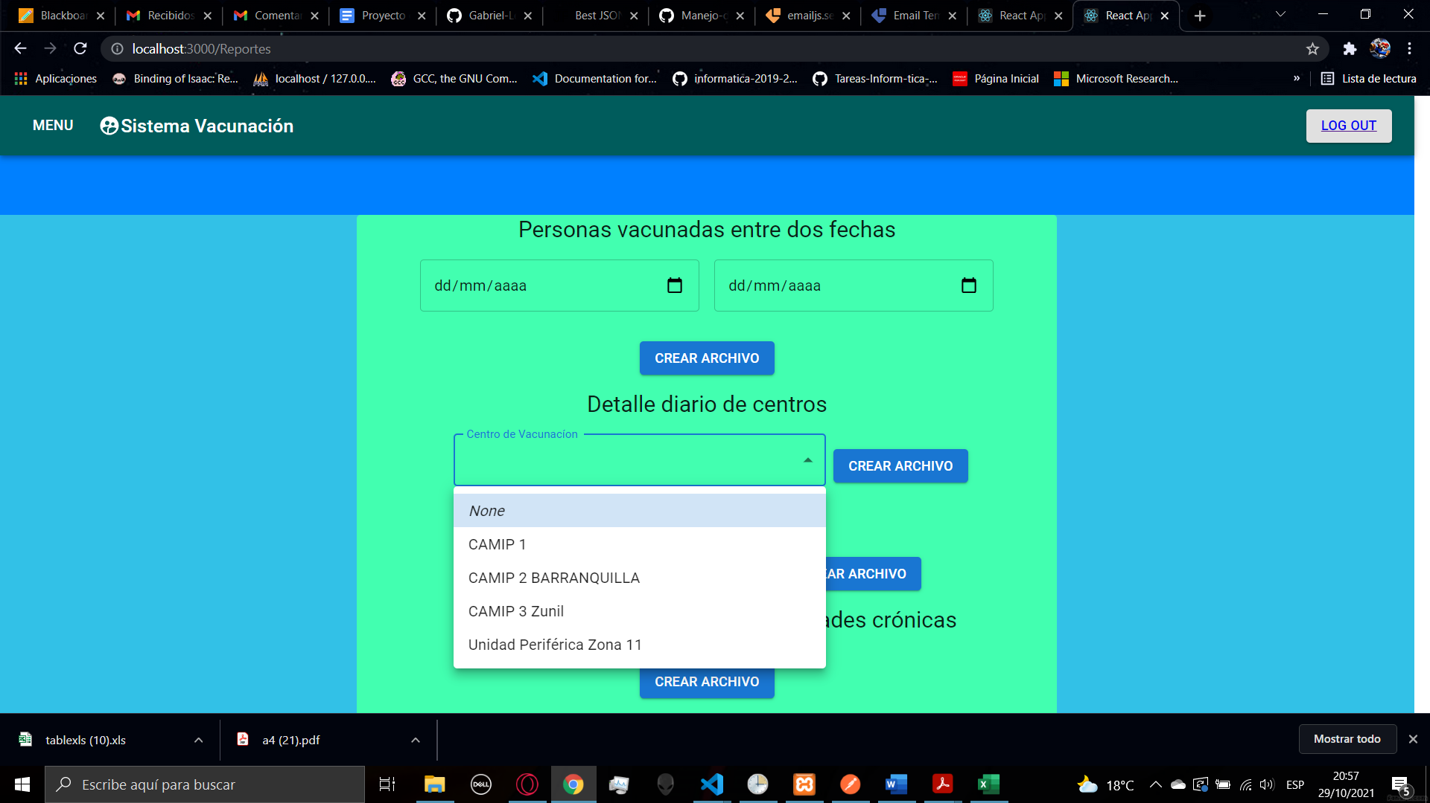

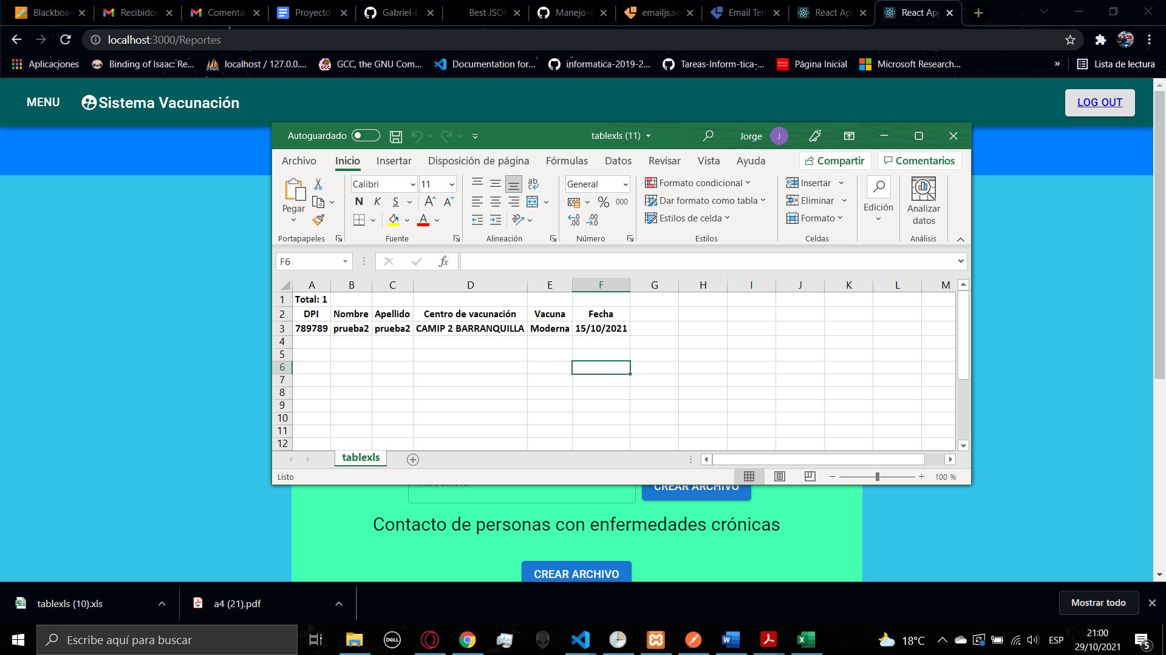

For the third report you will be able to get information about the of the people who miss some vaccination date, there will be a list that you can select to generate information about an specific dose missed or all the dose, after generating the file you can download the file.

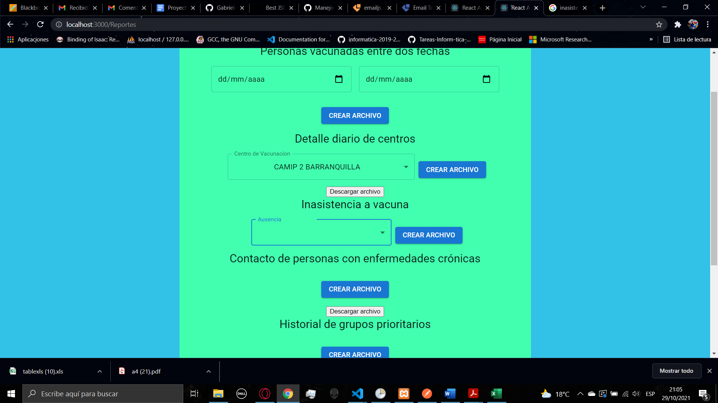

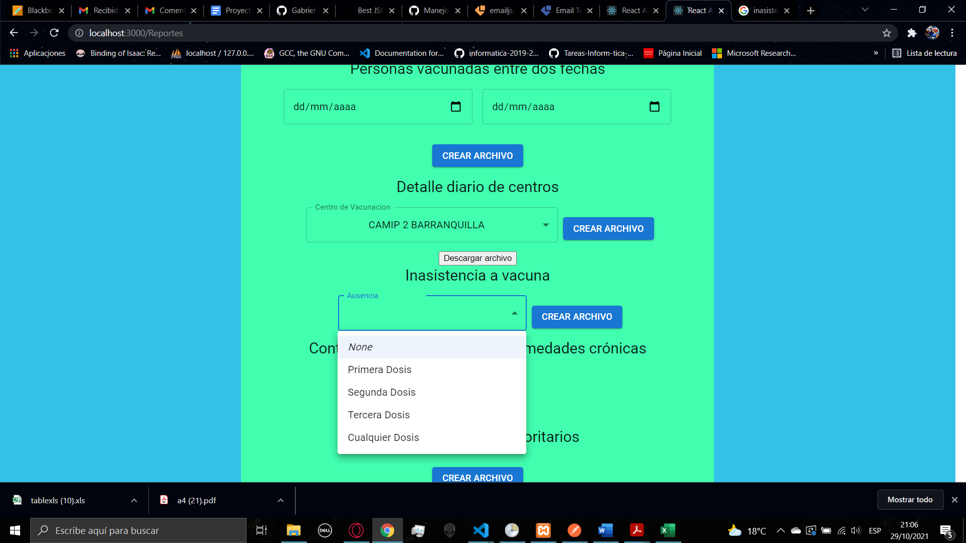

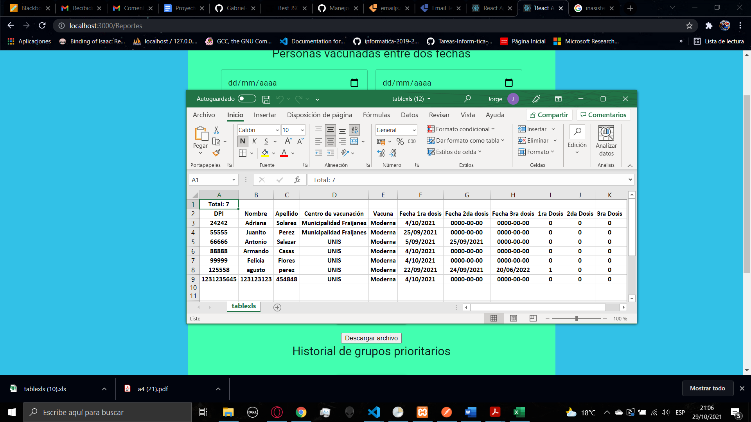

For the fourth and the fifth report there is no other parameters to generate the file there are just the buttons that give us the result of the report. For the fourth report you will able to get all the information related to people with chronic illness and their contact.

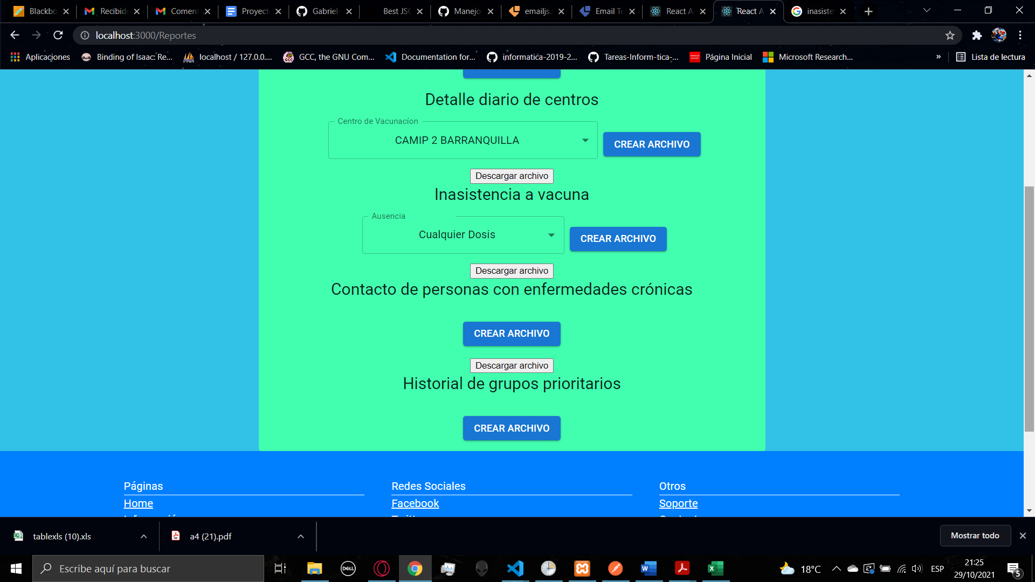

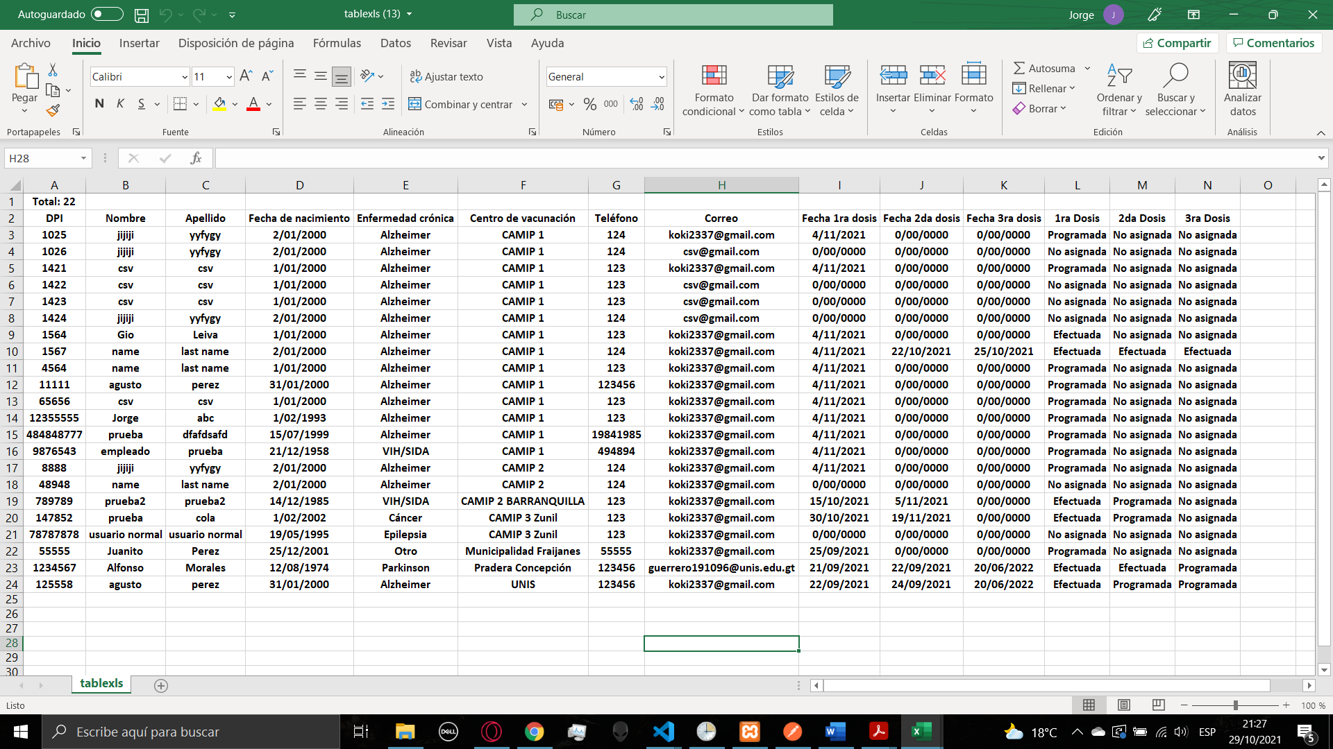

Fourth the fifth report you will be able to get all the information about the people that belongs to a priority group and all the information related

